REPUBLIC OF CAMEROON

*Peace – work – fatherland*



AFRICAN INSTITUTE OF COMPUTER SCIENCES PAUL BIYA TECHNOLOGICAL CENTER OF EXCELLENCE

P.O Box: 13719

Tel: (+237) 242-729-957| (+237) 242-729-958)

Email: contact@iaicameroun.com

Website: [www.iaicameroun.com](http://www.iaicameroun.com)

REPUBLIC OF CAMEROON

*Peace – work – fatherland*



AFRICAN INSTITUTE OF COMPUTER SCIENCES PAUL BIYA TECHNOLOGICAL CENTER OF EXCELLENCE

P.O Box: 13719

Tel: (+237) 242-729-957| (+237) 242-729-958)

Email: contact@iaicameroun.com

Website: [www.iaicameroun.com](http://www.iaicameroun.com)

REPUBLIC OF CAMEROON

*Peace – work – fatherland*



AFRICAN INSTITUTE OF COMPUTER SCIENCES PAUL BIYA TECHNOLOGICAL CENTER OF EXCELLENCE

P.O Box: 13719

Tel: (+237) 242-729-957| (+237) 242-729-958)

Email: contact@iaicameroun.com

Website: [www.iaicameroun.com](http://www.iaicameroun.com)

REPUBLIC OF CAMEROON

*Peace – work – fatherland*



AFRICAN INSTITUTE OF COMPUTER SCIENCES PAUL BIYA TECHNOLOGICAL CENTER OF EXCELLENCE

P.O Box: 13719

Tel: (+237) 242-729-957| (+237) 242-729-958)

Email: contact@iaicameroun.com

Website: [www.iaicameroun.com](http://www.iaicameroun.com)

REPUBLIC OF CAMEROON

*Peace – work – fatherland*



AFRICAN INSTITUTE OF COMPUTER SCIENCES PAUL BIYA TECHNOLOGICAL CENTER OF EXCELLENCE

P.O Box: 13719

Tel: (+237) 242-729-957| (+237) 242-729-958)

Email: contact@iaicameroun.com

Website: [www.iaicameroun.com](http://www.iaicameroun.com)

REALIZE

Tel: (+237) 222-224-601| (+237) 654-486-985

Email: realize.contactus@gmail.com

Website: www.realize.com

REPUBLIQUE DU CAMEROUN

*Paix – travail – patrie*

**ACADEMIC INTERNSHIP REPORT**

MANAGEMENT SYSTEM FOR A LOCAL ELECTRONICS VENDOR

DEVELOPMENT

AND SALES

WEB-BASED

OF

A

INVENTORY

THEME:

Internship carried out from 3rd July to the 30th September 2025

In view of obtaining a Higher Technician Diploma (HTD)

Option: SOFTWARE ENGINEERING

**Written by:**

**BALEMBA JESSY NJEA MASSOMA**

Third year student in software engineering at AICS Cameroon

Supervised by:

SUPERVISOR:

**Mr. Bill Nelson**

Lecturer at AICS-Cameroon

Academic Year 2024 - 2025

**DEDICATION**

**DEDICATION**

**DEDICATION**

**DEDICATION**

**DEDICATION**

**DEDICATION**

**DEDICATION**

**DEDICATION**

**DEDICATION**

**DEDICATION**

**DEDICATION**

**DEDICATION**

**DEDICATION**

**DEDICATION**

**DEDICATION**

**DED****ICATION**

**THIS DOCUMENT IS DEDICATED**

**TO THE**

**BALEMBA’S**

**ACKNOWLEDGEMENTS**

**THIS DOCUMENT IS DEDICATED**

**TO THE**

**BALEMBA’S**

**ACKNOWLEDGEMENTS**

**THIS DOCUMENT IS DEDICATED**

**TO THE**

**BALEMBA’S**

**ACKNOWLEDGEMENTS**

**THIS DOCUMENT IS DEDICATED**

**TO THE**

**BALEMBA’S**

**ACKNOWLEDGEMENTS**

**THIS DOCUMENT IS DEDICATED**

**TO THE**

**BALEMBA’S**

**ACKNOWLEDGEMENTS**

**THIS DOCUMENT IS DEDICATED**

**TO THE**

**BALEMBA’S**

**ACKNOWLEDGEMENTS**

**THIS DOCUMENT IS DEDICATED**

**TO THE**

**BALEMBA’S**

**ACKNOWLEDGEMENTS**

**THIS DOCUMENT IS DEDICATED**

**TO THE**

**BALEMBA’S**

**ACKNOWLEDGEMENTS**

**THIS DOCUMENT IS DEDICATED**

**TO THE**

**BALEMBA’S**

**ACKNOWLEDGEMENTS**

**THIS DOCUMENT IS DEDICATED**

**TO THE**

**BALEMBA’S**

**ACKNOWLEDGEMENTS**

**THIS DOCUMENT IS DEDICATED**

**TO THE**

**BALEMBA’S**

**ACKNOWLEDGEMENTS**

**THIS DOCUMENT IS DEDICATED**

**TO THE**

**BALEMBA’S**

**ACKNOWLEDGEMENTS**

**THIS DOCUMENT IS DEDICATED**

**TO THE**

**BALEMBA’S**

**ACKNOWLEDGEMENTS**

**THIS DOCUMENT IS DEDICATED**

**TO THE**

**BALEMBA’S**

**ACKNOWLEDGEMENTS**

**THIS DOCUMENT IS DEDICATED**

**TO THE**

**BALEMBA’S**

**ACKNOWLEDGEMENTS**

**THIS DOCUMENT IS DEDICATED**

**TO THE**

**BALEMBA’S**

**ACKNOWLEDGEMENTS**

**SUMMARYACKNOWLEDGEMENTS**

**SUMMARYACKNOWLEDGEMENTS**

**THIS DOCUMENT IS DEDICATED**

**TO THE**

**BALEMBA’S**

**ACKNOWLEDGEMENTS**

**THIS DOCUMENT IS DEDICATED**

**TO THE**

**BALEMBA’S**

**ACKNOWLEDGEMENTS**

**THIS DOCUMENT IS DEDICATED**

**TO THE**

**BALEMBA’S**

**ACKNOWLEDGEMENTS**

**THIS DOCUMENT IS DEDICATED**

**TO THE**

**BALEMBA’S**

**ACKNOWLEDGEMENTS**

**THIS DOCUMENT IS DEDICATED**

**TO THE**

**BALEMBA’S**

**ACKNOWLEDGEMENTS**

**THIS DOCUMENT IS DEDICATED**

**TO THE**

**BALEMBA’S**

**ACKNOWLEDGEMENTS**

**THIS DOCUMENT IS DEDICATED**

**TO THE**

**BALEMBA’S**

**ACKNOWLEDGEMENTS**

**THIS DOCUMENT IS DEDICATED**

**TO THE**

**BALEMBA’S**

**ACKNOWLEDGEMENTS**

**THIS DOCUMENT IS DEDICATED**

**TO THE**

**BALEMBA’S**

**ACKNOWLEDGEMENTS**

**THIS DOCUMENT IS DEDICATED**

**TO THE**

**BALEMBA’S**

**ACKNOWLEDGEMENTS**

**THIS DOCUMENT IS DEDICATED**

**TO THE**

**BALEMBA’S**

**ACKNOWLEDGEMENTS**

**THIS DOCUMENT IS DEDICATED**

**TO THE**

**BALEMBA’S**

**ACKNOWLEDGEMENTS**

**THIS DOCUMENT IS DEDICATED**

**TO THE**

**BALEMBA’S**

**ACKNOWLEDGEMENTS**

**THIS DOCUMENT IS DEDICATED**

**TO THE**

**BALEMBA’S**

**ACKNOWLEDGEMENTS**

**THIS DOCUMENT IS DEDICATED**

**TO THE**

**BALEMBA’S**

**ACKNOWLEDGEMENTS**

**THIS DOCUMENT IS DEDICATED**

**TO THE**

**BALEMBA’S**

**ACKNOWLEDGEMENTS**

**SUMMARYACKNOWLEDGEMENTS**

**SUMMARYACKNOWLEDGEMENTS**

**SUMMARYACKNOWLEDGEMENTS**

**SUMMARY**

**LIST OF FIGURESSUMMARY**

**LIST OF FIGURESSUMMARYACKNOWLEDGEMENTS**

**SUMMARYACKNOWLEDGEMENTS**

**SUMMARYACKNOWLEDGEMENTS**

**SUMMARYACKNOWLEDGEMENTS**

The path to completing this dissertation has been fraught with both professional challenges and personal adversities. I am profoundly grateful for the enduring support of:

* God Almighty for His unconditional love and grace, allowing me to go through this intense period safely, successfully, and overcome my fears and challenges with growth.
* **Mr. Abanda ARMAND Claude**, the Resident Representative of AICS-Cameroon.
* **Mr. NGU Prince,** my Academic Supervisor for his sage advice, rigorous academic guidance and the confidence he instilled in me.
* **Mr. Bill Nelson** Our supervisor for his availability, advices and indispensable assistance throughout the internship period.
* **Mr. AGBOR Anderson,** the Head of the Software Engineering department and lecturer at AICS-Cameroon for his Inspirational pieces of advices, encouragements and moral support.
* **Mr. MESSIO Ulrich,** Computer Engineer and lecturer at AICS-Cameroon for his academic support. His expertise in in UML analysis greatly enriched my work.
* My Lecturers for their support through out our training at AICS-Cameroon.
* The amazing family at **IAI** for their necessary support that greatly enhanced my research experience. Their dedication and engagement create an environment conducive to academic success.
* My friends, who provided both distractions when needed and encouragement when it seemed impossible to continue.
* My Lovely Family who stepped in not only with emotional reassurance, but also with critical financial support, when personal challenges arose and special thanks to my late father for his moral support and for always being there for me.

**SUMMARY**

**LIST OF FIGURESSUMMARY**

**LIST OF FIGURESSUMMARY**

**LIST OF FIGURESSUMMARY**

**LIST OF FIGURES**

**LIST OF TABLESLIST OF FIGURESSUMMARY**

**LIST OF FIGURESSUMMARY**

**LIST OF FIGURESSUMMARY**

**LIST OF FIGURESSUMMARY**

DEDICATION …………………………………………………………………………….i

ACKNOWLEDGEMENTS ………………………………………………………………ii

SUMMARY ……………………………………………………………………………...iii

LIST OF FIGURES ………………………………………………………………………iv

LIST OF TABLES……………………………………………………………………….vii

GLOSSARY…………………………………………………………………………….viii

ABSTRACT ……………………………………………………………………………...ix

RESUME ………………………………………………………………………………….x

GENERAL INTRODUCTION ……………………………………………………………1

TECHNICAL PHASE ……………………………………………………………………..2

CHAPTER 1: EXISTING SYSTEM ………………………………………………………3

CHAPTER 2: SPECIFICATION BOOK …………………………………………………12

CHAPTER 3: ANALYSIS ………………………………………………………………..31

CHAPTER 4: CONCEPTION PHASE …………………………………………………...76

CHAPTER 5: REALIZATION PHASE ………………………………………………….93

CHAPTER 6: FUNCTIONALITY TESTING …………………………………………...103

CHAPTER 7: USER GUIDE ……………………………………………………………113

GENERAL CONCLUSION ……………………………………………………………...129

ANNEX…………………………………………………………………………………..XIV

BIBLIOGRAPHY ………………………………………………………………………...XV

WEBOGRAPHY ………………………………………………………………………….XVI

TABLE OF CONTENTS …………………………………………………………………XVII

**LIST OF FIGURES**

**LIST OF TABLESLIST OF FIGURES**

**LIST OF TABLES**

**GLOSSARY**

**ABSTRACTGLOSSARY**

**ABSTRACT**

**RESUMEABSTRACTGLOSSARY**

**ABSTRACTGLOSSARYLIST OF TABLES**

**GLOSSARY**

**ABSTRACTGLOSSARYLIST OF TABLES**

**GLOSSARY**

**ABSTRACTGLOSSARY**

**ABSTRACT**

**RESUMEABSTRACTGLOSSARY**

**ABSTRACTGLOSSARY**

**ABSTRACT**

**RESUMEABSTRACT**

**RESUME**

**RESUMEABSTRACT**

**RESUMEABSTRACTGLOSSARY**

**ABSTRACTGLOSSARY**

**ABSTRACT**

**RESUMEABSTRACTGLOSSARY**

**ABSTRACTGLOSSARYLIST OF TABLESLIST OF FIGURES**

**LIST OF TABLESLIST OF FIGURES**

Figure 1: Project plan 22

Figure 2: UML hierarchy diagram (source: https://images.edrawsoft.com/articles/what-is-uml/uml-diagram-types.png) 35

Figure 3: Phases of UP (source: https://ars.els-cdn.com/content/image/3-s2.0-B9780128054765000022-f02-01-9780128054765.jpg ) 38

Figure 4: Graphical representation of 2TUP (source: Mr. Messio UML course AICS-Cameroon 2023-2024) 40

Figure 5: Use Case Diagram Formalism 42

Figure 6: General Use Case Diagram 45

Figure 7: Client Manage Cart Specific Use Case diagram 46

Figure 8: Supplier Overview Use Case Diagram 47

Figure 9: Communication Diagram Formalism 53

Figure 10: Communication Diagram for <<Authentication (Login)>> 55

Figure 11: Communication diagram for <<Make Order>> 56

Figure 12: Communication for <<Create Category>> 57

Figure 13: Sequence Diagram Formalism 58

Figure 14: Sequence diagram for <<Authentication (Login)>> 60

Figure 15: Sequence diagram for <<Make Order>> 61

Figure 16: Sequence diagram for <<Create Category>> 62

Figure 17: Activity diagram formalism 63

Figure 18: Activity diagram for <<Authentication>> 66

Figure 19: Activity diagram for <<Make Order>> 67

Figure 20: Activity diagram for <<Create Category>> 68

Figure 21: Activity diagram for <<Add Product>> 69

Figure 22: Visual representation of 3-Tier Architecture (Source: https://docs.aws.amazon.com/images/whitepapers/latest/serverless-multi-tier-architectures-api-gateway-lambda/images/image2.png ) 75

Figure 23: MVC Architecture (Source: https://encrypted-tbn0.gstatic.com /images? q=tbn:ANd9GcRx0n1oDz1SskHiZMKI5W0fAZ -KQ33yRlHruA&s ) 76

Figure 24: Class Diagram Formalism 77

Figure 25:General System Class Diagram 80

Figure 26: Formalism of a State machine diagram 81

Figure 27: State machine diagram for <<Order>> 83

Figure 28: Formalism of a Package diagram 84

Figure 29: System Package diagram 86

Figure 30: Formalism for Deployment Diagram 91

Figure 31: System's Deployment diagram 93

Figure 32: Formalism for Component Diagram 94

Figure 33: System's Component diagram 96

Figure 34:POST Request to /api/order/ to create an order 103

Figure 35: GET Request to /api/order to retrieve a list of all orders 104

Figure 36: Get Request to s/api/order?latest=true with parameter (latest = true) to get the most recent orders 104

Figure 37: API response displaying product details for particular product Id 105

Figure 38:Test to request payment from a client on behalf of a supplier 106

Figure 39: Creating MongoDB Atlas Account 112

Figure 40: Creating cluster 113

Figure 41: Creating Database (Bigger red circle) and collection (smaller red circle) 114

Figure 42: Allow access(IP Adress) from anywhere (Application Server) 115

Figure 43: Getting connection string to connect backend to cluster in Mongodb Atlas 116

Figure 44: Inserting Connection URI to env.local file into Next js project 117

Figure 45: Nodejs website for download and installation 117

Figure 46: Install npm 117

Figure 47: Downloading project to target machine 118

Figure 48:Installing Project or Application Dependences 118

Figure 49: Starting the development server 118

Figure 50: Home page with featured and New arrival products 119

Figure 51: All product listing page 120

Figure 52: Cart page 120

Figure 53: Payment/Checkout page 121

Figure 54: Shop manager Dashboard 121

Figure 55: Delivery Person Dashboard 122

Figure 56: Order page 122

**LIST OF TABLES**

**GLOSSARY**

**ABSTRACTGLOSSARY**

**ABSTRACT**

**RESUMEABSTRACTGLOSSARY**

**ABSTRACTGLOSSARYLIST OF TABLES**

**GLOSSARY**

**ABSTRACTGLOSSARYLIST OF TABLES**

**GLOSSARY**

**ABSTRACTGLOSSARY**

**ABSTRACT**

**RESUMEABSTRACTGLOSSARY**

**ABSTRACTGLOSSARY**

**ABSTRACT**

**RESUMEABSTRACT**

**RESUME**

**RESUMEABSTRACT**

**RESUMEABSTRACTGLOSSARY**

**ABSTRACTGLOSSARY**

**ABSTRACT**

**RESUMEABSTRACTGLOSSARY**

**ABSTRACTGLOSSARYLIST OF TABLES**

**GLOSSARY**

**ABSTRACTGLOSSARY**

**ABSTRACT**

**RESUMEABSTRACTGLOSSARY**

**ABSTRACTGLOSSARYLIST OF TABLES**

**GLOSSARY**

**ABSTRACTGLOSSARYLIST OF TABLES**

**GLOSSARY**

**ABSTRACTGLOSSARY**

**ABSTRACT**

**RESUMEABSTRACTGLOSSARY**

**ABSTRACTGLOSSARY**

**ABSTRACT**

**RESUMEABSTRACT**

**RESUME**

**RESUMEABSTRACT**

**RESUMEABSTRACTGLOSSARY**

**ABSTRACTGLOSSARY**

**ABSTRACT**

**RESUMEABSTRACTGLOSSARY**

**ABSTRACTGLOSSARY**

**ABSTRACT**

**RESUME**

**RESUMEABSTRACT**

**RESUMEABSTRACTGLOSSARY**

**ABSTRACTGLOSSARY**

**ABSTRACT**

**RESUMEABSTRACTGLOSSARY**

**ABSTRACTGLOSSARY**

**ABSTRACT**

**RESUMEABSTRACT**

**RESUME**

**RESUMEABSTRACT**

**RESUMEABSTRACTGLOSSARY**

**ABSTRACTGLOSSARY**

**ABSTRACT**

**RESUMEABSTRACTGLOSSARY**

**ABSTRACTGLOSSARYLIST OF TABLES**

**GLOSSARY**

**ABSTRACTGLOSSARY**

**ABSTRACT**

**RESUMEABSTRACTGLOSSARY**

**ABSTRACTGLOSSARYLIST OF TABLES**

**GLOSSARY**

**ABSTRACTGLOSSARYLIST OF TABLES**

**GLOSSARY**

**ABSTRACTGLOSSARY**

**ABSTRACT**

**RESUMEABSTRACTGLOSSARY**

**ABSTRACTGLOSSARY**

**ABSTRACT**

**RESUMEABSTRACT**

**RESUME**

**RESUMEABSTRACT**

**RESUMEABSTRACTGLOSSARY**

**ABSTRACTGLOSSARY**

**ABSTRACT**

**RESUMEABSTRACTGLOSSARY**

**ABSTRACTGLOSSARYLIST OF TABLES**

**GLOSSARY**

**ABSTRACTGLOSSARY**

**ABSTRACT**

**RESUMEABSTRACTGLOSSARY**

**ABSTRACTGLOSSARYLIST OF TABLES**

**GLOSSARY**

**ABSTRACTGLOSSARYLIST OF TABLES**

Table 3: Limitations of the existing system and proposed solutions 10

Table 4:Project Plan 21

Table 5: Software Resources (source: mercurial 2024) 23

Table 6: Hardware Resources (source: mercurial 2024) 25

Table 7: Human Resources 25

Table 8: Total Estimated Cost for Project 26

Table 9 : Project Participants 27

Table 10: Comparative Study between UML and MERISE 36

Table 11: Comparative study between 2TUP and UP 41

Table 12: Components of a Use Case Diagram 43

Table 13: Components of Use Case Diagram (Continued) 44

Table 14: Formalism of Textual Description of a Use Case 48

Table 15: <<Authenticate>> Textual Description 49

Table 16: <<Make Order>> Textual Description 51

Table 17: <<Submit Driver License Application>> Textual Description **Error! Bookmark not defined.**

Table 18: <<Submit Business License Application>> Textual Description **Error! Bookmark not defined.**

Table 19: Components of Communication Diagram 54

Table 20: Components of a Sequence Diagram 59

Table 21: Components of an Activity Diagram 64

Table 22: Components of a Class Diagram 78

Table 23: Components of a State Diagram 82

Table 24: Components of a Package Diagram 85

Table 25: Components of a Deployment Diagram 92

Table 26: Components of a Component Diagram 95

**GLOSSARY**

**ABSTRACTGLOSSARY**

**ABSTRACT**

**RESUMEABSTRACTGLOSSARY**

**ABSTRACTGLOSSARY**

**ABSTRACT**

**RESUMEABSTRACT**

**RESUME**

**RESUMEABSTRACT**

**RESUMEABSTRACTGLOSSARY**

**ABSTRACTGLOSSARY**

**ABSTRACT**

**RESUMEABSTRACTGLOSSARY**

**ABSTRACTGLOSSARY**

**ABSTRACT**

**RESUME**

**RESUMEABSTRACT**

**RESUMEABSTRACTGLOSSARY**

**ABSTRACTGLOSSARY**

**ABSTRACT**

**RESUMEABSTRACTGLOSSARY**

**ABSTRACTGLOSSARY**

**ABSTRACT**

**RESUMEABSTRACT**

**RESUME**

**RESUMEABSTRACT**

**RESUMEABSTRACTGLOSSARY**

**ABSTRACTGLOSSARY**

**ABSTRACT**

**RESUMEABSTRACTGLOSSARY**

**ABSTRACTGLOSSARY**

**ABSTRACT**

**RESUME**

**RESUMEABSTRACT**

**RESUMEABSTRACT**

**RESUMEABSTRACT**

**RESUME**

**RESUMEABSTRACT**

**RESUMEABSTRACTGLOSSARY**

**ABSTRACTGLOSSARY**

**ABSTRACT**

**RESUMEABSTRACTGLOSSARY**

**ABSTRACTGLOSSARY**

**ABSTRACT**

**RESUMEABSTRACT**

**RESUME**

**RESUMEABSTRACT**

**RESUMEABSTRACTGLOSSARY**

**ABSTRACTGLOSSARY**

**ABSTRACT**

**RESUMEABSTRACTGLOSSARY**

**ABSTRACTGLOSSARY**

**ABSTRACT**

**RESUME**

**RESUMEABSTRACT**

**RESUMEABSTRACTGLOSSARY**

**ABSTRACTGLOSSARY**

**ABSTRACT**

**RESUMEABSTRACTGLOSSARY**

**ABSTRACTGLOSSARY**

**ABSTRACT**

**RESUMEABSTRACT**

**RESUME**

**RESUMEABSTRACT**

**RESUMEABSTRACTGLOSSARY**

**ABSTRACTGLOSSARY**

**ABSTRACT**

**RESUMEABSTRACTGLOSSARY**

**ABSTRACTGLOSSARY**

**2TUP:** Two track unified process

**API**: Application Programming Interface

**AICS:** African Institute of Computer Sciences

**CD-ROM:** Compact Disk- Read Only Memory

**CRUD:** Create Read Update Delete

**CSS:** Cascading Style Sheet

**DB:** Database

**DBMS:** Database Management System

**JS:** JavaScript

**JSX:** JavaScript XML

**MOMO:** Mobile Money

**Mr:** Mister

**MVC:** Model View Controller

**SQL:** Structured Query Language

**UML:** Unified Modelling Language

**UP:** Unified Process

**ABSTRACT**

**RESUME**

**RESUMEABSTRACT**

**RESUMEABSTRACT**

**RESUMEABSTRACT**

**RESUME**

**RESUMEABSTRACT**

**RESUMEABSTRACT**

**RESUME**

**RESUMEABSTRACT**

**RESUME**

**RESUMEABSTRACT**

**RESUMEABSTRACT**

**RESUMEABSTRACT**

**RESUME**

**RESUMEABSTRACT**

**RESUMEABSTRACT**

In today's digital age, small electronics vendors in Cameroon face increasing pressure to modernize operations and meet evolving customer expectations. Traditional methods of managing inventory and recording sales often result in inefficiencies, such as stock mismanagement, delayed order processing, and poor customer service. To address these challenges, our project focuses on the **DEVELOPMENT OF A WEB-BASED INVENTORY AND SALES MANAGEMENT SYSTEM** TAILORED FOR A **LOCAL ELECTRONICS VENDOR**.

The application, named **Locavend**, allows the shop manager to easily manage product listings, track stock levels, and monitor daily sales, while enabling clients to browse and place orders online. Our approach involved conducting feasibility studies, system design, and full-stack web development using modern technologies. The solution enhances transparency, reduces manual errors, and streamlines operations, ultimately improving the vendor’s business efficiency and customer satisfaction.

**Keywords:**

* Inventory Management
* Sales Tracking
* Order Management
* Web-based system
* Electronics Shop

**RESUME**

**RESUME**

**RESUME**

**RESUME**

À l’ère du numérique, les petits vendeurs d’électronique au Cameroun sont de plus en plus confrontés à la nécessité de moderniser leurs opérations pour répondre aux attentes croissantes des clients. Les méthodes traditionnelles de gestion de stock et d’enregistrement des ventes entraînent souvent des inefficacités telles que la mauvaise gestion des produits, les retards dans le traitement des commandes et un service client peu satisfaisant.

Pour remédier à ces problèmes, notre projet porte sur le **DEVELOPPEMENT D’UNE APPLICATION WEB DE GESTION DES STOCKS ET DES VENTES** destinée à un **vendeur local d’équipements électroniques**. L’application, nommée **Locavend**, permet au gérant du magasin de gérer facilement les produits, suivre les niveaux de stock et consulter les ventes quotidiennes, tandis que les clients peuvent naviguer et passer leurs commandes en ligne.

Notre démarche a consisté à réaliser des études de faisabilité, l’analyse, la conception et le développement complet du système web à l’aide de technologies modernes. Cette solution permet d’améliorer la transparence, de réduire les erreurs manuelles et de faciliter les opérations, tout en augmentant l’efficacité et la satisfaction client du vendeur.

**Mots-clés:**

* Systeme Web
* **GENERAL INTRODUCTION**Systeme Web

**GENERAL INTRODUCTION**

* **GENERAL INTRODUCTION**Systeme Web
* **GENERAL INTRODUCTION**Systeme Web

**GENERAL INTRODUCTION**

**GENERAL INTRODUCTION**

**GENERAL INTRODUCTION**

* **GENERAL INTRODUCTION**Systeme Web
* **GENERAL INTRODUCTION**Systeme Web

**GENERAL INTRODUCTION**

* **GENERAL INTRODUCTION**Systeme Web
* **GENERAL INTRODUCTION**Systeme Web

**GENERAL INTRODUCTION**

**GENERAL INTRODUCTION**

**GENERAL INTRODUCTION**

**GENERAL INTRODUCTION**

**GENERAL INTRODUCTION**

**GENERAL INTRODUCTION**

* **GENERAL INTRODUCTION**Systeme Web
* **GENERAL INTRODUCTION**Systeme Web

**GENERAL INTRODUCTION**

* **GENERAL INTRODUCTION**Systeme Web
* **GENERAL INTRODUCTION**Systeme Web

**GENERAL INTRODUCTION**

**GENERAL INTRODUCTION**

**GENERAL INTRODUCTION**

* **GENERAL INTRODUCTION**Systeme Web
* **GENERAL INTRODUCTION**Systeme Web

**GENERAL INTRODUCTION**

* **GENERAL INTRODUCTION**Systeme Web
* **GENERAL INTRODUCTION**Systeme Web

**GENERAL INTRODUCTION**

**GENERAL INTRODUCTION**

**GENERAL INTRODUCTION**

**GENERAL INTRODUCTION**

**GENERAL INTRODUCTION**

**GENERAL INTRODUCTION**

**GENERAL INTRODUCTION**

**GENERAL INTRODUCTION**

**GENERAL INTRODUCTION**

**GENERAL INTRODUCTION**

**GENERAL INTRODUCTION**

**GENERAL INTRODUCTION**

**GENERAL INTRODUCTION**

* **GENERAL INTRODUCTION**Systeme Web
* **GENERAL INTRODUCTION**Systeme Web

**GENERAL INTRODUCTION**

* **GENERAL INTRODUCTION**Systeme Web
* **GENERAL INTRODUCTION**Systeme Web

**GENERAL INTRODUCTION**

**GENERAL INTRODUCTION**

**GENERAL INTRODUCTION**

* **GENERAL INTRODUCTION**Systeme Web
* **GENERAL INTRODUCTION**Systeme Web

**GENERAL INTRODUCTION**

* **GENERAL INTRODUCTION**Systeme Web
* **GENERAL INTRODUCTION**Systeme Web

**GENERAL INTRODUCTION**

**GENERAL INTRODUCTION**

**GENERAL INTRODUCTION**

**GENERAL INTRODUCTION**

**GENERAL INTRODUCTION**

**GENERAL INTRODUCTION**

* **GENERAL INTRODUCTION**Systeme Web
* **GENERAL INTRODUCTION**Systeme Web

**GENERAL INTRODUCTION**

* **GENERAL INTRODUCTION**Systeme Web
* **GENERAL INTRODUCTION**Systeme Web

**GENERAL INTRODUCTION**

**GENERAL INTRODUCTION**

**GENERAL INTRODUCTION**

* **GENERAL INTRODUCTION**Systeme Web
* **GENERAL INTRODUCTION**Systeme Web

**GENERAL INTRODUCTION**

* **GENERAL INTRODUCTION**Systeme Web
* **GENERAL INTRODUCTION**Systeme Web
* Gestion de stock
* Suivi des ventes
* Commandes
* Vendeur local

**GENERAL INTRODUCTION**

**GENERAL INTRODUCTION**

**GENERAL INTRODUCTION**

**GENERAL INTRODUCTION**

**GENERAL INTRODUCTION**

**GENERAL INTRODUCTION**

**GENERAL INTRODUCTION**

**GENERAL INTRODUCTION**

**GENERAL INTRODUCTION**

**GENERAL INTRODUCTION**

**GENERAL INTRODUCTION**

**GENERAL INTRODUCTION**

**GENERAL INTRODUCTION**

**GENERAL INTRODUCTION**

**GENERAL INTRODUCTION**

**GENERAL INTRODUCTION**

**GENERAL INTRODUCTION**

**GENERAL INTRODUCTION**

**GENERAL INTRODUCTION**

**GENERAL INTRODUCTION**

**GENERAL INTRODUCTION**

**GENERAL INTRODUCTION**

**GENERAL INTRODUCTION**

**GENERAL INTRODUCTION**

**GENERAL INTRODUCTION**

**GENERAL INTRODUCTION**

**GENERAL INTRODUCTION**

**GENERAL INTRODUCTION**

In recent years, the need for digital transformation has become increasingly apparent among small businesses in Cameroon, especially for local electronics vendors. These businesses often rely on manual methods to manage inventory and sales, leading to inefficiencies such as stock mismanagement, delayed customer service, and lack of accurate sales tracking. As consumer expectations rise and competition intensifies, there is a growing need for local vendors to modernize their operations. This project focuses on addressing these challenges by designing and implementing a web-based application to manage inventory and sales for a local electronics shop. The system provides tools for the shop manager to track stock levels, monitor sales activities, and handle customer orders with greater accuracy and efficiency. Clients can also browse available products and place orders through the platform, enhancing convenience and customer experience. Based on our theme, **“DEVELOPMENT OF A WEB-BASED INVENTORY AND SALES MANAGEMENT SYSTEM FOR A LOCAL ELECTRONICS VENDOR,”**, we conducted thorough research to provide a viable solution. This report is structured around a single phase: the **Technical Phase**, which is composed of seven key sections as outlined below:

Technical Phase

* Existing System
* Specification Book
* Analysis
* Conception
* Implementation/Deployment
* Functionality Testing
* User Guide
* Existing System
* Specification Book
* Analysis
* Conception
* Implementation/Deployment
* Functionality Testing
* User Guide
* Existing System
* Specification Book
* Analysis
* Conception
* Implementation/Deployment
* Functionality Testing
* User Guide
* Existing System
* Specification Book
* Analysis
* Conception
* Implementation/Deployment
* Functionality Testing
* User Guide
* Existing System
* Specification Book
* Analysis
* Conception
* Implementation/Deployment
* Functionality Testing
* User Guide
* Existing System
* Specification Book
* Analysis
* Conception
* Implementation/Deployment
* Functionality Testing
* User Guide
* Existing System
* Specification Book
* Analysis
* Conception
* Implementation/Deployment
* Functionality Testing
* User Guide
* Existing System
* Specification Book
* Analysis
* Conception
* Implementation/Deployment
* Functionality Testing
* User Guide
* Existing System
* Specification Book
* Analysis
* Conception
* Implementation/Deployment
* Functionality Testing
* User Guide
* Existing System
* Specification Book
* Analysis
* Conception
* Implementation/Deployment
* Functionality Testing
* User Guide
* Existing System
* Specification Book
* Analysis
* Conception
* Implementation/Deployment
* Functionality Testing
* User Guide
* Existing System
* Specification Book
* Analysis
* Conception
* Implementation/Deployment
* Functionality Testing
* User Guide
* Existing System
* Specification Book
* Analysis
* Conception
* Implementation/Deployment
* Functionality Testing
* User Guide
* Existing System
* Specification Book
* Analysis
* Conception
* Implementation/Deployment
* Functionality Testing
* User Guide
* Existing System
* Specification Book
* Analysis
* Conception
* Implementation/Deployment
* Functionality Testing
* User Guide
* Existing System
* Specification Book
* Analysis
* Conception
* Implementation/Deployment
* Functionality Testing
* User Guide
* Existing System
* Specification Book
* Analysis
* Conception
* Implementation/Deployment
* Functionality Testing
* User Guide
* Existing System
* Specification Book
* Analysis
* Conception
* Implementation/Deployment
* Functionality Testing
* User Guide
* Existing System
* Specification Book
* Analysis
* Conception
* Implementation/Deployment
* Functionality Testing
* User Guide
* Existing System
* Specification Book
* Analysis
* Conception
* Implementation/Deployment
* Functionality Testing
* User Guide
* Existing System
* Specification Book
* Analysis
* Conception
* Implementation/Deployment
* Functionality Testing
* User Guide
* Existing System
* Specification Book
* Analysis
* Conception
* Implementation/Deployment
* Functionality Testing
* User Guide
* Existing System
* Specification Book
* Analysis
* Conception
* Implementation/Deployment
* Functionality Testing
* User Guide
* Existing System
* Specification Book
* Analysis
* Conception
* Implementation/Deployment
* Functionality Testing
* User Guide
* Existing System
* Specification Book
* Analysis
* Conception
* Implementation/Deployment
* Functionality Testing
* User Guide
* Existing System
* Specification Book
* Analysis
* Conception
* Implementation/Deployment
* Functionality Testing
* User Guide
* Existing System
* Specification Book
* Analysis
* Conception
* Implementation/Deployment
* Functionality Testing
* User Guide
* Existing System
* Specification Book
* Analysis
* Conception
* Implementation/Deployment
* Functionality Testing
* User Guide
* Existing System
* Specification Book
* Analysis
* Conception
* Implementation/Deployment
* Functionality Testing
* User Guide
* Existing System
* Specification Book
* Analysis
* Conception
* Implementation/Deployment
* Functionality Testing
* User Guide
* Existing System
* Specification Book
* Analysis
* Conception
* Implementation/Deployment
* Functionality Testing
* User Guide
* Existing System
* Specification Book
* Analysis
* Conception
* Implementation/Deployment
* Functionality Testing
* User Guide

Preamble

**PART 2: TECHNICAL PHASE**Preamble

**PART 2: TECHNICAL PHASE**

**PART 2: TECHNICAL PHASE**Preamble

**PART 2: TECHNICAL PHASE**Preamble

**PART 2: TECHNICAL PHASE**

**PART 2: TECHNICAL PHASE**

**PART 2: TECHNICAL PHASE**

**PART 2: TECHNICAL PHASE**Preamble

**PART 2: TECHNICAL PHASE**Preamble

**PART 2: TECHNICAL PHASE**

**PART 2: TECHNICAL PHASE**Preamble

**PART 2: TECHNICAL PHASE**Preamble

**TECHNICAL PHASE**

**PART 2: TECHNICAL PHASE**

**PART 2: TECHNICAL PHASE**

**PART 2: TECHNICAL PHASE**

**PART 2: TECHNICAL PHASE**

**PART 2: TECHNICAL PHASE**

**PART 2: TECHNICAL PHASE**

**PART 2: TECHNICAL PHASE**Preamble

**PART 2: TECHNICAL PHASE**Preamble

**PART 2: TECHNICAL PHASE**

**PART 2: TECHNICAL PHASE**Preamble

**PART 2: TECHNICAL PHASE**Preamble

**PART 2: TECHNICAL PHASE**

**PART 2: TECHNICAL PHASE**

**PART 2: TECHNICAL PHASE**

**PART 2: TECHNICAL PHASE**Preamble

**PART 2: TECHNICAL PHASE**Preamble

**PART 2: TECHNICAL PHASE**

**PART 2: TECHNICAL PHASE**Preamble

**PART 2: TECHNICAL PHASE**Preamble

**TECHNICAL PHASE**

**PART 2: TECHNICAL PHASE**

**PART 2: TECHNICAL PHASE**

**PART 2: TECHNICAL PHASE**

**PART 2: TECHNICAL PHASE**

**PART 2: TECHNICAL PHASE**

**PART 2: TECHNICAL PHASE**

**PART 2: TECHNICAL PHASE**

**TECHNICAL PHASE**

**PART 2: TECHNICAL PHASE**

**PART 2: TECHNICAL PHASE**

**PART 2: TECHNICAL PHASE**

**PART 2: TECHNICAL PHASE**

**PART 2: TECHNICAL PHASE**

**PART 2: TECHNICAL PHASE**

**PART 2: TECHNICAL PHASE**Preamble

**PART 2: TECHNICAL PHASE**Preamble

**PART 2: TECHNICAL PHASE**

**PART 2: TECHNICAL PHASE**Preamble

**PART 2: TECHNICAL PHASE**Preamble

**PART 2: TECHNICAL PHASE**

**PART 2: TECHNICAL PHASE**

**PART 2: TECHNICAL PHASE**

**PART 2: TECHNICAL PHASE**Preamble

**PART 2: TECHNICAL PHASE**Preamble

**PART 2: TECHNICAL PHASE**

**PART 2: TECHNICAL PHASE**Preamble

**PART 2: TECHNICAL PHASE**Preamble

**TECHNICAL PHASE**

**PART 2: TECHNICAL PHASE**

**PART 2: TECHNICAL PHASE**

**PART 2: TECHNICAL PHASE**

**PART 2: TECHNICAL PHASE**

**PART 2: TECHNICAL PHASE**

**PART 2: TECHNICAL PHASE**

**PART 2: TECHNICAL PHASE**Preamble

**PART 2: TECHNICAL PHASE**Preamble

**PART 2: TECHNICAL PHASE**

**PART 2: TECHNICAL PHASE**Preamble

**PART 2: TECHNICAL PHASE**Preamble

**PART 2: TECHNICAL PHASE**

**PART 2: TECHNICAL PHASE**

**PART 2: TECHNICAL PHASE**

**PART 2: TECHNICAL PHASE**Preamble

**PART 2: TECHNICAL PHASE**Preamble

**PART 2: TECHNICAL PHASE**

**PART 2: TECHNICAL PHASE**Preamble

**PART 2: TECHNICAL PHASE**Preamble

**TECHNICAL PHASE**

**PART 2: TECHNICAL PHASE**

**PART 2: TECHNICAL PHASE**

**PART 2: TECHNICAL PHASE**

**PART 2: TECHNICAL PHASE**

**PART 2: TECHNICAL PHASE**

**PART 2: TECHNICAL PHASE**

**PART 2: TECHNICAL PHASE**

**TECHNICAL PHASE**

**PART 2: TECHNICAL PHASE**

**PART 2: TECHNICAL PHASE**

**PART 2: TECHNICAL PHASE**

**PART 2: TECHNICAL PHASE**

**PART 2: TECHNICAL PHASE**

**PART 2: TECHNICAL PHASE**

**PART 2: TECHNICAL PHASE**

**TECHNICAL PHASE**

**PART 2: TECHNICAL PHASE**

**PART 2: TECHNICAL PHASE**

**PART 2: TECHNICAL PHASE**

**PART 2: TECHNICAL PHASE**

**PART 2: TECHNICAL PHASE**

**PART 2: TECHNICAL PHASE**

**PART 2: TECHNICAL PHASE**

**TECHNICAL PHASE**

**PART 2: TECHNICAL PHASE**

**PART 2: TECHNICAL PHASE**

**PART 2: TECHNICAL PHASE**

**PART 2: TECHNICAL PHASE**

**PART 2: TECHNICAL PHASE**

**PART 2: TECHNICAL PHASE**

**PART 2: TECHNICAL PHASE**

This phase focuses on the various characteristics, specificities, and expectations of the subject under our study.

Content:

INTRODUCTIONContent:

INTRODUCTION

INTRODUCTIONContent:

INTRODUCTIONContent:

INTRODUCTION

INTRODUCTION

INTRODUCTION

INTRODUCTIONContent:

INTRODUCTIONContent:

INTRODUCTION

INTRODUCTIONContent:

INTRODUCTIONContent:

INTRODUCTIONContent:

INTRODUCTIONContent:

INTRODUCTION

INTRODUCTIONContent:

INTRODUCTIONContent:

INTRODUCTION

INTRODUCTION

INTRODUCTION

INTRODUCTIONContent:

INTRODUCTIONContent:

INTRODUCTION

INTRODUCTIONContent:

INTRODUCTIONContent:

INTRODUCTION

INTRODUCTION

INTRODUCTION

INTRODUCTION

INTRODUCTION

INTRODUCTION

INTRODUCTION

INTRODUCTION

INTRODUCTIONContent:

INTRODUCTIONContent:

INTRODUCTION

INTRODUCTIONContent:

INTRODUCTIONContent:

INTRODUCTION

INTRODUCTION

INTRODUCTION

INTRODUCTIONContent:

INTRODUCTIONContent:

INTRODUCTION

INTRODUCTIONContent:

INTRODUCTIONContent:

INTRODUCTIONContent:

INTRODUCTIONContent:

INTRODUCTION

INTRODUCTIONContent:

INTRODUCTIONContent:

INTRODUCTION

INTRODUCTION

INTRODUCTION

INTRODUCTIONContent:

INTRODUCTIONContent:

INTRODUCTION

INTRODUCTIONContent:

INTRODUCTIONContent:

INTRODUCTION

INTRODUCTION

INTRODUCTION

INTRODUCTION

INTRODUCTION

INTRODUCTION

INTRODUCTION

INTRODUCTION

INTRODUCTION

INTRODUCTION

INTRODUCTION

INTRODUCTION

INTRODUCTION

INTRODUCTION

INTRODUCTION

INTRODUCTION

INTRODUCTION

INTRODUCTION

INTRODUCTION

INTRODUCTION

INTRODUCTION

INTRODUCTION

INTRODUCTION

INTRODUCTION

INTRODUCTION

INTRODUCTION

INTRODUCTION

INTRODUCTION

INTRODUCTION

INTRODUCTION

INTRODUCTION

INTRODUCTION

I.

I.

I.

I.

I.

I.

I.

I.

I.

I.

I.

I.

I.

I.

I.

I.

I.

I.

I.

I.

I.

I.

I.

I.

I.

I.

I.

I.

I.

I.

I.

I.

EXISTING SYSTEM

EXISTING SYSTEM

EXISTING SYSTEM

EXISTING SYSTEM

EXISTING SYSTEM

EXISTING SYSTEM

EXISTING SYSTEM

EXISTING SYSTEM

EXISTING SYSTEM

EXISTING SYSTEM

EXISTING SYSTEM

EXISTING SYSTEM

EXISTING SYSTEM

EXISTING SYSTEM

EXISTING SYSTEM

EXISTING SYSTEM

EXISTING SYSTEM

EXISTING SYSTEM

EXISTING SYSTEM

EXISTING SYSTEM

EXISTING SYSTEM

EXISTING SYSTEM

EXISTING SYSTEM

EXISTING SYSTEM

EXISTING SYSTEM

EXISTING SYSTEM

EXISTING SYSTEM

EXISTING SYSTEM

EXISTING SYSTEM

EXISTING SYSTEM

EXISTING SYSTEM

EXISTING SYSTEM

II.

II.

II.

II.

II.

II.

II.

II.

II.

II.

II.

II.

II.

II.

II.

II.

II.

II.

II.

II.

II.

II.

II.

II.

II.

II.

II.

II.

II.

II.

II.

II.

SPECIFICATION BOOK

SPECIFICATION BOOK

SPECIFICATION BOOK

SPECIFICATION BOOK

SPECIFICATION BOOK

SPECIFICATION BOOK

SPECIFICATION BOOK

SPECIFICATION BOOK

SPECIFICATION BOOK

SPECIFICATION BOOK

SPECIFICATION BOOK

SPECIFICATION BOOK

SPECIFICATION BOOK

SPECIFICATION BOOK

SPECIFICATION BOOK

SPECIFICATION BOOK

SPECIFICATION BOOK

SPECIFICATION BOOK

SPECIFICATION BOOK

SPECIFICATION BOOK

SPECIFICATION BOOK

SPECIFICATION BOOK

SPECIFICATION BOOK

SPECIFICATION BOOK

SPECIFICATION BOOK

SPECIFICATION BOOK

SPECIFICATION BOOK

SPECIFICATION BOOK

SPECIFICATION BOOK

SPECIFICATION BOOK

SPECIFICATION BOOK

SPECIFICATION BOOK

III.

III.

III.

III.

III.

III.

III.

III.

III.

III.

III.

III.

III.

III.

III.

III.

III.

III.

III.

III.

III.

III.

III.

III.

III.

III.

III.

III.

III.

III.

III.

III.

ANALYSIS PHASE

ANALYSIS PHASE

ANALYSIS PHASE

ANALYSIS PHASE

ANALYSIS PHASE

ANALYSIS PHASE

ANALYSIS PHASE

ANALYSIS PHASE

ANALYSIS PHASE

ANALYSIS PHASE

ANALYSIS PHASE

ANALYSIS PHASE

ANALYSIS PHASE

ANALYSIS PHASE

ANALYSIS PHASE

ANALYSIS PHASE

ANALYSIS PHASE

ANALYSIS PHASE

ANALYSIS PHASE

ANALYSIS PHASE

ANALYSIS PHASE

ANALYSIS PHASE

ANALYSIS PHASE

ANALYSIS PHASE

ANALYSIS PHASE

ANALYSIS PHASE

ANALYSIS PHASE

ANALYSIS PHASE

ANALYSIS PHASE

ANALYSIS PHASE

ANALYSIS PHASE

ANALYSIS PHASE

IV.

IV.

IV.

IV.

IV.

IV.

IV.

IV.

IV.

IV.

IV.

IV.

IV.

IV.

IV.

IV.

IV.

IV.

IV.

IV.

IV.

IV.

IV.

IV.

IV.

IV.

IV.

IV.

IV.

IV.

IV.

IV.

CONCEPTION PHASE

CONCEPTION PHASE

CONCEPTION PHASE

CONCEPTION PHASE

CONCEPTION PHASE

CONCEPTION PHASE

CONCEPTION PHASE

CONCEPTION PHASE

CONCEPTION PHASE

CONCEPTION PHASE

CONCEPTION PHASE

CONCEPTION PHASE

CONCEPTION PHASE

CONCEPTION PHASE

CONCEPTION PHASE

CONCEPTION PHASE

CONCEPTION PHASE

CONCEPTION PHASE

CONCEPTION PHASE

CONCEPTION PHASE

CONCEPTION PHASE

CONCEPTION PHASE

CONCEPTION PHASE

CONCEPTION PHASE

CONCEPTION PHASE

CONCEPTION PHASE

CONCEPTION PHASE

CONCEPTION PHASE

CONCEPTION PHASE

CONCEPTION PHASE

CONCEPTION PHASE

CONCEPTION PHASE

V.

V.

V.

V.

V.

V.

V.

V.

V.

V.

V.

V.

V.

V.

V.

V.

V.

V.

V.

V.

V.

V.

V.

V.

V.

V.

V.

V.

V.

V.

V.

V.

REALIZATION PHASE

REALIZATION PHASE

REALIZATION PHASE

REALIZATION PHASE

REALIZATION PHASE

REALIZATION PHASE

REALIZATION PHASE

REALIZATION PHASE

REALIZATION PHASE

REALIZATION PHASE

REALIZATION PHASE

REALIZATION PHASE

REALIZATION PHASE

REALIZATION PHASE

REALIZATION PHASE

REALIZATION PHASE

REALIZATION PHASE

REALIZATION PHASE

REALIZATION PHASE

REALIZATION PHASE

REALIZATION PHASE

REALIZATION PHASE

REALIZATION PHASE

REALIZATION PHASE

REALIZATION PHASE

REALIZATION PHASE

REALIZATION PHASE

REALIZATION PHASE

REALIZATION PHASE

REALIZATION PHASE

REALIZATION PHASE

REALIZATION PHASE

VI.

VI.

VI.

VI.

VI.

VI.

VI.

VI.

VI.

VI.

VI.

VI.

VI.

VI.

VI.

VI.

VI.

VI.

VI.

VI.

VI.

VI.

VI.

VI.

VI.

VI.

VI.

VI.

VI.

VI.

VI.

VI.

FUNCTIONALITY TESTING

FUNCTIONALITY TESTING

FUNCTIONALITY TESTING

FUNCTIONALITY TESTING

FUNCTIONALITY TESTING

FUNCTIONALITY TESTING

FUNCTIONALITY TESTING

FUNCTIONALITY TESTING

FUNCTIONALITY TESTING

FUNCTIONALITY TESTING

FUNCTIONALITY TESTING

FUNCTIONALITY TESTING

FUNCTIONALITY TESTING

FUNCTIONALITY TESTING

FUNCTIONALITY TESTING

FUNCTIONALITY TESTING

FUNCTIONALITY TESTING

FUNCTIONALITY TESTING

FUNCTIONALITY TESTING

FUNCTIONALITY TESTING

FUNCTIONALITY TESTING

FUNCTIONALITY TESTING

FUNCTIONALITY TESTING

FUNCTIONALITY TESTING

FUNCTIONALITY TESTING

FUNCTIONALITY TESTING

FUNCTIONALITY TESTING

FUNCTIONALITY TESTING

FUNCTIONALITY TESTING

FUNCTIONALITY TESTING

FUNCTIONALITY TESTING

FUNCTIONALITY TESTING

VII.

VII.

VII.

VII.

VII.

VII.

VII.

VII.

VII.

VII.

VII.

VII.

VII.

VII.

VII.

VII.

VII.

VII.

VII.

VII.

VII.

VII.

VII.

VII.

VII.

VII.

VII.

VII.

VII.

VII.

VII.

VII.

REALIZATION PHASE

CONCLUSIONREALIZATION PHASE

CONCLUSION

**CHAPTER 1: EXISTING SYSTEM**CONCLUSIONREALIZATION PHASE

CONCLUSIONREALIZATION PHASE

CONCLUSION

**CHAPTER 1: EXISTING SYSTEM**CONCLUSION

**CHAPTER 1: EXISTING SYSTEM**

Preamble**CHAPTER 1: EXISTING SYSTEM**CONCLUSION

**CHAPTER 1: EXISTING SYSTEM**CONCLUSIONREALIZATION PHASE

CONCLUSIONREALIZATION PHASE

CONCLUSION

**CHAPTER 1: EXISTING SYSTEM**CONCLUSIONREALIZATION PHASE

CONCLUSIONREALIZATION PHASE

CONCLUSIONREALIZATION PHASE

CONCLUSIONREALIZATION PHASE

CONCLUSION

**CHAPTER 1: EXISTING SYSTEM**CONCLUSIONREALIZATION PHASE

CONCLUSIONREALIZATION PHASE

CONCLUSION

**CHAPTER 1: EXISTING SYSTEM**CONCLUSION

**CHAPTER 1: EXISTING SYSTEM**

Preamble**CHAPTER 1: EXISTING SYSTEM**CONCLUSION

**CHAPTER 1: EXISTING SYSTEM**CONCLUSIONREALIZATION PHASE

CONCLUSIONREALIZATION PHASE

CONCLUSION

**CHAPTER 1: EXISTING SYSTEM**CONCLUSIONREALIZATION PHASE

CONCLUSIONREALIZATION PHASE

CONCLUSION

**CHAPTER 1: EXISTING SYSTEM**CONCLUSION

**CHAPTER 1: EXISTING SYSTEM**

Preamble**CHAPTER 1: EXISTING SYSTEM**CONCLUSION

**CHAPTER 1: EXISTING SYSTEM**CONCLUSION

**CHAPTER 1: EXISTING SYSTEM**

Preamble**CHAPTER 1: EXISTING SYSTEM**

Preamble

Preamble**CHAPTER 1: EXISTING SYSTEM**

Preamble**CHAPTER 1: EXISTING SYSTEM**CONCLUSION

**CHAPTER 1: EXISTING SYSTEM**CONCLUSION

**CHAPTER 1: EXISTING SYSTEM**

Preamble**CHAPTER 1: EXISTING SYSTEM**CONCLUSION

**CHAPTER 1: EXISTING SYSTEM**CONCLUSION

**CHAPTER 1: EXISTING SYSTEM**

Preamble**CHAPTER 1: EXISTING SYSTEM**

Preamble

Preamble**CHAPTER 1: EXISTING SYSTEM**

Preamble**CHAPTER 1: EXISTING SYSTEM**

Preamble

Preamble

Preamble

Preamble**CHAPTER 1: EXISTING SYSTEM**

Preamble**CHAPTER 1: EXISTING SYSTEM**

Preamble

Preamble**CHAPTER 1: EXISTING SYSTEM**

Preamble**CHAPTER 1: EXISTING SYSTEM**CONCLUSIONREALIZATION PHASE

CONCLUSIONREALIZATION PHASE

CONCLUSION

**CHAPTER 1: EXISTING SYSTEM**CONCLUSIONREALIZATION PHASE

CONCLUSIONREALIZATION PHASE

CONCLUSION

**CHAPTER 1: EXISTING SYSTEM**CONCLUSION

**CHAPTER 1: EXISTING SYSTEM**

Preamble**CHAPTER 1: EXISTING SYSTEM**CONCLUSION

**CHAPTER 1: EXISTING SYSTEM**CONCLUSIONREALIZATION PHASE

CONCLUSIONREALIZATION PHASE

CONCLUSION

**CHAPTER 1: EXISTING SYSTEM**CONCLUSIONREALIZATION PHASE

CONCLUSIONREALIZATION PHASE

CONCLUSIONREALIZATION PHASE

CONCLUSIONREALIZATION PHASE

CONCLUSION

**CHAPTER 1: EXISTING SYSTEM**CONCLUSIONREALIZATION PHASE

CONCLUSIONREALIZATION PHASE

CONCLUSION

**CHAPTER 1: EXISTING SYSTEM**CONCLUSION

**CHAPTER 1: EXISTING SYSTEM**

Preamble**CHAPTER 1: EXISTING SYSTEM**CONCLUSION

**CHAPTER 1: EXISTING SYSTEM**CONCLUSIONREALIZATION PHASE

CONCLUSIONREALIZATION PHASE

CONCLUSION

**CHAPTER 1: EXISTING SYSTEM**CONCLUSIONREALIZATION PHASE

CONCLUSIONREALIZATION PHASE

CONCLUSION

**CHAPTER 1: EXISTING SYSTEM**CONCLUSION

**CHAPTER 1: EXISTING SYSTEM**

Preamble**CHAPTER 1: EXISTING SYSTEM**CONCLUSION

**CHAPTER 1: EXISTING SYSTEM**CONCLUSION

**CHAPTER 1: EXISTING SYSTEM**

Preamble**CHAPTER 1: EXISTING SYSTEM**

Preamble

Preamble**CHAPTER 1: EXISTING SYSTEM**

Preamble**CHAPTER 1: EXISTING SYSTEM**CONCLUSION

**CHAPTER 1: EXISTING SYSTEM**CONCLUSION

**CHAPTER 1: EXISTING SYSTEM**

Preamble**CHAPTER 1: EXISTING SYSTEM**CONCLUSION

**CHAPTER 1: EXISTING SYSTEM**CONCLUSION

**CHAPTER 1: EXISTING SYSTEM**

Preamble**CHAPTER 1: EXISTING SYSTEM**

Preamble

Preamble**CHAPTER 1: EXISTING SYSTEM**

Preamble**CHAPTER 1: EXISTING SYSTEM**

Preamble

Preamble

Preamble

Preamble**CHAPTER 1: EXISTING SYSTEM**

Preamble**CHAPTER 1: EXISTING SYSTEM**

Preamble

Preamble**CHAPTER 1: EXISTING SYSTEM**

Preamble**CHAPTER 1: EXISTING SYSTEM**CONCLUSION

**CHAPTER 1: EXISTING SYSTEM**CONCLUSION

**CHAPTER 1: EXISTING SYSTEM**

Preamble**CHAPTER 1: EXISTING SYSTEM**CONCLUSION

**CHAPTER 1: EXISTING SYSTEM**CONCLUSION

**CHAPTER 1: EXISTING SYSTEM**

Preamble**CHAPTER 1: EXISTING SYSTEM**

Preamble

Preamble**CHAPTER 1: EXISTING SYSTEM**

Preamble**CHAPTER 1: EXISTING SYSTEM**CONCLUSION

**CHAPTER 1: EXISTING SYSTEM**CONCLUSION

**CHAPTER 1: EXISTING SYSTEM**

Preamble**CHAPTER 1: EXISTING SYSTEM**CONCLUSION

**CHAPTER 1: EXISTING SYSTEM**CONCLUSION

**CHAPTER 1: EXISTING SYSTEM**

Preamble**CHAPTER 1: EXISTING SYSTEM**

Preamble

Preamble**CHAPTER 1: EXISTING SYSTEM**

Preamble**CHAPTER 1: EXISTING SYSTEM**

Preamble

Preamble

Preamble

Preamble**CHAPTER 1: EXISTING SYSTEM**

Preamble**CHAPTER 1: EXISTING SYSTEM**

Preamble

Preamble**CHAPTER 1: EXISTING SYSTEM**

Preamble**CHAPTER 1: EXISTING SYSTEM**

Preamble**CHAPTER 1: EXISTING SYSTEM**

Preamble**CHAPTER 1: EXISTING SYSTEM**

Preamble

Preamble**CHAPTER 1: EXISTING SYSTEM**

Preamble**CHAPTER 1: EXISTING SYSTEM**

Preamble

Preamble

Preamble

Preamble**CHAPTER 1: EXISTING SYSTEM**

Preamble**CHAPTER 1: EXISTING SYSTEM**

Preamble

Preamble**CHAPTER 1: EXISTING SYSTEM**

Preamble**CHAPTER 1: EXISTING SYSTEM**CONCLUSION

**CHAPTER 1: EXISTING SYSTEM**CONCLUSION

**CHAPTER 1: EXISTING SYSTEM**

Preamble**CHAPTER 1: EXISTING SYSTEM**CONCLUSION

**CHAPTER 1: EXISTING SYSTEM**CONCLUSION

**CHAPTER 1: EXISTING SYSTEM**

Preamble**CHAPTER 1: EXISTING SYSTEM**

Preamble

Preamble**CHAPTER 1: EXISTING SYSTEM**

Preamble**CHAPTER 1: EXISTING SYSTEM**CONCLUSION

**CHAPTER 1: EXISTING SYSTEM**CONCLUSION

**CHAPTER 1: EXISTING SYSTEM**

Preamble**CHAPTER 1: EXISTING SYSTEM**CONCLUSION

**CHAPTER 1: EXISTING SYSTEM**CONCLUSION

**CHAPTER 1: EXISTING SYSTEM**

Preamble**CHAPTER 1: EXISTING SYSTEM**

Preamble

Preamble**CHAPTER 1: EXISTING SYSTEM**

Preamble**CHAPTER 1: EXISTING SYSTEM**

Preamble

Preamble

Preamble

Preamble**CHAPTER 1: EXISTING SYSTEM**

Preamble**CHAPTER 1: EXISTING SYSTEM**

Preamble

Preamble**CHAPTER 1: EXISTING SYSTEM**

Preamble**CHAPTER 1: EXISTING SYSTEM**CONCLUSION

**CHAPTER 1: EXISTING SYSTEM**CONCLUSION

**CHAPTER 1: EXISTING SYSTEM**

Preamble**CHAPTER 1: EXISTING SYSTEM**CONCLUSION

**CHAPTER 1: EXISTING SYSTEM**CONCLUSION

**CHAPTER 1: EXISTING SYSTEM**

Preamble**CHAPTER 1: EXISTING SYSTEM**

Preamble

Preamble**CHAPTER 1: EXISTING SYSTEM**

Preamble**CHAPTER 1: EXISTING SYSTEM**CONCLUSION

**CHAPTER 1: EXISTING SYSTEM**CONCLUSION

**CHAPTER 1: EXISTING SYSTEM**

Preamble**CHAPTER 1: EXISTING SYSTEM**CONCLUSION

**CHAPTER 1: EXISTING SYSTEM**CONCLUSION



**CHAPTER 1: EXISTING SYSTEM**

Preamble**CHAPTER 1: EXISTING SYSTEM**

Preamble

Preamble**CHAPTER 1: EXISTING SYSTEM**

Preamble**CHAPTER 1: EXISTING SYSTEM**

Preamble

Preamble

Preamble

Preamble**CHAPTER 1: EXISTING SYSTEM**

Preamble**CHAPTER 1: EXISTING SYSTEM**

Preamble

Preamble**CHAPTER 1: EXISTING SYSTEM**

Preamble**CHAPTER 1: EXISTING SYSTEM**

Preamble**CHAPTER 1: EXISTING SYSTEM**

Preamble**CHAPTER 1: EXISTING SYSTEM**

Preamble

Preamble**CHAPTER 1: EXISTING SYSTEM**

Preamble**CHAPTER 1: EXISTING SYSTEM**

Preamble

Preamble

Preamble

Preamble**CHAPTER 1: EXISTING SYSTEM**

Preamble**CHAPTER 1: EXISTING SYSTEM**

Preamble

Preamble**CHAPTER 1: EXISTING SYSTEM**

Preamble**CHAPTER 1: EXISTING SYSTEM**

Preamble

Preamble

Preamble

Preamble

Preamble

Preamble

Preamble

Preamble

Preamble**CHAPTER 1: EXISTING SYSTEM**

Preamble**CHAPTER 1: EXISTING SYSTEM**

Preamble

Preamble**CHAPTER 1: EXISTING SYSTEM**

Preamble**CHAPTER 1: EXISTING SYSTEM**

Preamble

Preamble

Preamble

Preamble**CHAPTER 1: EXISTING SYSTEM**

Preamble**CHAPTER 1: EXISTING SYSTEM**

Preamble

Preamble**CHAPTER 1: EXISTING SYSTEM**

Preamble**CHAPTER 1: EXISTING SYSTEM**

Preamble**CHAPTER 1: EXISTING SYSTEM**

Preamble**CHAPTER 1: EXISTING SYSTEM**

Preamble

Preamble**CHAPTER 1: EXISTING SYSTEM**

Preamble**CHAPTER 1: EXISTING SYSTEM**

Preamble

Preamble

Preamble

Preamble**CHAPTER 1: EXISTING SYSTEM**

Preamble**CHAPTER 1: EXISTING SYSTEM**

Preamble

Preamble**CHAPTER 1: EXISTING SYSTEM**

Preamble**CHAPTER 1: EXISTING SYSTEM**

Preamble

Preamble

Preamble

Preamble

Preamble

Preamble

Preamble

Preamble

Preamble

Preamble

Preamble

Preamble

Preamble

Preamble

Preamble

Preamble

Preamble

Preamble

Preamble

Preamble

Preamble

Preamble

Preamble

Preamble

Preamble

Preamble

Preamble

Preamble

Preamble

Preamble

Preamble

Preamble

This document involves gathering information about the current system, including its purpose, functions, processes, and data. The goal of this document is to identify the strengths and weaknesses of the existing system in order to design a new system that betters meets the needs of the users or the organization

PROBLEMATIC

PROBLEMATIC

PROBLEMATIC

PROBLEMATIC

PROBLEMATIC

PROBLEMATIC

PROBLEMATIC

PROBLEMATIC

PROBLEMATIC

PROBLEMATIC

PROBLEMATIC

PROBLEMATIC

PROBLEMATIC

PROBLEMATIC

PROBLEMATIC

PROBLEMATIC

PROBLEMATIC

PROBLEMATIC

PROBLEMATIC

PROBLEMATIC

PROBLEMATIC

PROBLEMATIC

PROBLEMATIC

PROBLEMATIC

PROBLEMATIC

PROBLEMATIC

PROBLEMATIC

PROBLEMATIC

PROBLEMATIC

PROBLEMATIC

PROBLEMATIC

PROBLEMATIC

LIMITATIONS OF EXISTING SYSTEM AND

LIMITATIONS OF EXISTING SYSTEM AND

LIMITATIONS OF EXISTING SYSTEM AND

LIMITATIONS OF EXISTING SYSTEM AND

LIMITATIONS OF EXISTING SYSTEM AND

LIMITATIONS OF EXISTING SYSTEM AND

LIMITATIONS OF EXISTING SYSTEM AND

LIMITATIONS OF EXISTING SYSTEM AND

LIMITATIONS OF EXISTING SYSTEM AND

LIMITATIONS OF EXISTING SYSTEM AND

LIMITATIONS OF EXISTING SYSTEM AND

LIMITATIONS OF EXISTING SYSTEM AND

LIMITATIONS OF EXISTING SYSTEM AND

LIMITATIONS OF EXISTING SYSTEM AND

LIMITATIONS OF EXISTING SYSTEM AND

LIMITATIONS OF EXISTING SYSTEM AND

LIMITATIONS OF EXISTING SYSTEM AND

LIMITATIONS OF EXISTING SYSTEM AND

LIMITATIONS OF EXISTING SYSTEM AND

LIMITATIONS OF EXISTING SYSTEM AND

LIMITATIONS OF EXISTING SYSTEM AND

LIMITATIONS OF EXISTING SYSTEM AND

LIMITATIONS OF EXISTING SYSTEM AND

LIMITATIONS OF EXISTING SYSTEM AND

LIMITATIONS OF EXISTING SYSTEM AND

LIMITATIONS OF EXISTING SYSTEM AND

LIMITATIONS OF EXISTING SYSTEM AND

LIMITATIONS OF EXISTING SYSTEM AND

LIMITATIONS OF EXISTING SYSTEM AND

LIMITATIONS OF EXISTING SYSTEM AND

LIMITATIONS OF EXISTING SYSTEM AND

LIMITATIONS OF EXISTING SYSTEM AND



Content:

INTRODUCTIONContent:

INTRODUCTION

INTRODUCTIONContent:

INTRODUCTIONContent:

INTRODUCTION

INTRODUCTION

INTRODUCTION

INTRODUCTIONContent:

INTRODUCTIONContent:

INTRODUCTION

INTRODUCTIONContent:

INTRODUCTIONContent:

INTRODUCTIONContent:

INTRODUCTIONContent:

INTRODUCTION

INTRODUCTIONContent:

INTRODUCTIONContent:

INTRODUCTION

INTRODUCTION

INTRODUCTION

INTRODUCTIONContent:

INTRODUCTIONContent:

INTRODUCTION

INTRODUCTIONContent:

INTRODUCTIONContent:

INTRODUCTION

INTRODUCTION

INTRODUCTION

INTRODUCTION

INTRODUCTION

INTRODUCTION

INTRODUCTION

INTRODUCTION

INTRODUCTIONContent:

INTRODUCTIONContent:

INTRODUCTION

INTRODUCTIONContent:

INTRODUCTIONContent:

INTRODUCTION

INTRODUCTION

INTRODUCTION

INTRODUCTIONContent:

INTRODUCTIONContent:

INTRODUCTION

INTRODUCTIONContent:

INTRODUCTIONContent:

INTRODUCTIONContent:

INTRODUCTIONContent:

INTRODUCTION

INTRODUCTIONContent:

INTRODUCTIONContent:

INTRODUCTION

INTRODUCTION

INTRODUCTION

INTRODUCTIONContent:

INTRODUCTIONContent:

INTRODUCTION

INTRODUCTIONContent:

INTRODUCTIONContent:

INTRODUCTION

INTRODUCTION

INTRODUCTION

INTRODUCTION

INTRODUCTION

INTRODUCTION

INTRODUCTION

INTRODUCTION

INTRODUCTION

INTRODUCTION

INTRODUCTION

INTRODUCTION

INTRODUCTION

INTRODUCTION

INTRODUCTION

INTRODUCTION

INTRODUCTION

INTRODUCTION

INTRODUCTION

INTRODUCTION

INTRODUCTION

INTRODUCTION

INTRODUCTION

INTRODUCTION

INTRODUCTION

INTRODUCTION

INTRODUCTION

INTRODUCTION

INTRODUCTION

INTRODUCTION

INTRODUCTION

INTRODUCTION

PRESENTATION OF THEME

CONCLUSION PRESENTATION OF THEME

CONCLUSION

CONCLUSION PRESENTATION OF THEME

CONCLUSION PRESENTATION OF THEME

CONCLUSION

CONCLUSION

CONCLUSION

CONCLUSION PRESENTATION OF THEME

CONCLUSION PRESENTATION OF THEME

CONCLUSION

CONCLUSION PRESENTATION OF THEME

CONCLUSION PRESENTATION OF THEME

CONCLUSION PRESENTATION OF THEME

CONCLUSION PRESENTATION OF THEME

CONCLUSION

CONCLUSION PRESENTATION OF THEME

CONCLUSION PRESENTATION OF THEME

CONCLUSION

CONCLUSION

CONCLUSION

CONCLUSION PRESENTATION OF THEME

CONCLUSION PRESENTATION OF THEME

CONCLUSION

CONCLUSION PRESENTATION OF THEME

CONCLUSION PRESENTATION OF THEME

CONCLUSION

CONCLUSION

CONCLUSION

CONCLUSION

CONCLUSION

CONCLUSION

CONCLUSION

CONCLUSION

CONCLUSION PRESENTATION OF THEME

CONCLUSION PRESENTATION OF THEME

CONCLUSION

CONCLUSION PRESENTATION OF THEME

CONCLUSION PRESENTATION OF THEME

CONCLUSION

CONCLUSION

CONCLUSION

CONCLUSION PRESENTATION OF THEME

CONCLUSION PRESENTATION OF THEME

CONCLUSION

CONCLUSION PRESENTATION OF THEME

CONCLUSION PRESENTATION OF THEME

CONCLUSION PRESENTATION OF THEME

CONCLUSION PRESENTATION OF THEME

CONCLUSION

CONCLUSION PRESENTATION OF THEME

CONCLUSION PRESENTATION OF THEME

CONCLUSION

CONCLUSION

CONCLUSION

CONCLUSION PRESENTATION OF THEME

CONCLUSION PRESENTATION OF THEME

CONCLUSION

CONCLUSION PRESENTATION OF THEME

CONCLUSION PRESENTATION OF THEME

CONCLUSION

CONCLUSION

CONCLUSION

CONCLUSION

CONCLUSION

CONCLUSION

CONCLUSION

CONCLUSION

CONCLUSION

CONCLUSION

CONCLUSION

CONCLUSION

CONCLUSION

CONCLUSION

CONCLUSION

CONCLUSION

CONCLUSION

CONCLUSION

CONCLUSION

CONCLUSION

CONCLUSION

CONCLUSION

CONCLUSION

CONCLUSION

CONCLUSION

CONCLUSION

CONCLUSION

CONCLUSION

CONCLUSION

CONCLUSION

CONCLUSION

CONCLUSION

PROBLEMATIC

PROBLEMATIC

PROBLEMATIC

PROBLEMATIC

PROBLEMATIC

PROBLEMATIC

PROBLEMATIC

PROBLEMATIC

PROBLEMATIC

PROBLEMATIC

PROBLEMATIC

PROBLEMATIC

PROBLEMATIC

PROBLEMATIC

PROBLEMATIC

PROBLEMATIC

PROBLEMATIC

PROBLEMATIC

PROBLEMATIC

PROBLEMATIC

PROBLEMATIC

PROBLEMATIC

PROBLEMATIC

PROBLEMATIC

PROBLEMATIC

PROBLEMATIC

PROBLEMATIC

PROBLEMATIC

PROBLEMATIC

PROBLEMATIC

PROBLEMATIC

PROBLEMATIC

CRITICISMS OF THE EXISTING

CRITICISMS OF THE EXISTING

CRITICISMS OF THE EXISTING

CRITICISMS OF THE EXISTING

CRITICISMS OF THE EXISTING

CRITICISMS OF THE EXISTING

CRITICISMS OF THE EXISTING

CRITICISMS OF THE EXISTING

CRITICISMS OF THE EXISTING

CRITICISMS OF THE EXISTING

CRITICISMS OF THE EXISTING

CRITICISMS OF THE EXISTING

CRITICISMS OF THE EXISTING

CRITICISMS OF THE EXISTING

CRITICISMS OF THE EXISTING

CRITICISMS OF THE EXISTING

CRITICISMS OF THE EXISTING

CRITICISMS OF THE EXISTING

CRITICISMS OF THE EXISTING

CRITICISMS OF THE EXISTING

CRITICISMS OF THE EXISTING

CRITICISMS OF THE EXISTING

CRITICISMS OF THE EXISTING

CRITICISMS OF THE EXISTING

CRITICISMS OF THE EXISTING

CRITICISMS OF THE EXISTING

CRITICISMS OF THE EXISTING

CRITICISMS OF THE EXISTING

CRITICISMS OF THE EXISTING

CRITICISMS OF THE EXISTING

CRITICISMS OF THE EXISTING

CRITICISMS OF THE EXISTING

STUDY OF THE EXISTING SYSTEM

STUDY OF THE EXISTING SYSTEM

STUDY OF THE EXISTING SYSTEM

STUDY OF THE EXISTING SYSTEM

STUDY OF THE EXISTING SYSTEM

STUDY OF THE EXISTING SYSTEM

STUDY OF THE EXISTING SYSTEM

STUDY OF THE EXISTING SYSTEM

STUDY OF THE EXISTING SYSTEM

STUDY OF THE EXISTING SYSTEM

STUDY OF THE EXISTING SYSTEM

STUDY OF THE EXISTING SYSTEM

STUDY OF THE EXISTING SYSTEM

STUDY OF THE EXISTING SYSTEM

STUDY OF THE EXISTING SYSTEM

STUDY OF THE EXISTING SYSTEM

STUDY OF THE EXISTING SYSTEM

STUDY OF THE EXISTING SYSTEM

STUDY OF THE EXISTING SYSTEM

STUDY OF THE EXISTING SYSTEM

STUDY OF THE EXISTING SYSTEM

STUDY OF THE EXISTING SYSTEM

STUDY OF THE EXISTING SYSTEM

STUDY OF THE EXISTING SYSTEM

STUDY OF THE EXISTING SYSTEM

STUDY OF THE EXISTING SYSTEM

STUDY OF THE EXISTING SYSTEM

STUDY OF THE EXISTING SYSTEM

STUDY OF THE EXISTING SYSTEM

STUDY OF THE EXISTING SYSTEM

STUDY OF THE EXISTING SYSTEM

STUDY OF THE EXISTING SYSTEM

**INTRODUCTION**

We initiate our exploration by delving deep into the existing system. This serves a dual purpose: recognizing its merits and equally importantly, identifying areas where it falls short. By casting a critical eye, we don’t just identify problems; we open doors to potential improvements and innovative solutions. This section will articulate challenges, discrepancies, and the gaps we aim to bridge.

1. **PRESENTATION THEME**

The electronics market in Cameroon, especially for small local vendors, faces several challenges such as manual stock management and the lack of tools to effectively monitor sales. To address these issues, this project aims to develop a tailored digital solution through a web-based application.

**DEVELOPMENT OF A WEB-BASED INVENTORY AND SALES MANAGEMENT SYSTEM FOR A LOCAL ELECTRONICS VENDOR**

**CHAPTER 2: SPECIFICATION BOOKDEVELOPMENT OF A WEB-BASED INVENTORY AND SALES MANAGEMENT SYSTEM FOR A LOCAL ELECTRONICS VENDOR**

**CHAPTER 2: SPECIFICATION BOOK**

Preamble**CHAPTER 2: SPECIFICATION BOOKDEVELOPMENT OF A WEB-BASED INVENTORY AND SALES MANAGEMENT SYSTEM FOR A LOCAL ELECTRONICS VENDOR**

**CHAPTER 2: SPECIFICATION BOOKDEVELOPMENT OF A WEB-BASED INVENTORY AND SALES MANAGEMENT SYSTEM FOR A LOCAL ELECTRONICS VENDOR**

**CHAPTER 2: SPECIFICATION BOOK**

Preamble**CHAPTER 2: SPECIFICATION BOOK**

Preamble

Preamble**CHAPTER 2: SPECIFICATION BOOK**

Preamble**CHAPTER 2: SPECIFICATION BOOKDEVELOPMENT OF A WEB-BASED INVENTORY AND SALES MANAGEMENT SYSTEM FOR A LOCAL ELECTRONICS VENDOR**

**CHAPTER 2: SPECIFICATION BOOKDEVELOPMENT OF A WEB-BASED INVENTORY AND SALES MANAGEMENT SYSTEM FOR A LOCAL ELECTRONICS VENDOR**

**CHAPTER 2: SPECIFICATION BOOK**

Preamble**CHAPTER 2: SPECIFICATION BOOKDEVELOPMENT OF A WEB-BASED INVENTORY AND SALES MANAGEMENT SYSTEM FOR A LOCAL ELECTRONICS VENDOR**

**CHAPTER 2: SPECIFICATION BOOKDEVELOPMENT OF A WEB-BASED INVENTORY AND SALES MANAGEMENT SYSTEM FOR A LOCAL ELECTRONICS VENDOR**

**THEME:**

DEFINITION OF TERMS:

1. **Web-based Application:** A software application that runs on a web server and is accessed through a web browser over the internet or an intranet.
2. **Inventory:** The collection of products available in the vendor’s stock. The application enables the vendor to add, edit, or delete products and monitor their quantities.
3. **Sales:** The transactions through which clients purchase products from the vendor. The application helps record completed sales.
4. **Management:** The process of organizing and overseeing business operations such as tracking product entries and exits, monitoring orders, and ensuring product availability.

1. **STUDY OF THE EXISTING SYSTEM**
2. DELIMITATION OF THE FIELD OF STUDY

Our field of study is focused on the existing processes involved in the purchase, supply, and delivery of cooking gas bottles in Cameroon and Yaoundé in particular. It examines the manual methods of ordering gas, the interactions between clients, suppliers, and delivery personnel, as well as challenges such as fraud, pricing inconsistencies, and lack of communication.

Based on the analysis of this sector, our primary aim is to automate the process of purchase, supply, and delivery by creating a web application accessible to all actors in the sector (clients, suppliers, and delivery personnel) on any platform, as long as it has a browser and internet connection.

1. DESCRIPTION OF THE EXISTING SYSTEM

The current system used by local electronics vendors for managing sales and inventory is mostly manual and inefficient. Based on our observations, the following describes how product purchase and stock management typically occur:

* When a client wants to buy an item (e.g., phone, laptop, or accessory), they either visit the shop physically or call the vendor to check availability.
* The vendor manually checks the availability of the product, either from memory, physical stock, or a paper-based record.
* If the product is available, the vendor communicates the price and holds the product until the client arrives.
* Sales are noted in notebooks or simple registers without any centralized tracking system.
* Stock updates are rarely done in real time, leading to difficulties in knowing the exact quantity of items remaining.
* Tracking of which products sell the most, daily or weekly sales totals, and low-stock alerts is done manually, if at all.
* If the product is not available, the vendor either informs the client or tries to restock later without a proper notification system.

This manual process often leads to errors, delays, overstocking or stockouts, and missed sales opportunities.

1. **CRITICISMS OF THE EXISTING**

Following our study of the current operations of a local electronics vendor, several limitations were identified that affect the efficiency of sales and inventory management:

* **Manual inventory tracking**: Products are tracked using notebooks or memory, increasing the risk of stock miscounts and errors.
* **No real-time sales monitoring**: The shop manager cannot easily monitor what items sell the most or track daily and monthly revenue without calculations.
* **No alert for low stock**: Restocking decisions are reactive, based on memory or when a product is completely out, instead of proactive alerts.
* **Customer dependency on physical visits**: Clients must visit the shop or call to inquire about product availability, which is inconvenient and time-consuming.
* **Lack of structured sales records**: Without a system to track and store sales history, it's difficult to make data-driven decisions or retrieve past transaction details.

1. **PROBLEMATIC**

***"How can we digitize and streamline the management of sales and inventory for a local electronics vendor to ensure accurate stock tracking, real-time reporting, and improved customer experience?"***

1. **LIMITATIONS OF EXISTING SYSTEM AND PROPOSED SOLUTIONS**

In this section, we will explore the limitations(problems) in detail and propose solutions that can be implemented to address these challenges.

Table 1: Limitations of the existing system and proposed solutions

|  |  |  |
| --- | --- | --- |
| Problem | Consequences | Proposed Solution(s) |
| Shop manager tracks inventory manually using notebooks or memory | Risk of stock miscounts and errors Difficulty knowing what is in stock at any moment | Develop a web-based application to digitally manage inventory in real-time with automatic updates when products are sold |
| Sales records are not properly stored or tracked | No overview of total sales Hard to evaluate best-selling items Difficulty retrieving past sales | Include a sales tracking module in the web application to record each transaction and generate sales reports (daily, weekly, monthly) |
| Clients must physically visit or call to ask for available products | Time-consuming for clients Loss of potential customers due to lack of information | Build a customer interface to allow clients to browse available products and place orders online |

**CONCLUSION**

Studying the existing system is crucial for several reasons. It allows analysts to understand the current processes, workflows, and functionalities in place. In this section, we describe the existing system, highlight its weaknesses and challenges, and propose a solution. With this foundation, we proceed to the specification book.6



**CHAPTER 2: SPECIFICATION BOOK**

Preamble**CHAPTER 2: SPECIFICATION BOOK**

Preamble

Preamble**CHAPTER 2: SPECIFICATION BOOK**

Preamble**CHAPTER 2: SPECIFICATION BOOK**

Preamble

Preamble

Preamble

Preamble**CHAPTER 2: SPECIFICATION BOOK**

Preamble**CHAPTER 2: SPECIFICATION BOOK**

Preamble

Preamble**CHAPTER 2: SPECIFICATION BOOK**

Preamble**CHAPTER 2: SPECIFICATION BOOK**

Preamble

Preamble

Preamble

Preamble

Preamble

Preamble

Preamble

Preamble

This document frames the student’s academic internship and is designed collaboratively by the project owner and project manager. This stage involves organization, planning, adherence to pedagogical standards, and work monitoring. It serves as a vital reference point throughout the project, helping to manage expectations, control costs, and maintain quality.



Content:

INTRODUCTIONContent:

INTRODUCTION

INTRODUCTIONContent:

INTRODUCTIONContent:

INTRODUCTION

INTRODUCTION

INTRODUCTION

INTRODUCTIONContent:

INTRODUCTIONContent:

INTRODUCTION

INTRODUCTIONContent:

INTRODUCTIONContent:

INTRODUCTION

INTRODUCTION

INTRODUCTION

INTRODUCTION

INTRODUCTION

INTRODUCTION

INTRODUCTION

INTRODUCTION

I.

I.

I.

I.

I.

I.

I.

I.

CONTEXT AND JUSTIFICATION OF PROJECT

CONCLUSION CONTEXT AND JUSTIFICATION OF PROJECT

CONCLUSION

CONCLUSION CONTEXT AND JUSTIFICATION OF PROJECT

CONCLUSION CONTEXT AND JUSTIFICATION OF PROJECT

CONCLUSION

CONCLUSION

CONCLUSION

CONCLUSION CONTEXT AND JUSTIFICATION OF PROJECT

CONCLUSION CONTEXT AND JUSTIFICATION OF PROJECT

CONCLUSION

CONCLUSION CONTEXT AND JUSTIFICATION OF PROJECT

CONCLUSION CONTEXT AND JUSTIFICATION OF PROJECT

CONCLUSION

CONCLUSION

CONCLUSION

CONCLUSION

CONCLUSION

CONCLUSION

CONCLUSION

CONCLUSION

VII.

VII.

VII.

VII.

VII.

VII.

VII.

VII.

V.

V.

V.

V.

V.

V.

V.

V.

IV.

IV.

IV.

IV.

IV.

IV.

IV.

IV.

DELIVERABLES

DELIVERABLES

DELIVERABLES

DELIVERABLES

DELIVERABLES

DELIVERABLES

DELIVERABLES

DELIVERABLES

PROJECT CONSTRAINTS

PROJECT CONSTRAINTS

PROJECT CONSTRAINTS

PROJECT CONSTRAINTS

PROJECT CONSTRAINTS

PROJECT CONSTRAINTS

PROJECT CONSTRAINTS

PROJECT CONSTRAINTS

ESTIMATED COST OF PROJECT

ESTIMATED COST OF PROJECT

ESTIMATED COST OF PROJECT

ESTIMATED COST OF PROJECT

ESTIMATED COST OF PROJECT

ESTIMATED COST OF PROJECT

ESTIMATED COST OF PROJECT

ESTIMATED COST OF PROJECT

PROJECT PLANNING

PROJECT PLANNING

PROJECT PLANNING

PROJECT PLANNING

PROJECT PLANNING

PROJECT PLANNING

PROJECT PLANNING

PROJECT PLANNING

EXPRESSIONS OF NEEDS

EXPRESSIONS OF NEEDS

EXPRESSIONS OF NEEDS

EXPRESSIONS OF NEEDS

EXPRESSIONS OF NEEDS

EXPRESSIONS OF NEEDS

EXPRESSIONS OF NEEDS

EXPRESSIONS OF NEEDS

III.

III.

III.

III.

III.

III.

III.

III.

II.

II.

II.

II.

II.

II.

II.

II.

PROJECT OBJECTIVES

PROJECT OBJECTIVES

PROJECT OBJECTIVES

PROJECT OBJECTIVES

PROJECT OBJECTIVES

PROJECT OBJECTIVES

PROJECT OBJECTIVES

PROJECT OBJECTIVES

VI.

VI.

VI.

VI.

VI.

VI.

VI.

VI.

**INTRODUCTION**

Embarking on a project without a detailed specification book can lead to numerous pitfalls. Detailed specifications are essential for avoiding these issues, ensuring that the project is completed on time, within budget, and to the highest quality standards. This document permits us to provide detailed, precise description of the requirements(clients), deliverables (products), and resources (workmanship) required to complete this project.

1. **CONTEXT AND JUSTIFICATION**
2. CONTEXT

In recent years, the retail sector in Cameroon—especially among local electronics vendors—has increasingly shifted toward modern inventory and sales models. Despite this evolution, many local vendors still rely on manual methods to manage their stock and sales, such as recording product entries in notebooks or mentally tracking sales. This creates room for errors, inventory mismanagement, pricing inconsistencies, and poor visibility into daily performance. To address these limitations, we have developed a web-based application—**Locavend**—designed specifically for a local electronics vendor. This application enables digital inventory tracking, automated sales recording, and real-time access to product availability. With **Locavend**, the vendor can efficiently monitor stock levels, products update prices, and generate sales reports, while clients can view available products online and place orders. This improves both management and customer experience, offering a reliable, structured, and transparent system that meets the evolving needs of small retail businesses in Cameroon.

1. JUSTIFICATIONS

The persistent challenges faced by local electronics vendors in Cameroon, especially in urban centers like Yaoundé, highlight the urgent need for a digital solution. Traditional sales and inventory management practices—such as manual stock tracking, paper-based sales records, and lack of real-time data—lead to errors, inefficiencies, and lost revenue.

Our proposed project, **“DEVELOPMENT OF A WEB-BASED INVENTORY AND SALES MANAGEMENT SYSTEM FOR A LOCAL ELECTRONICS VENDOR”**, directly addresses these issues. By building a dedicated web application, we aim to:

* Digitize and automate inventory management for better stock control
* Track sales activities in real-time with automated reporting
* Improve order processing through structured product listings
* Enhance accuracy and decision-making with clear data visualization
* Eliminate manual errors and inefficiencies for smoother operations

1. **PROJECT OBJECTIVES**
2. GENERAL OBJECTIVE

Develop a **web-based inventory and sales management system** for a local electronics vendor that enables the vendor to manage stock, track sales, and process client orders more efficiently and accurately.

1. SPECIFIC OBJECTIVES

With this platform:

* **Shop Manager should be able to:**
* Add, update, and delete products from inventory
* Track product quantities and get notified of low stock
* View and manage client orders in real-time
* Update the status of each order (e.g., pending, processing, completed)
* View analytics on total sales, orders per day/week/month, and product performance
* **Clients should be able to:**
* Browse available electronic products (phones, laptops, etc.)
* Place orders from the shop's catalog
* View order confirmation and status updates

The project has the following characteristics:

* Name of Project: **LocaVend**.
* Project Target: Digitalize inventory and sales management for a local electronics vendor.
* Technical Specification: Web-Based Application using Next.js (full-stack).

1. **EXPRESSION OF NEEDS**
2. FUNCTIONAL NEEDS

These are the requirements that the system must meet to fulfil its purpose, typically expressed in terms of the system’s inputs, outputs, and behaviours. They are as follows:

* The Shop manager should be able to:
* Delete Product
* Manage Order
* Management Payments
* Track Product quantities
* **SUM TOTAL:**Delete Product
* Manage Order
* Management Payments
* Track Product quantities

**SUM TOTAL:**

* **7, 490, 333.4 FCFASUM TOTAL:**Delete Product
* Manage Order
* Management Payments
* Track Product quantities
* **SUM TOTAL:**Delete Product
* Manage Order
* Management Payments
* Track Product quantities

**SUM TOTAL:**

**7, 490, 333.4 FCFASUM TOTAL:**

**7, 490, 333.4 FCFA**

**Seven Million, Four Hundred and Ninety Thousand Three Hundred and Thirty-Three Point Four FCFA7, 490, 333.4 FCFASUM TOTAL:**

* **7, 490, 333.4 FCFASUM TOTAL:**Delete Product
* Manage Order
* Management Payments
* Track Product quantities
* **SUM TOTAL:**Delete Product
* Manage Order
* Management Payments
* Track Product quantities

**SUM TOTAL:**

* **7, 490, 333.4 FCFASUM TOTAL:**Delete Product
* Manage Order
* Management Payments
* Track Product quantities
* **SUM TOTAL:**Delete Product
* Manage Order
* Management Payments
* Track Product quantities
* Manage Account
* Manage Product Stock
* Add New Product (e.g., phones, laptops,)
* Update Product Info
* The Client should be able to:
* Successful Payment
* Successful Order Notification
* Successful Payment
* Successful Order Notification
* Successful Payment
* Successful Order Notification
* Successful Payment
* Successful Order Notification
* Successful Payment
* Successful Order Notification
* Successful Payment
* Successful Order Notification
* Successful Payment
* Successful Order Notification
* Successful Payment
* Successful Order Notification
* Place Order
* Review Order
* Cancel Order
* Make Payment
* Pay by Cash on Delivery
* Pay by Mobile Money or Orange Money

1. NON-FUNCTIONAL NEEDS

These specify the quality attributes of a software system. They evaluate the software system based on its performance, usability, scalability, portability, and other non-functional standards that are critical to its success. Failing to meet these non-functional needs can result in the system not fulfilling the users' needs.

* + - Performance and Scalability:

**Performance** refers to how quickly the web application responds to user actions under various workloads. It measures how long a user must wait for the system to process an action, such as placing an order, even when multiple users are using the application simultaneously. Our goal is to deliver optimal performance, as it greatly impacts user satisfaction and overall experience.

**Scalability**, on the other hand, refers to the system’s ability to maintain its performance standards as the number of users increases. The platform should scale efficiently, ensuring clients, suppliers, and delivery personnel can all access it comfortably, even during peak demand.

* + - **Accessibility:** The platform should be accessible across multiple platforms, including mobile phones, tablets, and desktop computers. As long as a user has a browser and an internet connection, the system should work seamlessly, ensuring flexibility in use.
* The application should be intuitive, with a simple user interface that allows users to easily navigate and complete tasks;
* The application should implement robust security measures to protect user data, ensuring safe transactions and preventing unauthorized access; The code should be clean and well-organized to allow for easy updates and future improvements.

1. **PROJECT PLANNING**

Project planning involves scheduling tasks and milestones within a set time frame, based on the structured phases of the project. Our personal project spanned three months, from the 03th of April to the 21st of June, and the following outlines how the work phases were organized during this period.

1. PROJECT PLAN

Table 2:Project Plan

|  |  |  |
| --- | --- | --- |
| TASK | Duration(days) | Period |
| Prepare an Existing System | 14 days | 03rd April - 18th April |
| Production of Revised Specification Book | 5 days | 19th April – 25th April |
| Solution Analysis and Drafting of the Analysis Document | 5 days | 26th April – 2nd May |
| Conception | 14 days | 3rd May – 17th May |
| Realization | 14 days | 20th May – 3rd June |
| Functionality Test | 14 days | 4th June – 18th June |
| Writing User Guide | 4 days | 19th June – 21st June |

1. GANTT DIAGRAM

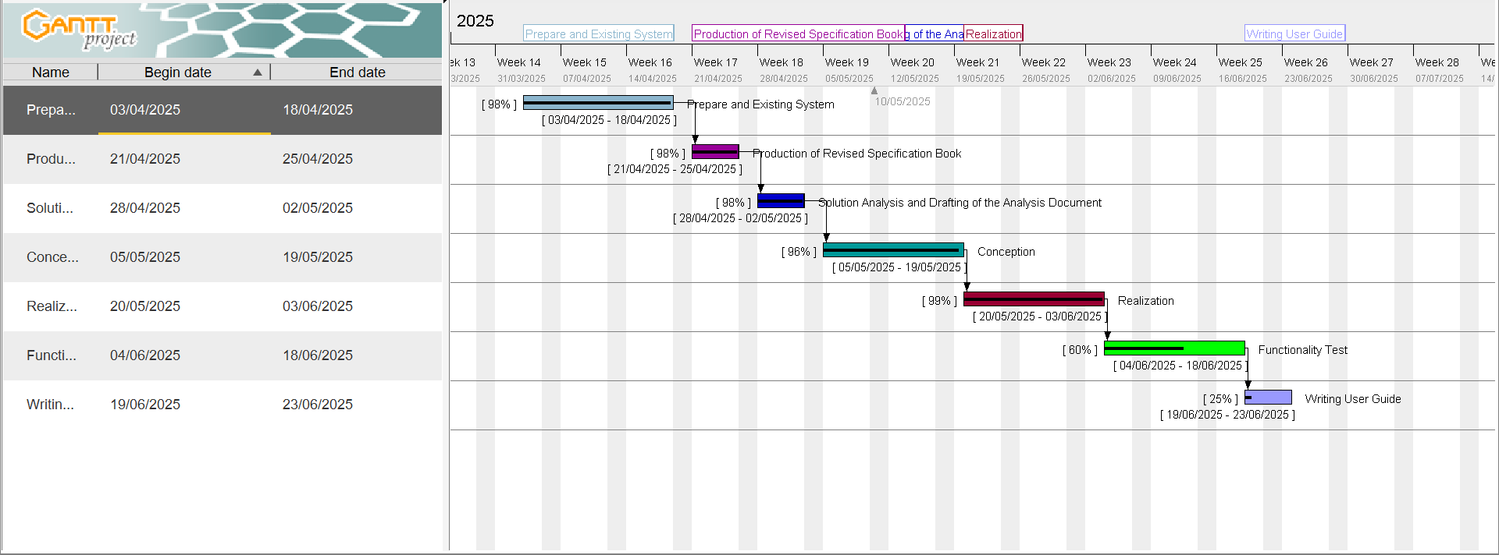The Gantt chart is a project management tool that provides a visual representation of a project's schedule. It displays the various tasks and their timelines, allowing project managers to track progress and ensure timely completion. The Gantt chart for this project is as follows:

Figure 1: Project plan

1. **ESTIMATED COST OF PROJECT**

Project cost estimation involves calculating the total expenses, including human resources, hardware, and software of the project. It is critical for any project and essential for effective project management. The tables below provide a detailed breakdown of the project cost estimation.

1. SOFTWARE RESOURCES

The following software applications or resources were necessary for the successful realization of this project:

Table 3: Software Resources (source: mercurial 2024)

|  |  |  |  |  |
| --- | --- | --- | --- | --- |
| Software Resource | Description | Quantity | Price (FCFA)/ day | Total Price  (FCFA) |
| Microsoft 365 | Suite for document creation, spreadsheets, presentations, and collaboration. | 1 | 47, 998 | 47, 998 |
| Visual Studio | |  | | --- | |  |  |  | | --- | | Integrated Development Environment (IDE) for coding and debugging. | | 1 | Freeware | Freeware |
| Node.js | |  | | --- | |  |  |  | | --- | | JavaScript runtime environment for building server-side applications. | | 1 | Freeware | Freeware |
| MySQL Workbench Community Edition | Database design and management tool for MySQL. | 1 | Open Source | Open Source |
| |  | | --- | |  |  |  | | --- | | **XAMPP** | | |  | | --- | |  |  |  | | --- | | Local server for testing and running PHP and MySQL applications. | | 1 | Open Source | Open Source |
| Git | |  | | --- | |  |  |  | | --- | | Version control system used to track changes in the project code. | | 1 | Open Source | Open Source |
| GitHub | Online platform for hosting and managing code repositories. | 1 | Freemium | Freemium |
| Thunder Client | |  | | --- | |  |  |  | | --- | | API testing tool integrated with Visual Studio Code. | | 1 | |  | | --- | |  |  |  | | --- | | Freeware | | |  | | --- | |  |  |  | | --- | | Freeware | |
| Mozilla Firefox | Web browser used for testing and development. | 1 | Freeware | Freeware |
| Visual Paradigm | creating UML diagrams and system modelling. | 1 | Freemium | Freemium |
| Icogram | Software for designing illustrative diagrams and graphics. | 1 | Freemium | Freemium |
| GanttProject | |  | | --- | |  |  |  | | --- | | Project management tool for creating Gantt charts | | 1 | Freeware | Freeware |
| Total Cost of Software Resources (FCFA) | | | | **47, 998** |

1. HARDWARE RESOURCES

This includes the material resources used to realise the project. The table below provides a summary of these materials.

Table 4: Hardware Resources (source: mercurial 2024)

|  |  |  |  |
| --- | --- | --- | --- |
| Hardware Resource | Quantity | Price (FCFA) / day | Total Price (FCFA) |
| Laptop Acer Spin 3  10th Gen Intel Core i5-1035G1 14,  8 GB RAM, 256 GB SSD | 01 | 287,359.25 | 287,359 |
| Modem (Camtel) | 01 | 40,000 | 40,000 |
| Internet Connection | / | 20,990 | 20,990 |
| Total Cost of Hardware Resources (FCFA) | | | **348,349** |

1. HUMAN RESOURCES

Table 5: Human Resources

|  |  |  |  |  |
| --- | --- | --- | --- | --- |
| Human  resource | Quantity | Price (FCFA)/ day | Duration (days) | Total Price (FCFA) |
| Project Manager | 01 | 40,500 | 90 | 2,745,000 |
| Analyst | 01 | 35,000 | 21 | 735,000 |
| UI/UX Designer | 01 | 30,000 | 10 | 300,000 |
| Developer | 02 | 80,000 | 30 | 2,400,000 |
| Tester | 01 | 20,000 | 14 | 280,000 |
| Total Cost of Human Resources (FCFA) | | | | **6,460,000** |

TOTAL ESTIMATED COST FOR THE PROJECT

Table 6: Total Estimated Cost for Project

|  |  |
| --- | --- |
|  | |
| SOFTWARE RESOURCE | 47, 998 FCFA |
| HARDWARE RESOURCE | 348,349 FCFA |
| HUMAN RESOURCE | 6,460,000 FCFA |
| Unexpected charges (10%)  (Total cost) * 10% | 680,939.4 FCFA |
| TOTAL COST | 7,490,333.4 FCFA |
| Total | 7,490,333.4 FCFA |

**SUM TOTAL:**

**7, 490, 333.4 FCFASUM TOTAL:**

**7, 490, 333.4 FCFA**

**Seven Million, Four Hundred and Ninety Thousand Three Hundred and Thirty-Three Point Four FCFA7, 490, 333.4 FCFASUM TOTAL:**

**7, 490, 333.4 FCFASUM TOTAL:**

**7, 490, 333.4 FCFA**

**Seven Million, Four Hundred and Ninety Thousand Three Hundred and Thirty-Three Point Four FCFA7, 490, 333.4 FCFA**

**Seven Million, Four Hundred and Ninety Thousand Three Hundred and Thirty-Three Point Four FCFA**

**CHAPTER 3: ANALYSISSeven Million, Four Hundred and Ninety Thousand Three Hundred and Thirty-Three Point Four FCFA7, 490, 333.4 FCFA**

**Seven Million, Four Hundred and Ninety Thousand Three Hundred and Thirty-Three Point Four FCFA7, 490, 333.4 FCFASUM TOTAL:**

**7, 490, 333.4 FCFASUM TOTAL:**

**7, 490, 333.4 FCFA**

**Seven Million, Four Hundred and Ninety Thousand Three Hundred and Thirty-Three Point Four FCFA7, 490, 333.4 FCFASUM TOTAL:**

**7, 490, 333.4 FCFASUM TOTAL:**

**7, 490, 333.4 FCFA**

**Seven Million, Four Hundred and Ninety Thousand Three Hundred and Thirty-Three Point Four FCFA7, 490, 333.4 FCFA**

**Seven Million, Four Hundred and Ninety Thousand Three Hundred and Thirty-Three Point Four FCFA**

**CHAPTER 3: ANALYSISSeven Million, Four Hundred and Ninety Thousand Three Hundred and Thirty-Three Point Four FCFA7, 490, 333.4 FCFA**

**Seven Million, Four Hundred and Ninety Thousand Three Hundred and Thirty-Three Point Four FCFA7, 490, 333.4 FCFA**

**Seven Million, Four Hundred and Ninety Thousand Three Hundred and Thirty-Three Point Four FCFA**

**CHAPTER 3: ANALYSISSeven Million, Four Hundred and Ninety Thousand Three Hundred and Thirty-Three Point Four FCFA**

**CHAPTER 3: ANALYSIS**

Preamble**CHAPTER 3: ANALYSISSeven Million, Four Hundred and Ninety Thousand Three Hundred and Thirty-Three Point Four FCFA**

**CHAPTER 3: ANALYSISSeven Million, Four Hundred and Ninety Thousand Three Hundred and Thirty-Three Point Four FCFA7, 490, 333.4 FCFA**

**Seven Million, Four Hundred and Ninety Thousand Three Hundred and Thirty-Three Point Four FCFA7, 490, 333.4 FCFA**

**Seven Million, Four Hundred and Ninety Thousand Three Hundred and Thirty-Three Point Four FCFA**

**CHAPTER 3: ANALYSISSeven Million, Four Hundred and Ninety Thousand Three Hundred and Thirty-Three Point Four FCFA7, 490, 333.4 FCFA**

**Seven Million, Four Hundred and Ninety Thousand Three Hundred and Thirty-Three Point Four FCFA7, 490, 333.4 FCFA**

**Seven Million, Four Hundred and Ninety Thousand Three Hundred and Thirty-Three Point Four FCFA**

**CHAPTER 3: ANALYSISSeven Million, Four Hundred and Ninety Thousand Three Hundred and Thirty-Three Point Four FCFA**

**CHAPTER 3: ANALYSIS**

Preamble**CHAPTER 3: ANALYSISSeven Million, Four Hundred and Ninety Thousand Three Hundred and Thirty-Three Point Four FCFA**

**CHAPTER 3: ANALYSISSeven Million, Four Hundred and Ninety Thousand Three Hundred and Thirty-Three Point Four FCFA**

**CHAPTER 3: ANALYSIS**

Preamble**CHAPTER 3: ANALYSIS**

Preamble

Preamble**CHAPTER 3: ANALYSIS**

Preamble**CHAPTER 3: ANALYSISSeven Million, Four Hundred and Ninety Thousand Three Hundred and Thirty-Three Point Four FCFA**

**CHAPTER 3: ANALYSISSeven Million, Four Hundred and Ninety Thousand Three Hundred and Thirty-Three Point Four FCFA**

**CHAPTER 3: ANALYSIS**

Preamble**CHAPTER 3: ANALYSISSeven Million, Four Hundred and Ninety Thousand Three Hundred and Thirty-Three Point Four FCFA**

**CHAPTER 3: ANALYSISSeven Million, Four Hundred and Ninety Thousand Three Hundred and Thirty-Three Point Four FCFA**

1. PARTICIPANTS

The table below presents the different individuals who took part in the accomplishment of this project. They include:

Table 7 : Project Participants

|  |  |  |
| --- | --- | --- |
| Names | Functions | Role and Tasks |
| Mr. BILL NELSON | Lecturer at AICS-Cameroon  Software Engineer | Supervisor |
| Mr. BALEMBA JESSE NJEA MASSOMA | Second year Student at AICS - Cameroon | Project Head, Analyst, Project Design and Coding, Testing. |

1. **PROJECT CONSTRAINTS**

Because every project and its resources are finite, we must respect three main constraints which includes;

* **Budget Constraint**: The total budget for the project is strictly limited to 7,490,333.4 FCFA and must be adhered to without exceeding this amount;
* **Deadline Constraint**: The project must be completed before 21st June while meeting all specified objectives and milestones;
* **Quality Constraint**: The application must be flexible, web-based, and reusable, ensuring it meets high standards of user-friendliness, reliability, and security.

1. **DELIVERABLES**

In this section, we will outline the elements to be delivered upon project completion. These include:

* A CD-ROM containing the web application;
* The installation guide and user manual;
* A PowerPoint presentation of the application;
* A video demonstration of the application's functionality.

**CONCLUSION**

Creating a specification book is a necessary step in minimizing the risks of a project. On the one hand, it serves to fulfil the requirements listed in the specifications and to plan the implementation in the best possible way so that there are no nasty surprises at the end. On the other hand, it helps to validate the implemented solution at the end of the project and to protect both parties. Through these we are now going forth to the Analysis.



**CHAPTER 3: ANALYSIS**

Preamble**CHAPTER 3: ANALYSIS**

Preamble

Preamble**CHAPTER 3: ANALYSIS**

Preamble**CHAPTER 3: ANALYSIS**

Preamble

Preamble

Preamble

Preamble**CHAPTER 3: ANALYSIS**

Preamble**CHAPTER 3: ANALYSIS**

Preamble

Preamble**CHAPTER 3: ANALYSIS**

Preamble**CHAPTER 3: ANALYSIS**

Preamble

Preamble

Preamble

Preamble

Preamble

Preamble

Preamble

Preamble

The Analysis file provides a detailed explanation of the solution using diagrams. Its main purpose is to capture user’s needs and define the process and methodologies used to address those needs.



Content:

INTRODUCTIONContent:

INTRODUCTION

INTRODUCTIONContent:

INTRODUCTIONContent:

INTRODUCTION

INTRODUCTION

INTRODUCTION

INTRODUCTIONContent:

INTRODUCTIONContent:

INTRODUCTION

INTRODUCTIONContent:

INTRODUCTIONContent:

INTRODUCTION

INTRODUCTION

INTRODUCTION

INTRODUCTION

INTRODUCTION

INTRODUCTION

INTRODUCTION

INTRODUCTION

I.

I.

I.

I.

I.

I.

I.

I.

METHODOLOGY

CONCLUSION METHODOLOGY

CONCLUSION

CONCLUSION METHODOLOGY

CONCLUSION METHODOLOGY

CONCLUSION

CONCLUSION

CONCLUSION

CONCLUSION METHODOLOGY

CONCLUSION METHODOLOGY

CONCLUSION

CONCLUSION METHODOLOGY

CONCLUSION METHODOLOGY

CONCLUSION

CONCLUSION

CONCLUSION

CONCLUSION

CONCLUSION

CONCLUSION

CONCLUSION

CONCLUSION

d.)

d.)

d.)

d.)

d.)

d.)

d.)

d.)

c.)

c.)

c.)

c.)

c.)

c.)

c.)

c.)

b.)

b.)

b.)

b.)

b.)

b.)

b.)

b.)

a.)

a.)

a.)

a.)

a.)

a.)

a.)

a.)

ACTIVITY DIAGRAM

ACTIVITY DIAGRAM

ACTIVITY DIAGRAM

ACTIVITY DIAGRAM

ACTIVITY DIAGRAM

ACTIVITY DIAGRAM

ACTIVITY DIAGRAM

ACTIVITY DIAGRAM

SEQUENCE DIAGRAM

SEQUENCE DIAGRAM

SEQUENCE DIAGRAM

SEQUENCE DIAGRAM

SEQUENCE DIAGRAM

SEQUENCE DIAGRAM

SEQUENCE DIAGRAM

SEQUENCE DIAGRAM

b.)

b.)

b.)

b.)

b.)

b.)

b.)

b.)

a.)

a.)

a.)

a.)

a.)

a.)

a.)

a.)

II.

II.

II.

II.

II.

II.

II.

II.

COMMUNICATION DIAGRAM

COMMUNICATION DIAGRAM

COMMUNICATION DIAGRAM

COMMUNICATION DIAGRAM

COMMUNICATION DIAGRAM

COMMUNICATION DIAGRAM

COMMUNICATION DIAGRAM

COMMUNICATION DIAGRAM

USE CASE DIAGRAM

USE CASE DIAGRAM

USE CASE DIAGRAM

USE CASE DIAGRAM

USE CASE DIAGRAM

USE CASE DIAGRAM

USE CASE DIAGRAM

USE CASE DIAGRAM

MODELLING

MODELLING

MODELLING

MODELLING

MODELLING

MODELLING

MODELLING

MODELLING

COMPARATIVE STUDY OF UNIFIED PROCESSES

COMPARATIVE STUDY OF UNIFIED PROCESSES

COMPARATIVE STUDY OF UNIFIED PROCESSES

COMPARATIVE STUDY OF UNIFIED PROCESSES

COMPARATIVE STUDY OF UNIFIED PROCESSES

COMPARATIVE STUDY OF UNIFIED PROCESSES

COMPARATIVE STUDY OF UNIFIED PROCESSES

COMPARATIVE STUDY OF UNIFIED PROCESSES

UML

UML

UML

UML

UML

UML

UML

UML

COMPARATIVE STUDY BETWEEN MERISE AND

COMPARATIVE STUDY BETWEEN MERISE AND

COMPARATIVE STUDY BETWEEN MERISE AND

COMPARATIVE STUDY BETWEEN MERISE AND

COMPARATIVE STUDY BETWEEN MERISE AND

COMPARATIVE STUDY BETWEEN MERISE AND

COMPARATIVE STUDY BETWEEN MERISE AND

COMPARATIVE STUDY BETWEEN MERISE AND

**INTRODUCTION**

The analysis phase of a project is a crucial step in ensuring that the solution aligns with the needs of the users. In this phase, we delve deeper into the proposed solution, providing a comprehensive explanation supported by diagrams. This document serves to clearly capture the user’s requirements while outlining the processes and methodologies that will be used to meet those needs. By offering a detailed analysis, we ensure that the project is built on a strong foundation, minimizing the risk of misunderstandings and ensuring a more successful implementation.

1. **METHODOLOGY**

Analysis is a fundamental step in the conception of software and serves as the foundation for the realization of any information system. An information system involves the organization of resources; human, software, and hardware along with data and feedback mechanisms, to achieve a specific objective. Several methods and languages, such as UML and MERISE, have been developed to facilitate the analysis and design of information systems.

**MERISE** (Méthode d’Etude et de Realization Informatique pour les Systèmes d’Entreprise) it is a method of analysis, conception and realization of information systems mostly used in French Speaking Companies or Enterprises. It is based on the separation of data and processing them using several conceptual and physical models. Its principal objective is to conceive an information system. Merise proposes examining the real system from two perspectives:

* The Static View (data);
* The Dynamic View (treatments).

**UML** (Unified Modelling System) a standardized modelling language consisting of an integrated set of diagrams, developed to help system and software developers for specifying, visualizing, constructing, and documenting the artifacts of software systems, as well as for business modelling and other non-software systems. UML proposes an approach different from MERISE as its readability and reusability makes it an ideal choice for programmers.

UML is currently at it 2.5 version and presents a number of advantages which includes:

* It is a formal and standardize language.
* It provides visual representation of the structure and behaviour of the system which can help to communicate and understand the design of the system.
* It is flexible and customizable to suit different domain and technologies.
* It is readable and re-useable i.e. you can easily see the relationships and interactions between classes and objects in UML.

UML is divided into two categories of diagrams:

* **Structural diagrams**, which illustrate the building blocks of the system, and
* 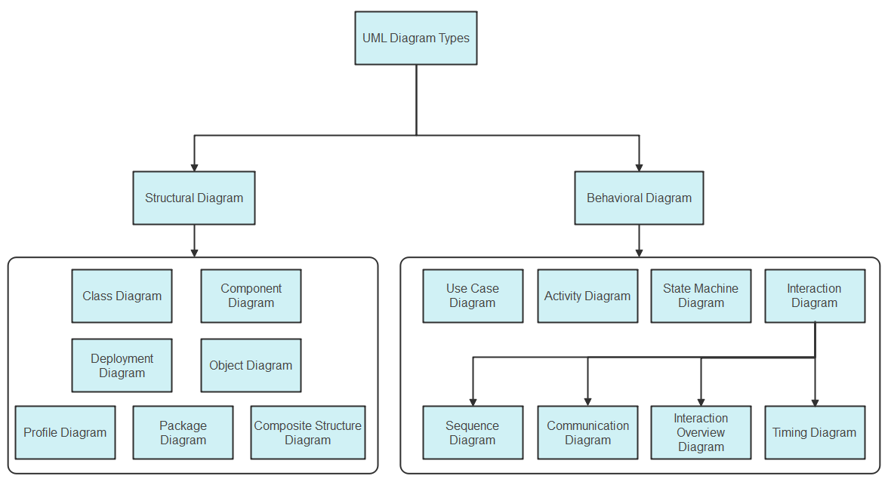**Behavioural diagrams**, which demonstrate how the system responds to changes, as shown below.

Figure 2: UML hierarchy diagram (source: https://images.edrawsoft.com/articles/what-is-uml/uml-diagram-types.png)

1. **COMPARATIVE STUDY BETWEEN MERISE AND UML**

Table 8: Comparative Study between UML and MERISE

|  |  |
| --- | --- |
| MERISE | UML |
| MERISE stands for Méthode d'Étude et de  Réalisation Informatique pour les Systèmes  d'Entreprises. | UML stands for Unified Modelling Language. |
| MERISE is a method for designing processing- and data-oriented systems. | UML is a modelling language, not a method. It needs a method that uses the UML language to design the system. (e.g. UP, RUP, 2TUP and possibly agile methods). |
| Less widely used | Widely used |
| Less complex and little or no time-consuming. | Complex and time-consuming due to the many diagrams it has. |
| Design for Organizational Information Systems. | Designed for Object-Oriented-based Information Systems. |

1. **COMPARATIVE STUDY OF UNIFIED PROCESSES**
2. PRESENTATION OF UP METHOD

**UP** (Unified Process) is an iterative, incremental, architecture-centric, and use-case-driven approach to software development built on UML. UP is organised into four major phases:

* + - * **Inception**: Defines project foundation, business case, scope, and boundaries.
      * **Elaboration**: Captures system requirements and plans risk management.
      * **Construction**: Builds the final product iteratively, focusing on lower-risk elements.
      * **Deployment**: Delivers the system to users, including data migration and training.

Each phase and its iteration consist of a set of predefined activities also known as disciplines. These disciplines include: **Business modelling**, **Requirements**, **Analysis and Design**, **Implementation**, **Test** and **Deployment.**

The different phases of the Unified Process (UP) are shown below:

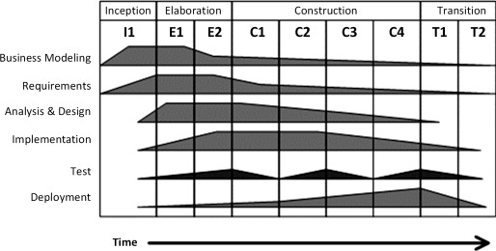

Figure 3: Phases of UP (source: https://ars.els-cdn.com/content/image/3-s2.0-B9780128054765000022-f02-01-9780128054765.jpg )

1. PRESENTATION OF THE 2-TUP METHOD

2TUP is a software development process that implements the unified process (i.e. iterative, incremental, based on UML). It proposes a development cycle which separates the technical aspects from the functional aspects. It begins with a preliminary study which essentially consists of identifying the actors and the system exchange. Then to produce the specifications and to model the context.

The software development process is structured around three branches:

* **Functional branch (the left-hand branch of the Y)**: identifies and models the users' business needs.
* **Technical branch (the right-hand branch of the Y)**: lists the technical needs and proposes a generic design validated by a prototype.
* **Realization branch (the middle branch)**: combines both functional and technical branches, enabling application design and ultimately delivering a solution tailored to the needs. This branch includes:
* **Preliminary design:** integrates the analysis model into the technical architecture to map out the system's components;
* **Detailed design:** studies how to make each component;
* **Coding stage:** produces the components and progressively tests the code units produced;
* **Acceptance(recipe) stage:** consists in validating the functions of the developed system.

Below is a graphical representation of the Two Track Unified Process (2TUP)

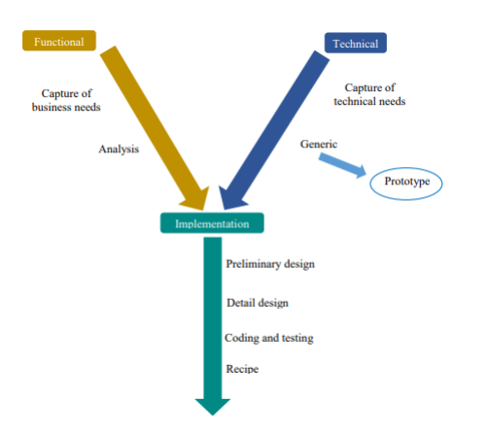

Figure 4: Graphical representation of 2TUP (source: Mr. Messio UML course AICS-Cameroon 2023-2024)

1. COMPARATIVE STUDY BETWEEN 2TUP AND UP

Table 9: Comparative study between 2TUP and UP

|  |  |
| --- | --- |
| 2TUP | UP |
| 2TUP is a software development process that implements the unified process (i.e. iterative, incremental, based on UML). | The Unified Process is a generic name for a family of process models that meet a number of criteria, such as being iterative and incremental, driven by use cases, and focusing on addressing risks early. It defines four project phases: Inception, Elaboration, Construction, and Transition. |

1. JUSTIFICATION ON THE CHOICE ANALYSIS

Our choice was based on the UML modelling language, combined with the 2TUP analysis method, due to the following criteria:

* UML is based on object-oriented approach;
* UML modelling also supports multiple views of the same system.
* UML enables the creation of specialized diagrams by focusing on specific elements for a particular purpose at a given time.
* 2TUP is a software development process built on the UML modelling language.
* 2TUP is user-oriented because built on their expectations (i.e. permits the development of software that responds to users' needs).

1. **MODELLING**
2. USE CASE DIAGRAM
3. Definition

A Use case diagram captures a system's high-level functions(requirements), dynamic nature and scope.

Use Case diagram serve for the following purposes;

* Specify the context or scope of a system.
* Capture the requirements of a system.

1. 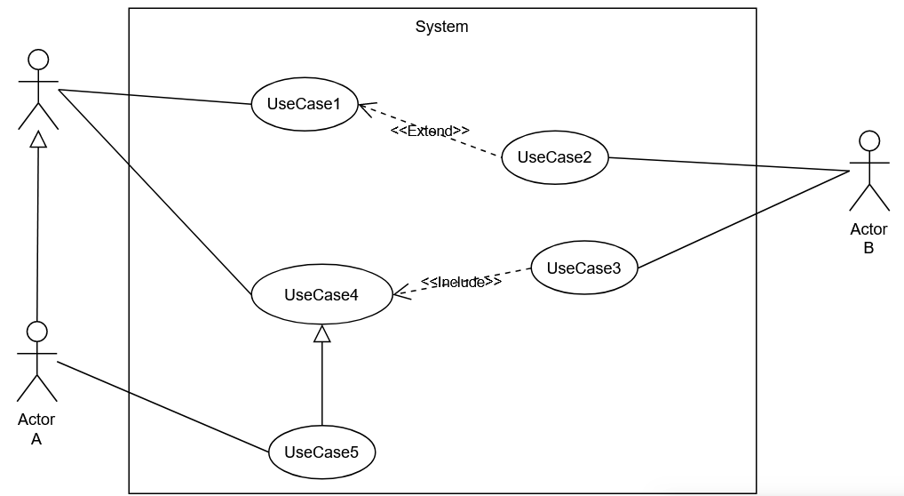Formalism

Figure 5: Use Case Diagram Formalism

|  |  |  |
| --- | --- | --- |
| ELEMENT | DESCRIPTION | NOTATION |
| Actor | Any Entity external to a system interacts with the system, maybe a human user or another system, and has goals and responsibilities to satisfy  in interacting with the system. |  |
| Use Case | A use case corresponds to a system's objective motivated by the actors' needs. |  |
| Association | It expresses the interaction between an actor and a use case. |  |
| Include | An Include Association from one use case (called the **Base use case**) to another use case (called the **inclusion use case**) indicates that the base use case will include or call the inclusion use case. |  |
| Extend | An Extend Association indicates that the extension use case will extend into) and augment the Base use case. |  |

1. Components of a Use Case Diagram

Table 10: Components of a Use Case Diagram

Table 11: Components of Use Case Diagram (Continued)

|  |  |  |
| --- | --- | --- |
| ELEMENT | DESCRIPTION | NOTATION |
| Generalisation  (Actor) | An Aactor generalization from a specialized, actor to a generalized, actor indicates that instances of the more specific actor may be substituted for instances of the more general actor. |  |
| Generalisation  (Use Case) | A use case generalization indicates that a specific use case inherits the behavior and characteristics of a more general use case. |  |
| System | It identifies what is part of the system and the actors interacting with it. |  |

1. General Use Cas Diagram

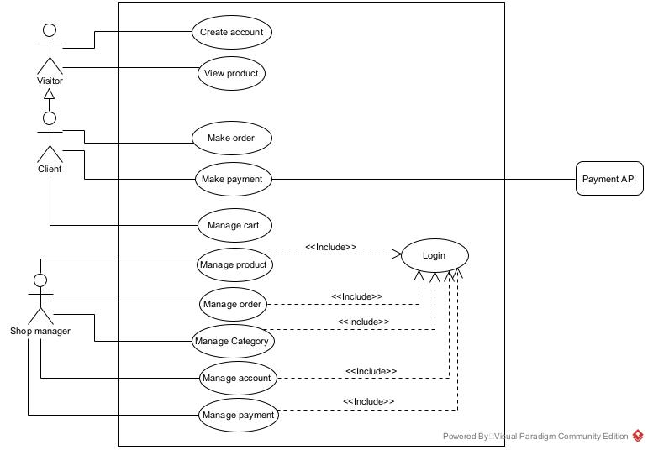

Figure 6: General Use Case Diagram

1. Client Manage Cart Specific Use Case Diagram

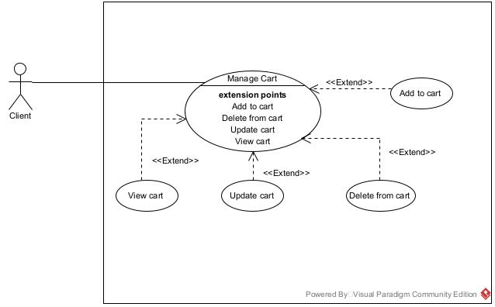

Figure 7: Client Manage Cart Specific Use Case diagram

1. 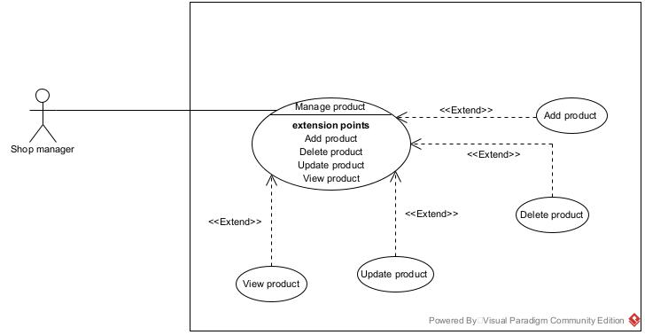Shop manager Manage Order Specific Use Case Diagram

Figure 8: Supplier Overview Use Case Diagram

TEXTUAL DESCRIPTION OF USE CASES

Use Case can be considered as a behaviour that a system offers to the actors to help meet the actors’ goals. So, we have to supply information on how the use case works — and put that information somewhere in a Textual description (Specification). This set of needed details placed inside a use case is sometimes called the **Use Case Textual Description.**

Formalism

Table 12: Formalism of Textual Description of a Use Case

|  |  |
| --- | --- |
| Title | Represents the name or title of the textual description |
| Description | It explains the goals, plot, and theme of the use case. |
| Actors | Description of the main and the secondary actors. |
| Date | Creation and update date. |
| Stakeholder | Names of creator(s). |
| Version | The version number. |
| Precondition | Specifies the state of the world that must be held before the course can be triggered. |
| Trigger | Any event that causes the use case to be initiated. |
| Nominal Scenario (Corresponds to the normal development of a use case) | |
| Alternative Scenario (Corresponds to variants of the nominal scenario) | |
| Post Condition of Success | Describes the state of the system after the end of each scenario. |
| Post Condition of Failure | Describes the state of the system after the end of each  Scenario. |

* Textual Description of the Use Case <<Authenticate>>

Table 13: <<Authenticate>> Textual Description

|  |  |  |
| --- | --- | --- |
| Title | Textual description of a Use case << Authenticate >> | |
| Description | | This use case allows any service provider (Supplier, Delivery Person) with an existing account to log in to the system using their credentials. |
| Actors | | Service Provider (Supplier, Delivery person) |
| Date | | March 23, 2025 |
| Stakeholder | | LocaVend Directors |
| Version | | 1.0 |
| Precondition | | The actor has an account in the system |
| Trigger | | The actor clicks on the Login button |
| Nominal Scenario | | |
| 1. The use case starts when the actor clicks on the "Login" button. | | |
| 1. The system displays the login page. | | |
| 1. The system prompts for the actor’s credentials (Email and Password). | | |
| 1. The actor fills in the fields with their credentials. | | |
| 1. The system queries the actor’s (email-related) data from the database. | | |
| 1. The database sends the query results. | | |
| 1. The system verifies the actor’s credentials against the query results. | | |
| 1. The system displays the actor’s dashboard. | | |
| 1. The use case ends when the service provider gains access to the dashboard. | | |
| Alternative Scenario: Verification Failure | | |
| 1. At step 7 of the nominal scenario the system fails to verify the actor’s specified credentials. | | |
| 1. The system displays an error message indicating the issue. | | |
| 1. The use case continues at step 2 of the nominal scenario. | | |
| Post Condition of Success | | The Service provider gains access to Personal dashboard |
| Post Condition of Failure | | Service provider unable to access dashboard |

* Textual Description of the Use Case <<Make Order>>

Table 14: <<Make Order>> Textual Description

|  |  |
| --- | --- |
| Title | Textual description of the use case <<Make Order>> |
| Description | This use case allows the actor, **Client**, to use a web browser to obtain a confirmed order from the system. |
| Actor(s) | Client |
| Date | March 21, 2025 |
| Stakeholder | LocaVend Directors. |
| Version | 1.0 |
| Precondition | Client visits welcome web page wanting to make an order. |
| Trigger | Client clicks on “Search here” button. |
| Nominal Scenario | |
| 1. The client enters the valid website URL. | |
| 1. The system displays the home Page with a products. | |
| 1. The client browses and selects a stock item | |
| 1. The client reviews the stock item and clicks a button (Add to Cart or Cancel). | |
| 1. The system verifies the type of button clicked. | |
| 1. If "Add to Cart" was clicked, the system redisplays the merchant’s business page with a "Checkout" button. | |
| 1. The client clicks the "Checkout" button. | |
| 1. The system displays the checkout page with the "Place Order" button. | |
| 1. The client confirms order information and clicks the "Place Order" button. | |
| 1. The system sends a "Create Order" query to the database. | |
| 1. The database executes the query and returns the results. | |
| 1. The system verifies and processes the results. | |
| 1. The system displays a success message to the client. | |
| Alternative Scenarios: | |
| 1. At step 9 of the nominal scenario, the client clicks the "Cancel" button. 2. The system redisplays the merchant's (supplier's) business page and continues from step 7 of the nominal scenario. | |
| 1. At step 9 of the nominal scenario, the database returns an error after processing or treating the query. | |
| 1. The system displays an error message and returns to step 13 of the nominal scenario for the client to attempt to place the order again. | |
| Post Condition of Success | The client successfully places an order. |
| Post Condition of Failure | The client fails to place an order. |

1. COMMUNICATION DIAGRAM
2. Definition

A Communication diagram focuses on the messages between a group of objects and the underlying messages of the objects. They show how objects collaborate to meet a goal. In other words, they are time- and space-oriented and emphasize the overall interaction, the elements involved, and their relationships.

1. Formalism

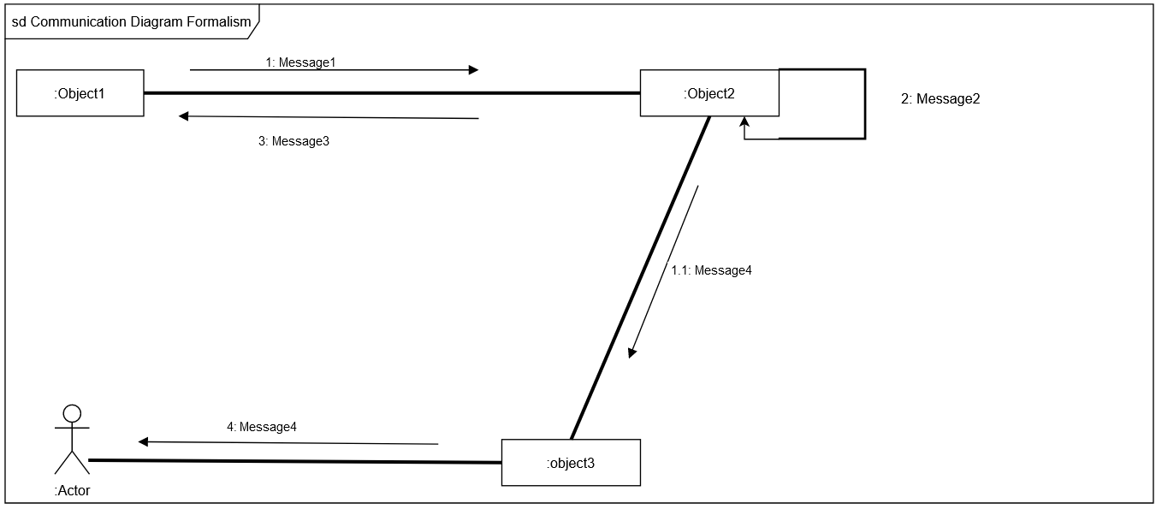

Figure 9: Communication Diagram Formalism

1. Components of a Communication Diagram

Table 15: Components of Communication Diagram

|  |  |  |
| --- | --- | --- |
| ELEMENT | DESCRIPTION | NOTATION |
| Message | It defines the communication between two objects at a given instant. | 1messageA()[condition] |
| Link | a link is a tool in a UML diagram to indicate that two objects communicate with each other. |  |
| Object | Objects can be any useful item that has identity, structure, and  behaviour. |  |
| Actor | A role played by an entity. |  |

* <<Authenticate (Login)>> Communication diagram

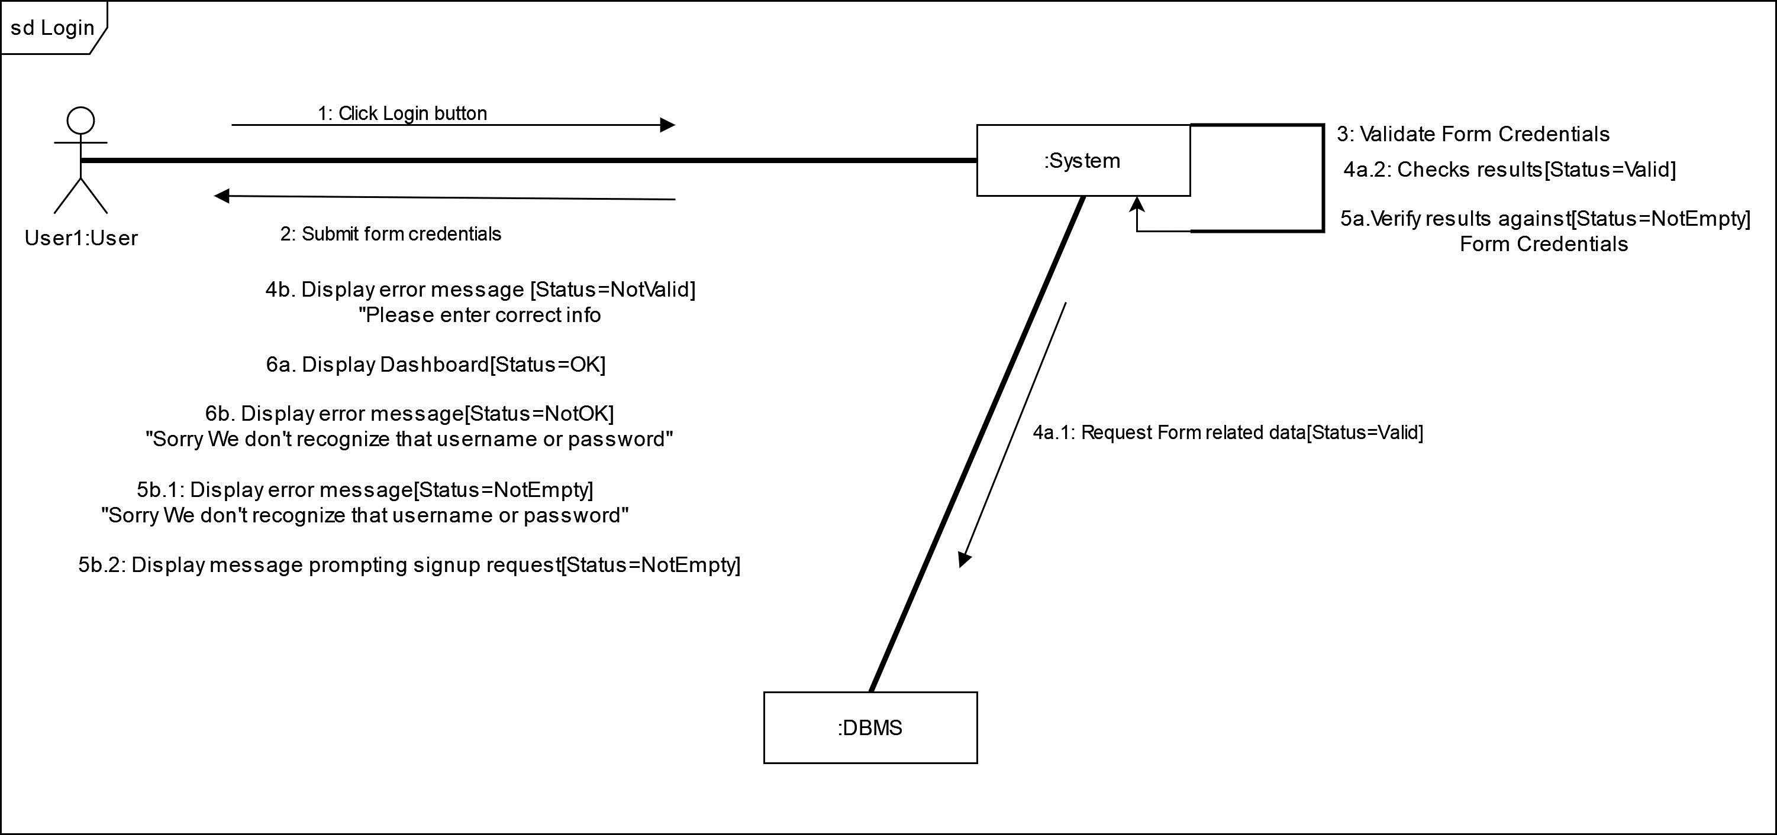

: Client

: Client

: Client

: Client

: Client

: Client

: Client

: Client

Figure 10: Communication Diagram for <<Authentication (Login)>>

* <<Make Order>> Communication diagram

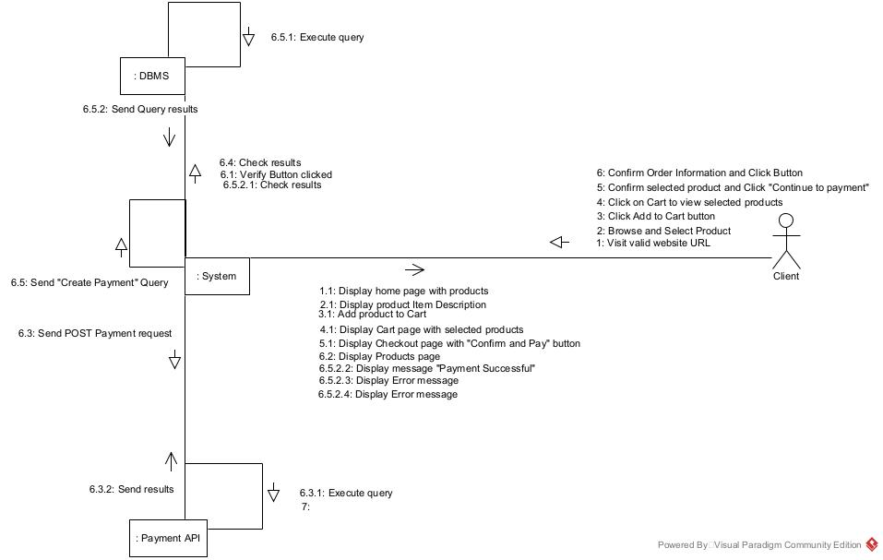

Figure 11: Communication diagram for <<Make Order>>

* <<Create Category>> Communication diagram

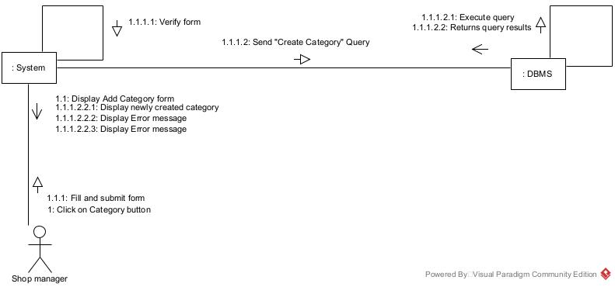

Figure 12: Communication for <<Create Category>>

1. SEQUENCE DIAGRAM
2. Definition

A sequence diagram is an Interaction diagram which captures the exchange of messages between participating objects. They are time-oriented and emphasize the overall flow of an interaction.

1. Formalism

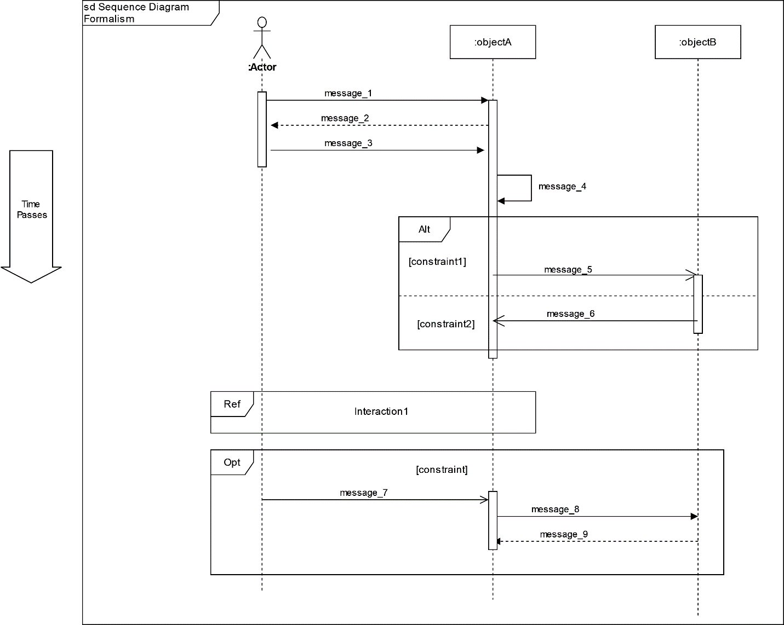

Figure 13: Sequence Diagram Formalism

1. Components of a Sequence Diagram

Table 16: Components of a Sequence Diagram

|  |  |  |
| --- | --- | --- |
| ELEMENT | DESCRIPTION | NOTATION |
| Lifelines | It is a vertical dashed line from an element which represents the existence of the element over time. |  |
| Object | It’s an instant of a class. |  |
| Actor | Communicate with other objects. |  |
| Activation | It represents the period during which an element is performing an operation. |  |
| Message | It indicates the communication between objects. We have Synchronous messages, reply messages, Asynchronous messages and Self messages as types of messages. |  |

* 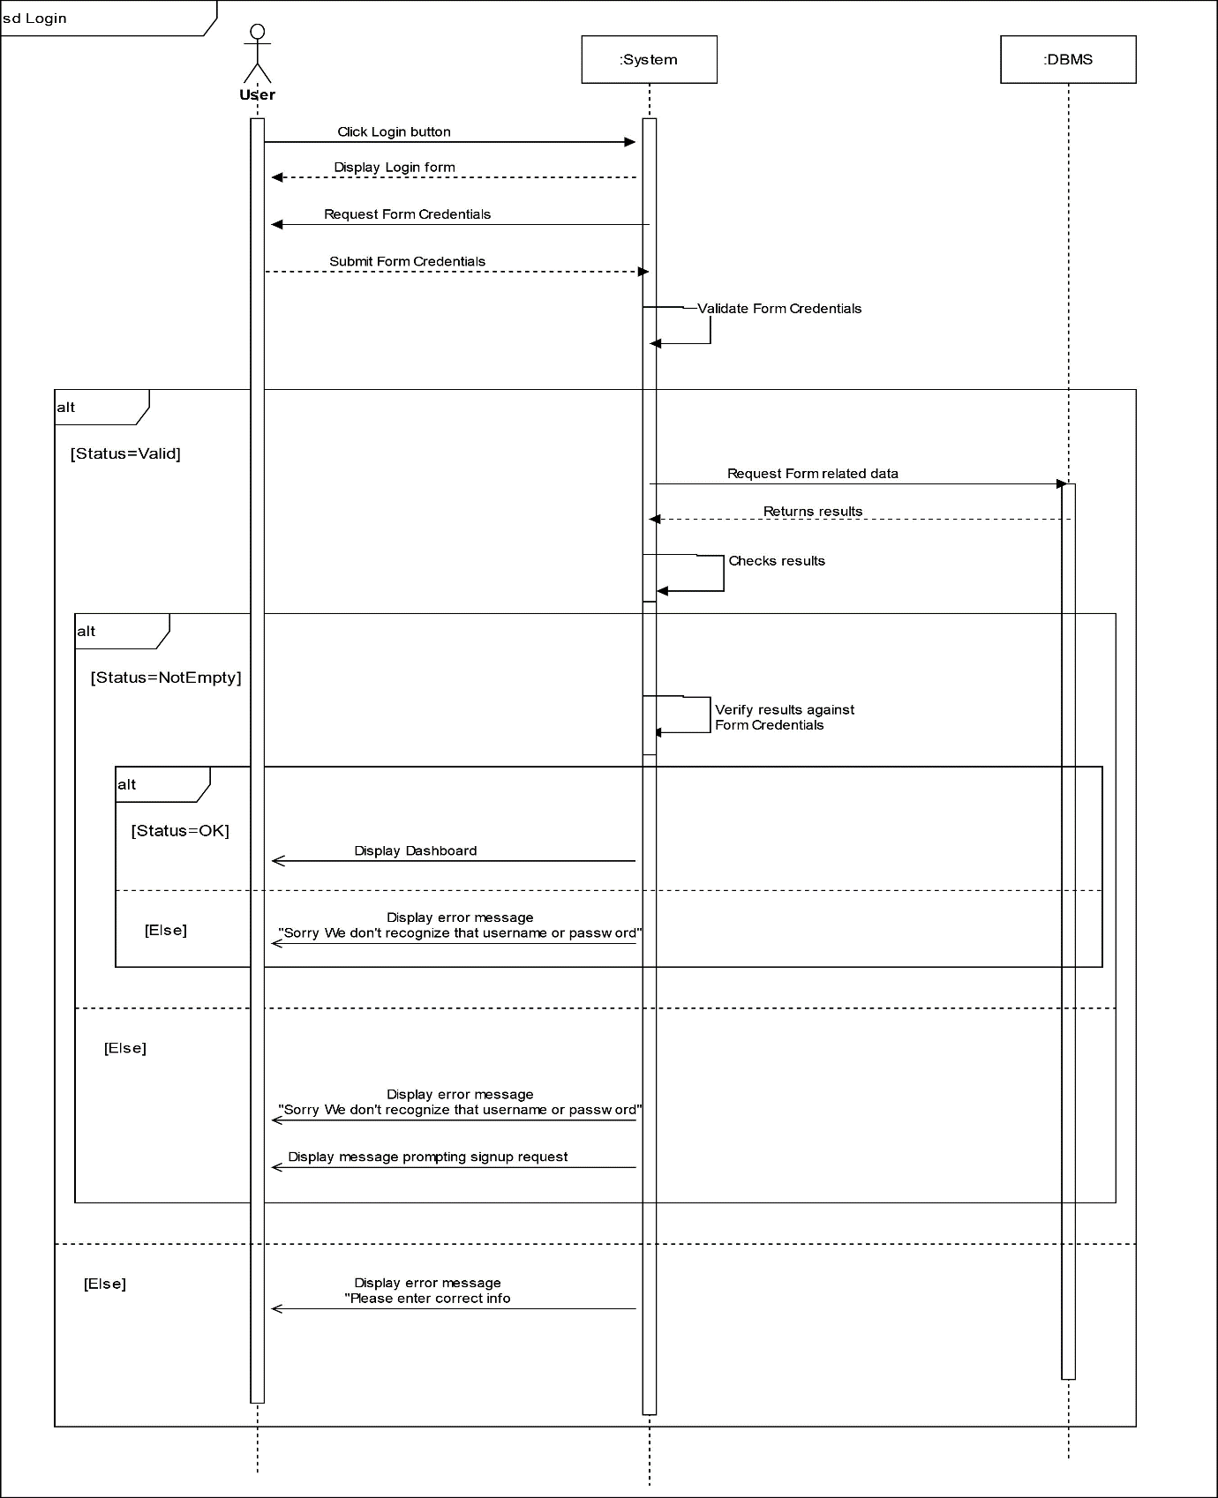<<Authentication (Login)>> Sequence Diagram

Client

**CHAPTER 4: CONCEPTION PHASE**Client

**CHAPTER 4: CONCEPTION PHASE**

Preamble**CHAPTER 4: CONCEPTION PHASE**Client

**CHAPTER 4: CONCEPTION PHASE**Client

**CHAPTER 4: CONCEPTION PHASE**

Preamble**CHAPTER 4: CONCEPTION PHASE**

Preamble

Preamble**CHAPTER 4: CONCEPTION PHASE**

Preamble**CHAPTER 4: CONCEPTION PHASE**Client

**CHAPTER 4: CONCEPTION PHASE**Client

**CHAPTER 4: CONCEPTION PHASE**

Preamble**CHAPTER 4: CONCEPTION PHASE**Client

**CHAPTER 4: CONCEPTION PHASE**Client

Figure 14: Sequence diagram for <<Authentication (Login)>>

* <<Make Order>> Sequence Diagram

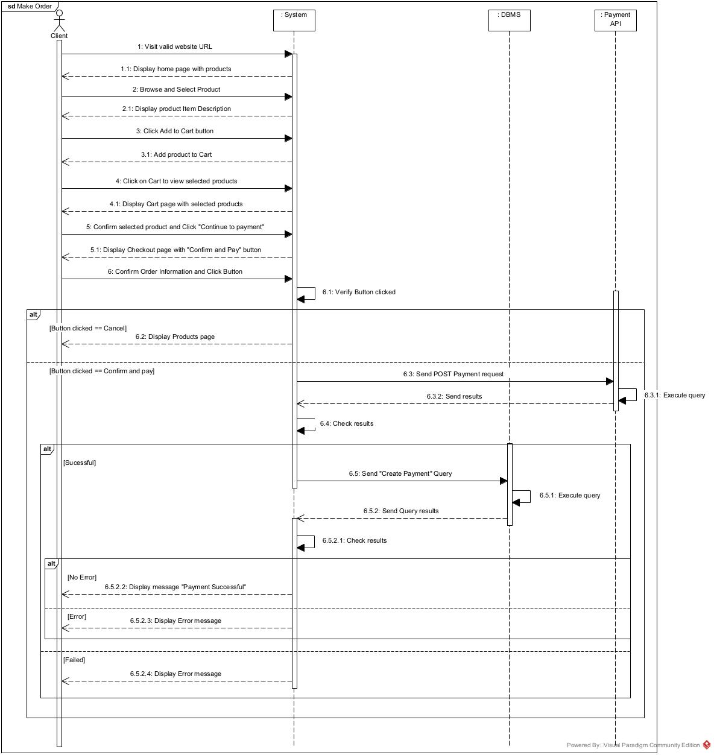

Figure 15: Sequence diagram for <<Make Order>>

* <<Create Category>> Sequence Diagram

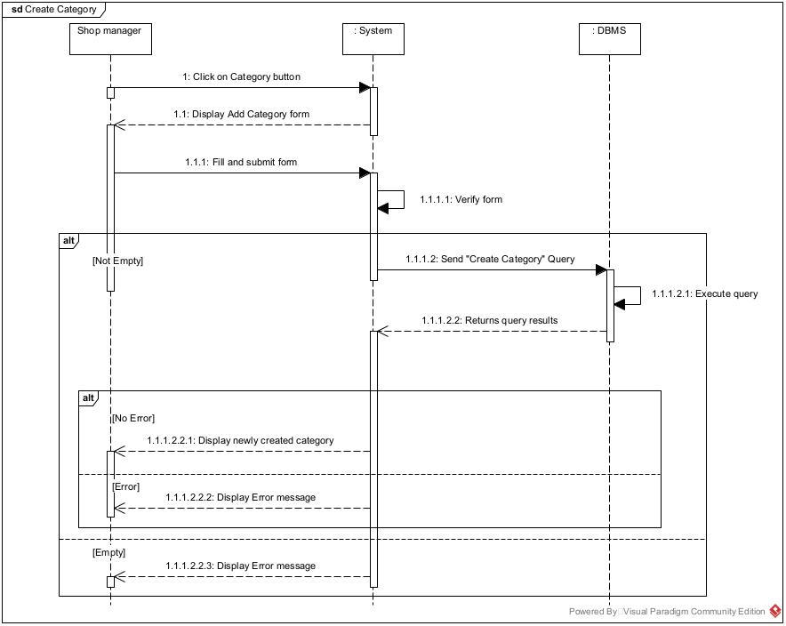

Figure 16: Sequence diagram for <<Create Category>>

1. ACTIVITY DIAGRAM
2. Definition

An activity diagram is a behavioural diagram that describes the sequence of actions in a process or specific activity, providing a view of the system's behaviour.

1. 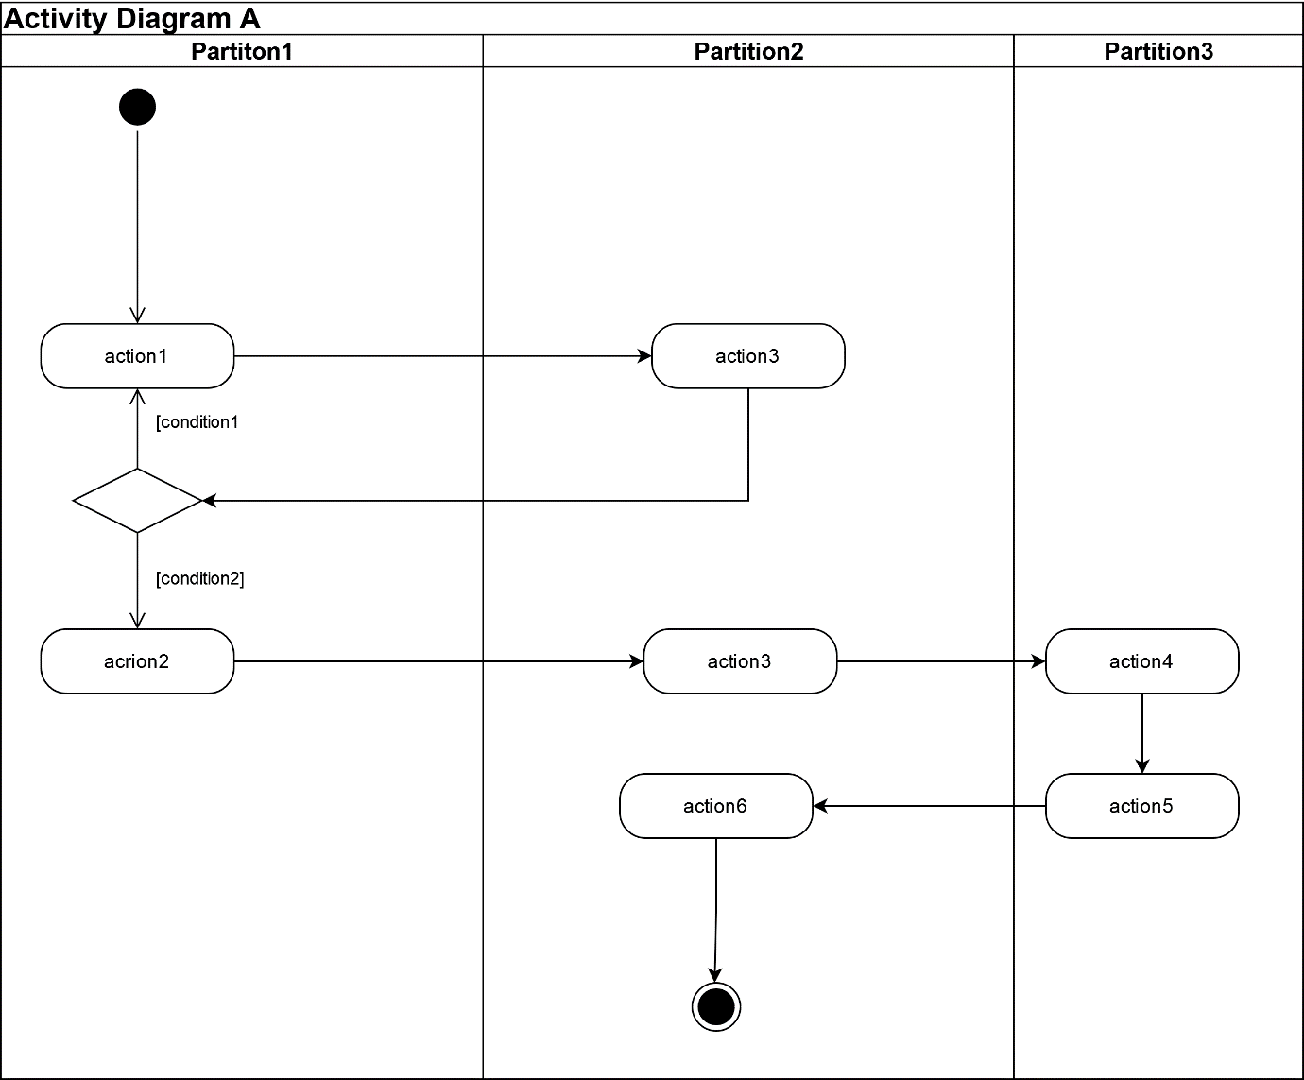Formalism

Figure 17: Activity diagram formalism

1. Components of an Activity Diagram

Table 17: Components of an Activity Diagram

|  |  |  |
| --- | --- | --- |
| ELEMENTS | DESCRIPTION | NOTATION |
| Activity | Activities contain sequences of actions and/or other activities. You use activities to group sequences of actions together. |  |
| Action | An action is a simple piece of behaviour an action. |  |
| Object node | Represents an activity  node that indicates an instance of a particular classifier in the activity. |  |
| Control flow | Connects actions and activities together; shows the sequence of execution. |  |
| Initial node | This shows the starting  point or first activity of the flow. |  |
| Final activity node | Ends all control flows and object flows in an activity, using the final-activity node. |  |
| Final flow node | End some — but not all — flows inside an activity. |  |
| Decision node | A decision node uses a test to make sure that an object or control flow goes down only one path. |  |
| Merge | Brings separate decision paths back together. |  |
| Fork node | Used to split behaviour into concurrent operations. |  |
| Join node | Used to synchronize incoming concurrent flows. |  |
| Swimlane | Swimlane is a visual region  in an activity diagram that indicates the element that has responsibility for action states within the region. |  |

* <<Authentication>> Activity Diagram

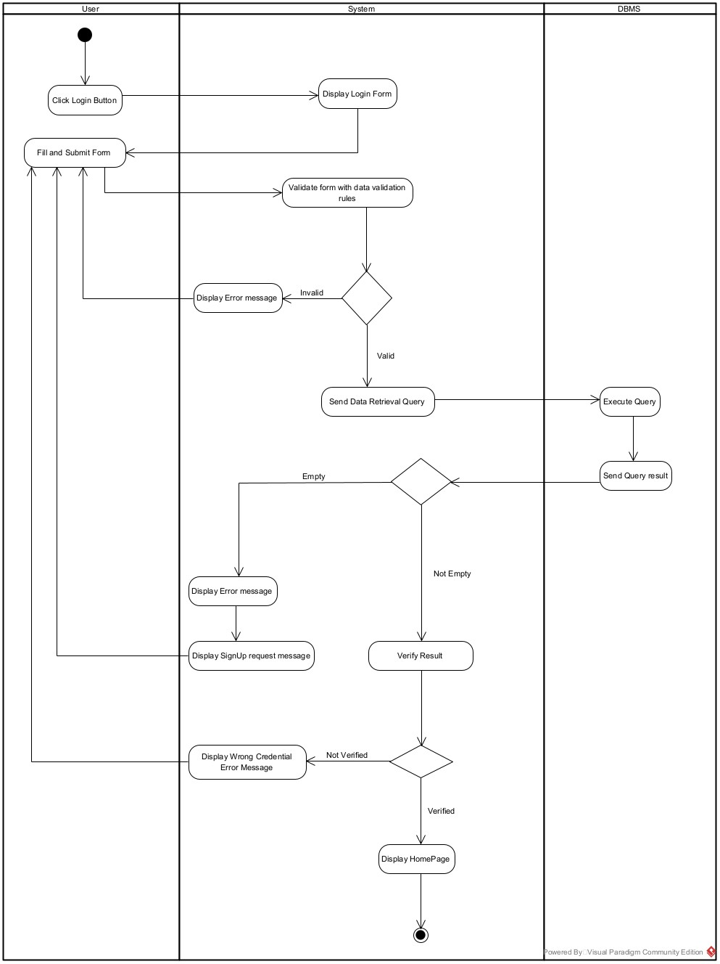

Figure 18: Activity diagram for <<Authentication>>

* 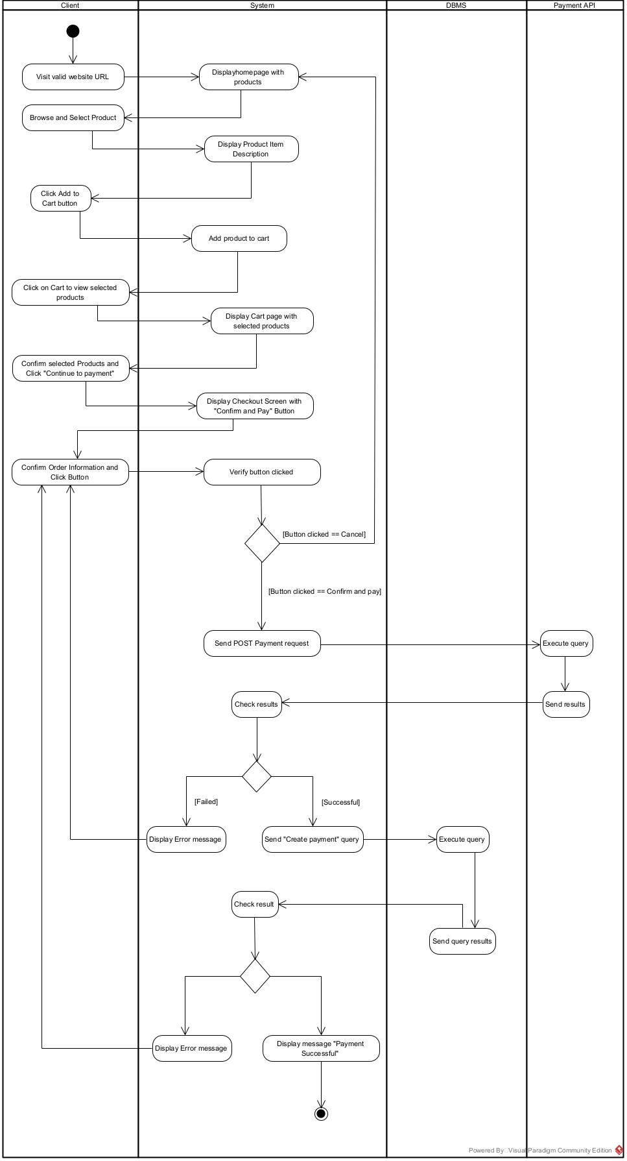<<Make Order>> Activity Diagram

Figure 19: Activity diagram for <<Make Order>>

* 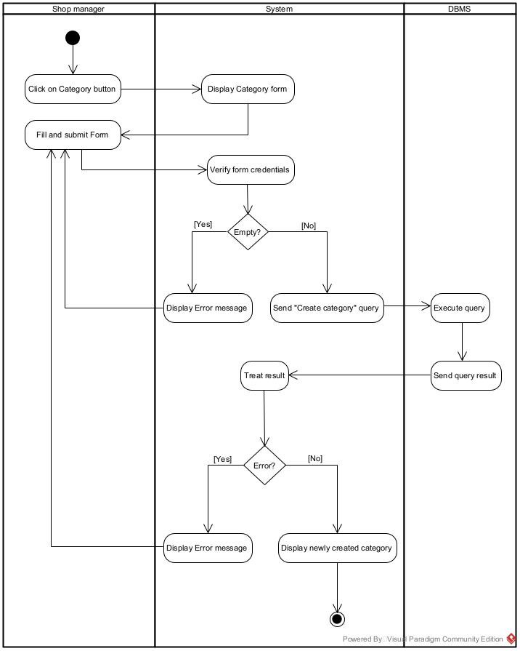<<Create Category>> Activity Diagram

Figure 20: Activity diagram for <<Create Category>>

* <<Add New Product>> Activity Diagram

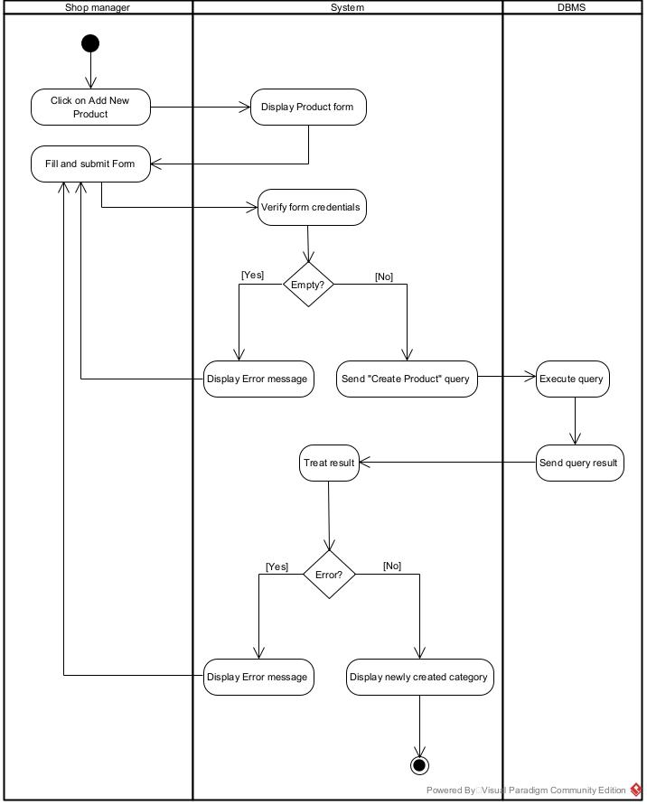

Figure 21: Activity diagram for <<Add Product>>

**CONCLUSION**

Having completed our analysis, we were tasked with illustrating the language and method used during this phase and presenting the various diagrams of the functional branch. This analysis has allowed us to define the functional needs of the web application and provided a detailed overview of the new system to be implemented. Without wasting time, we quickly dive into the conception phase.



**CHAPTER 4: CONCEPTION PHASE**

Preamble**CHAPTER 4: CONCEPTION PHASE**

Preamble

Preamble**CHAPTER 4: CONCEPTION PHASE**

Preamble**CHAPTER 4: CONCEPTION PHASE**

Preamble

Preamble

Preamble

Preamble**CHAPTER 4: CONCEPTION PHASE**

Preamble**CHAPTER 4: CONCEPTION PHASE**

Preamble

Preamble**CHAPTER 4: CONCEPTION PHASE**

Preamble**CHAPTER 4: CONCEPTION PHASE**

Preamble

Preamble

Preamble

Preamble

Preamble

Preamble

Preamble

Preamble

This document captures the technical requirements and establishes the system’s architecture, bridging the gap between the analysis and realization phases.



Content:

INTRODUCTIONContent:

INTRODUCTION

INTRODUCTIONContent:

INTRODUCTIONContent:

INTRODUCTION

INTRODUCTION

INTRODUCTION

INTRODUCTIONContent:

INTRODUCTIONContent:

INTRODUCTION

INTRODUCTIONContent:

INTRODUCTIONContent:

INTRODUCTION

INTRODUCTION

INTRODUCTION

INTRODUCTION

INTRODUCTION

INTRODUCTION

INTRODUCTION

INTRODUCTION

I.

I.

I.

I.

I.

I.

I.

I.

CLASS DIAGRAM

CONCLUSION CLASS DIAGRAM

CONCLUSION

CONCLUSION CLASS DIAGRAM

CONCLUSION CLASS DIAGRAM

CONCLUSION

CONCLUSION

CONCLUSION

CONCLUSION CLASS DIAGRAM

CONCLUSION CLASS DIAGRAM

CONCLUSION

CONCLUSION CLASS DIAGRAM

CONCLUSION CLASS DIAGRAM

CONCLUSION

CONCLUSION

CONCLUSION

CONCLUSION

CONCLUSION

CONCLUSION

CONCLUSION

CONCLUSION

PACKAGE DIAGRAM

PACKAGE DIAGRAM

PACKAGE DIAGRAM

PACKAGE DIAGRAM

PACKAGE DIAGRAM

PACKAGE DIAGRAM

PACKAGE DIAGRAM

PACKAGE DIAGRAM

III.

III.

III.

III.

III.

III.

III.

III.

II.

II.

II.

II.

II.

II.

II.

II.

STATE MACHINE DIAGRAM

**CHAPTER 5: REALIZATION PHASE** STATE MACHINE DIAGRAM

**CHAPTER 5: REALIZATION PHASE**

Preamble**CHAPTER 5: REALIZATION PHASE** STATE MACHINE DIAGRAM

**CHAPTER 5: REALIZATION PHASE** STATE MACHINE DIAGRAM

**CHAPTER 5: REALIZATION PHASE**

Preamble**CHAPTER 5: REALIZATION PHASE**

Preamble

Preamble**CHAPTER 5: REALIZATION PHASE**

Preamble**CHAPTER 5: REALIZATION PHASE** STATE MACHINE DIAGRAM

**CHAPTER 5: REALIZATION PHASE** STATE MACHINE DIAGRAM

**CHAPTER 5: REALIZATION PHASE**

Preamble**CHAPTER 5: REALIZATION PHASE** STATE MACHINE DIAGRAM

**CHAPTER 5: REALIZATION PHASE** STATE MACHINE DIAGRAM

**INTRODUCTION**

The capture of the technical needs can be carried out as soon as the required resources are identified. These resources include machines, networks, components, etc. At this stage, we will examine diagrams such as class diagrams, package diagrams, state machine diagrams, and more.

1. CAPTURE OF TECHNICAL NEEDS
2. PHYSICAL ARCHITECTURE

Modern web application architecture typically consists of several layers that work together to provide a robust, scalable, and maintainable system. Each layer serves a specific purpose, and together they form a cohesive and integrated solution that can handle a variety of tasks.

Choosing the right architecture is a complex decision. While scalability, maintainability, and Data Integrity are essential considerations, other factors such as budget, time-to-market, and technology stack also come into play reason why we choose Three-tier architecture. **Three-tier architecture** is a well-established software application architecture that organizes applications into three logical and physical computing tiers. The three-tier architecture is the most popular implementation of a multi-tier architecture and consists;

* **Presentation tier**: The user interface where end-users interact with the application.
* **Application tier**: The logic layer that processes data from the presentation tier using business rules.
* **Data tier**: The database management system (DBMS).

Below is a visual representation of the Three-Tier Architecture.

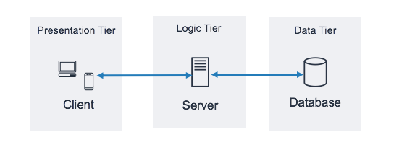

Figure 22: Visual representation of 3-Tier Architecture (Source: https://docs.aws.amazon.com/images/whitepapers/latest/serverless-multi-tier-architectures-api-gateway-lambda/images/image2.png )

1. LOGICAL ARCHITECTURE

Model View controller or MVC as it is popularly called, is a software design pattern for developing application. A model view controller pattern is made up of the following three parts.

* **Model**: The lowest level of the pattern which is responsible for maintaining data.
* **View**: This is responsible for displaying all or a portion of data to the user.
* **Controller**: It handles software codes that controls the interactions between the model and the view.

The MVC can be represented as follows.

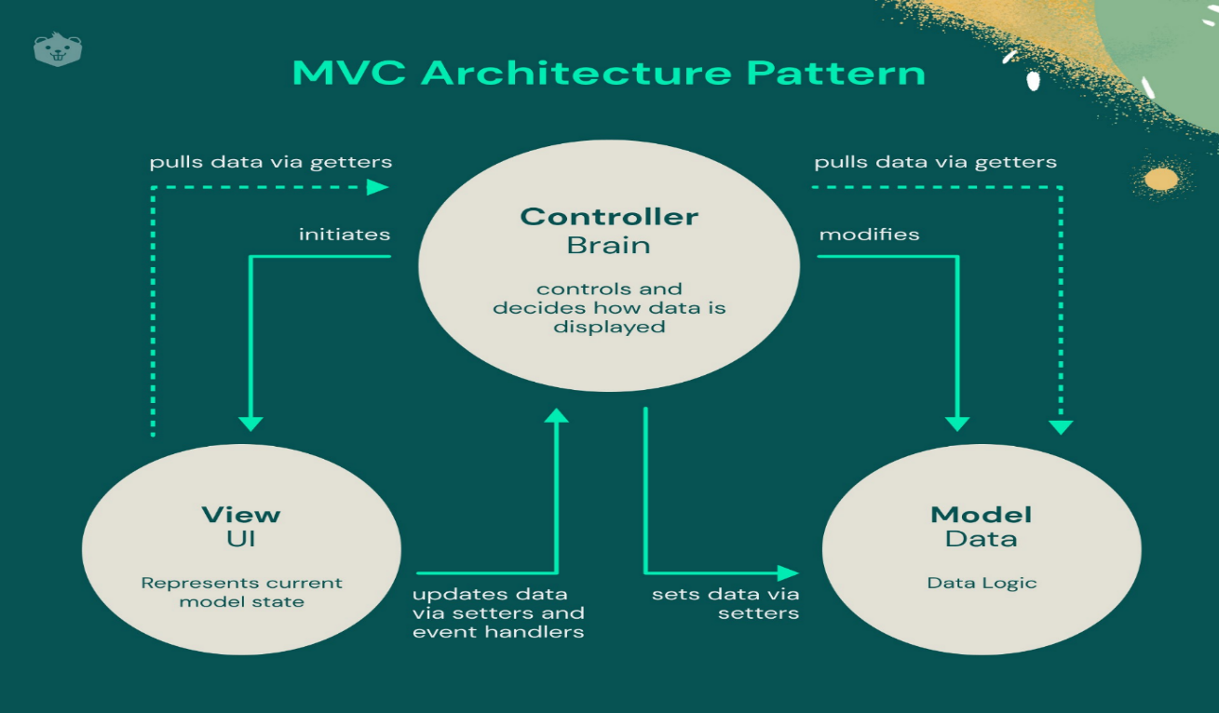

Figure 23: MVC Architecture (Source: https://encrypted-tbn0.gstatic.com /images? q=tbn:ANd9GcRx0n1oDz1SskHiZMKI5W0fAZ -KQ33yRlHruA&s )

1. **CLASS DIAGRAM**
2. Definition

The class diagram expresses the static structure of the system in terms of classes and the relationships between those classes. The interest of the class diagram is to model the entities of the information system.

1. Formalism

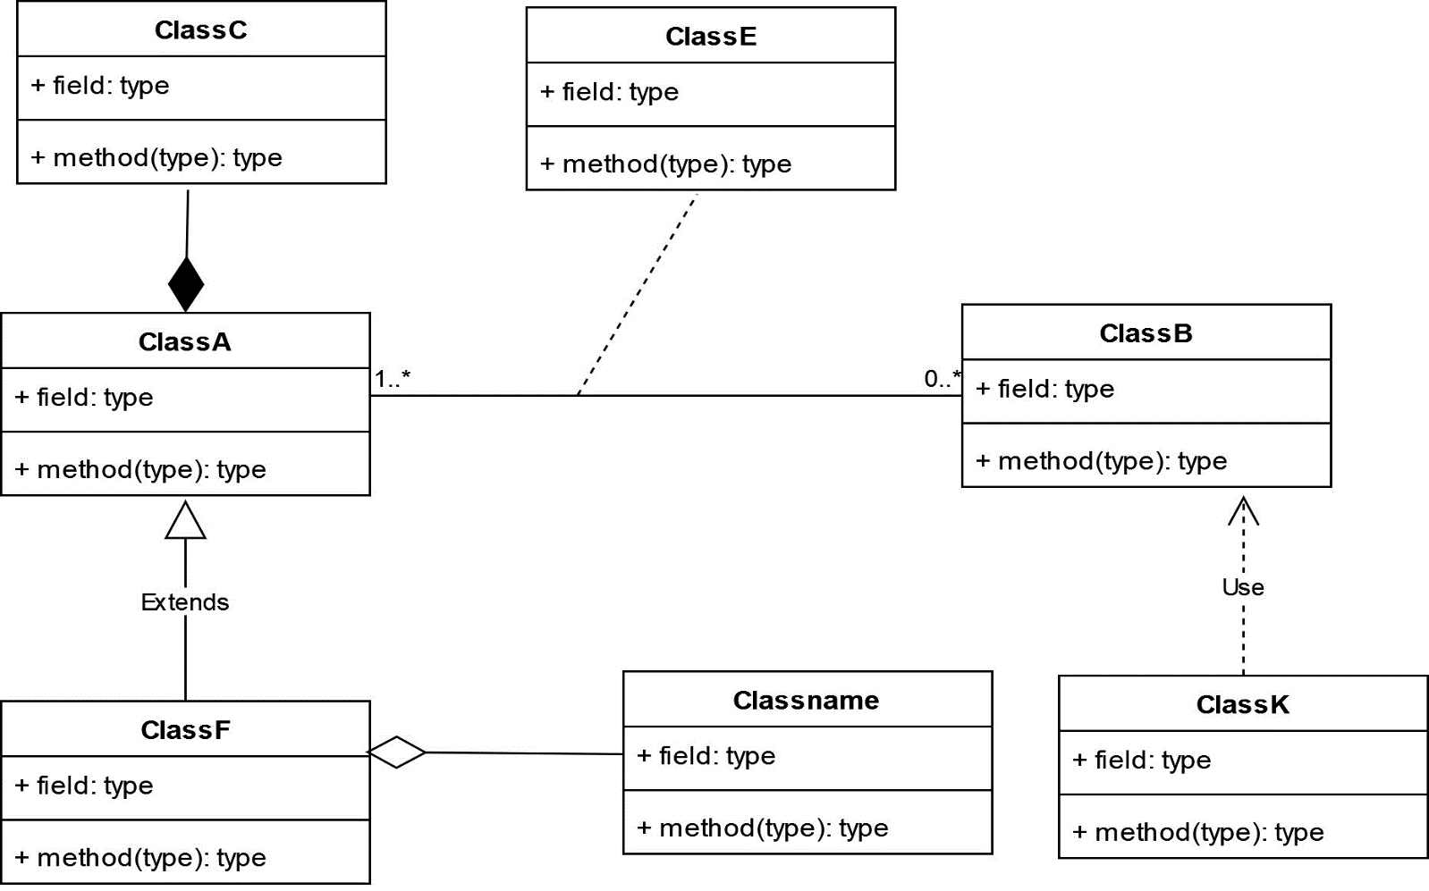

Figure 24: Class Diagram Formalism

1. Components of a Class Diagram

Table 18: Components of a Class Diagram

|  |  |  |
| --- | --- | --- |
| Element | Description | Representation |
| class | It defines the structure, the behaviour and the relationship of these objects. |  |
| Composition | If a parent of a composite is deleted, usually, all of its parts are deleted with it. |  |
| Aggregation | It models the notion that one object uses another object without "owning" it and thus is not responsible for its  creation or destruction. |  |
| Dependency | It existed between two classes, if one changes it may cause the change in the order, but the other way around. |  |
| Generalization | It is a relationship between a whole thing (called superclass) and a more specific thing (called subclass) |  |
| Association | It is a relationship between 2 or more classes. Types of association include Binary, Nary associations. |  |
| Association class | It is a class formed between 2 or more countries. |  |

1. 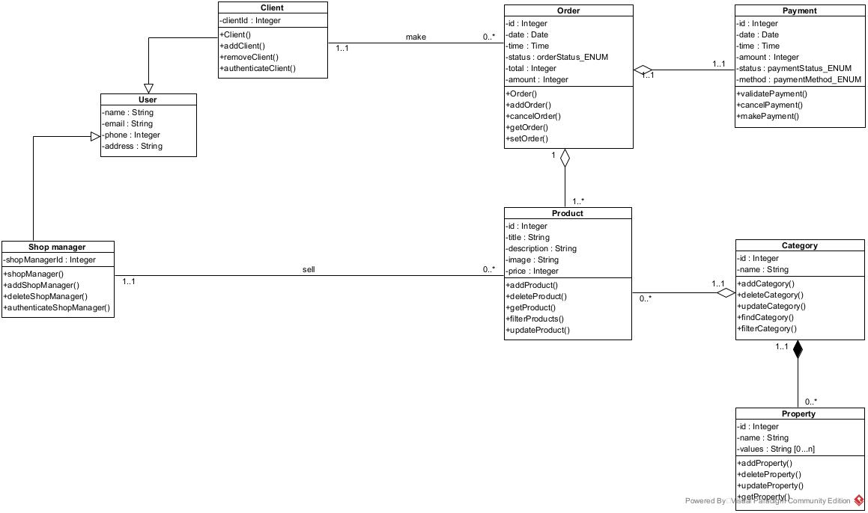System Class Diagram

Figure 25:General System Class Diagram

1. **STATE MACHINE DIAGRAM**
2. Definition

State diagrams are used to document the various states that a class can take, and the events that cause a state transition. They are typically applied to objects, showing how they respond to events by transitioning from one state to another.

1. 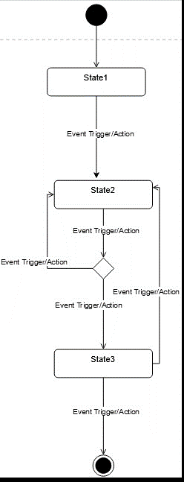Formalism

Figure 26: Formalism of a State machine diagram

1. Components of a State Machine Diagram

|  |  |  |
| --- | --- | --- |
| Element | Description | Representation |
| State | Models a situation during which a certain invariant condition holds. |  |
| First (Initial) State | It defines the initial state |  |
| Final State | It represents the final state or the end of a system. |  |
| Transition | It is a change of control from one state to another due to the occurrence of  some events. |  |
| Choice pseudo State | A diamond symbol that indicates a dynamic condition with branched potential results |  |
| Terminate | Implies that the execution of a state by means of it context is terminated. |  |
| Diagram Overview | A placeholder for the linked states in a state machine diagram. |  |

Table 19: Components of a State Diagram

* <<Order>> State Machine Diagram

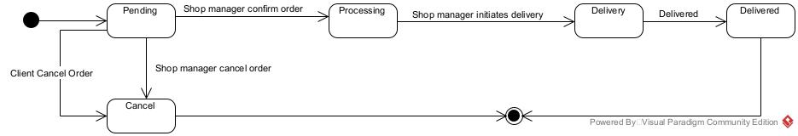

Figure 27: State machine diagram for <<Order>>

1. **PACKAGE DIAGRAM**
2. Definition

Package diagram is a structural diagram used to show the organisation and arrangement of various model elements in the form of packages. They can show both structure and dependencies between sub-systems or modules, showing different views of a system.

1. Formalism

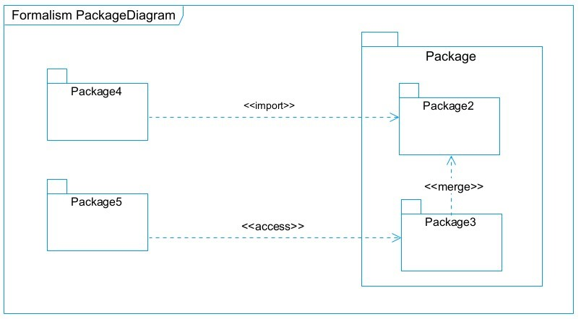

Figure 28: Formalism of a Package diagram

1. Components of a Package Diagram

|  |  |  |
| --- | --- | --- |
| NAME | Description | Representation |
| Package | A package is used to group together logically created elements within a system. |  |
| Package import | It indicates that a functionality has been imported from one packet  to another. |  |
| Package access | A relationship Indicates that one package requires assistance from the function of another package. |  |
| Package merge | It is a relationship which shows that, the functionality of two packages are combines to a single function. |  |

Table 20: Components of a Package Diagram

1. 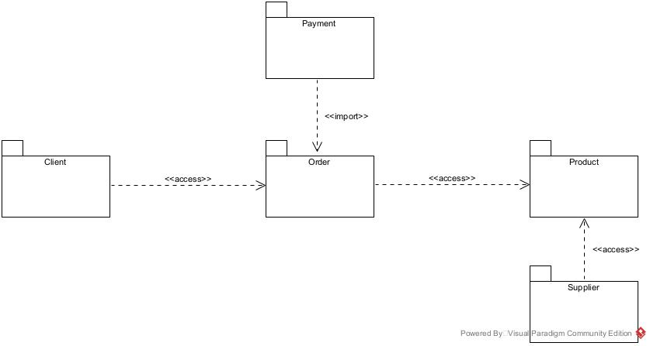System Package Diagram

Figure 29: System Package diagram

**CONCLUSION**

The conception phase helped us identify the data needed to create our database and implement our application. The elements modelled in this phase gave us an overall view of the various modules of our application. Therefore, the next step in our project will be drafting the implementation or realization file, considering the elements modelled earlier.



**CHAPTER 5: REALIZATION PHASE**

Preamble**CHAPTER 5: REALIZATION PHASE**

Preamble

Preamble**CHAPTER 5: REALIZATION PHASE**

Preamble**CHAPTER 5: REALIZATION PHASE**

Preamble

Preamble

Preamble

Preamble**CHAPTER 5: REALIZATION PHASE**

Preamble**CHAPTER 5: REALIZATION PHASE**

Preamble

Preamble**CHAPTER 5: REALIZATION PHASE**

Preamble**CHAPTER 5: REALIZATION PHASE**

Preamble

Preamble

Preamble

Preamble

Preamble

Preamble

Preamble

Preamble

In the realization phase, we focus on the practical aspects of implementing the system. This includes creating the deployment diagram, which shows the physical arrangement of hardware and software, and the component diagram, which outlines the structure and relationships of the system's components. These diagrams help ensure that the system is ready for deployment and functions as intended.

II.

II.

II.

II.

II.

II.

II.

II.

COMPONENT DIAGRAM

COMPONENT DIAGRAM

COMPONENT DIAGRAM

COMPONENT DIAGRAM

COMPONENT DIAGRAM

COMPONENT DIAGRAM

COMPONENT DIAGRAM

COMPONENT DIAGRAM



Content:

INTRODUCTIONContent:

INTRODUCTION

INTRODUCTIONContent:

INTRODUCTIONContent:

INTRODUCTION

INTRODUCTION

INTRODUCTION

INTRODUCTIONContent:

INTRODUCTIONContent:

INTRODUCTION

INTRODUCTIONContent:

INTRODUCTIONContent:

INTRODUCTION

INTRODUCTION

INTRODUCTION

INTRODUCTION

INTRODUCTION

INTRODUCTION

INTRODUCTION

INTRODUCTION

I.

I.

I.

I.

I.

I.

I.

I.

DEPLOYMENT DIAGRAM

CONCLUSION DEPLOYMENT DIAGRAM

CONCLUSION

**CHAPTER 6: FUNCTIONALITY TESTING**CONCLUSION DEPLOYMENT DIAGRAM

CONCLUSION DEPLOYMENT DIAGRAM

CONCLUSION

**CHAPTER 6: FUNCTIONALITY TESTING**CONCLUSION

**CHAPTER 6: FUNCTIONALITY TESTING**

Preamble**CHAPTER 6: FUNCTIONALITY TESTING**CONCLUSION

**CHAPTER 6: FUNCTIONALITY TESTING**CONCLUSION DEPLOYMENT DIAGRAM

CONCLUSION DEPLOYMENT DIAGRAM

CONCLUSION

**CHAPTER 6: FUNCTIONALITY TESTING**CONCLUSION DEPLOYMENT DIAGRAM

CONCLUSION DEPLOYMENT DIAGRAM

CONCLUSION

**CHAPTER 6: FUNCTIONALITY TESTING**CONCLUSION

**CHAPTER 6: FUNCTIONALITY TESTING**

Preamble**CHAPTER 6: FUNCTIONALITY TESTING**CONCLUSION

**CHAPTER 6: FUNCTIONALITY TESTING**CONCLUSION

**CHAPTER 6: FUNCTIONALITY TESTING**

Preamble**CHAPTER 6: FUNCTIONALITY TESTING**

Preamble

Preamble**CHAPTER 6: FUNCTIONALITY TESTING**

Preamble**CHAPTER 6: FUNCTIONALITY TESTING**CONCLUSION

**CHAPTER 6: FUNCTIONALITY TESTING**CONCLUSION

**CHAPTER 6: FUNCTIONALITY TESTING**

Preamble**CHAPTER 6: FUNCTIONALITY TESTING**CONCLUSION

**CHAPTER 6: FUNCTIONALITY TESTING**CONCLUSION

**INTRODUCTION**

The realization phase is where the system design is translated into practical implementation. In this phase, we will focus on the technical details necessary to deploy the system, including the creation of key diagrams such as the deployment and component diagrams. These will help illustrate how the system's components interact and are set up in the real world.

1. **DEPLOYMENT DIAGRAM**
2. Definition

A deployment diagram is a visual representation of the physical architecture of a computer. It represents the physical disposition of material resources that constitute the system and shows the component repartition (software elements) that are executed inside these materials(nodes)

1. Formalism

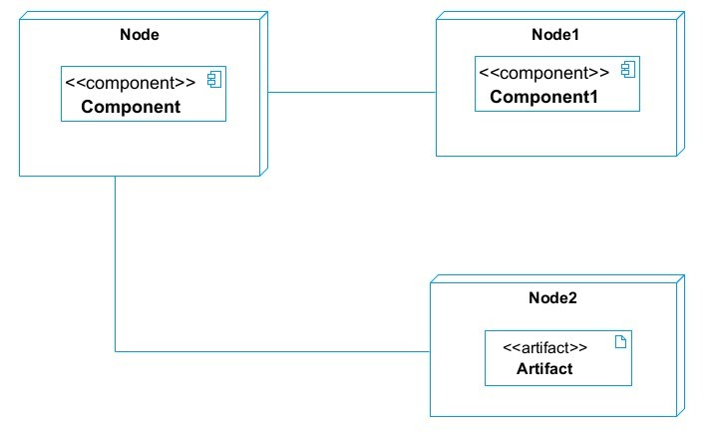

Figure 30: Formalism for Deployment Diagram

1. Components of Deployment Diagram

Table 21: Components of a Deployment Diagram

|  |  |  |
| --- | --- | --- |
| Element | Description | Notation |
| Node | It is a hardware used to deploy the application |  |
| Artifact | An artefact is a major product, which is produced or used during the development of a software. E.g diagrams, data models, setup scripts |  |
| Component | It represents a modular part of a system that encapsulates its content and whose manifestation is replaceable within it environment. |  |
| Association | An association helps to connect two nodes together which permits them to communicate  together |  |

1. 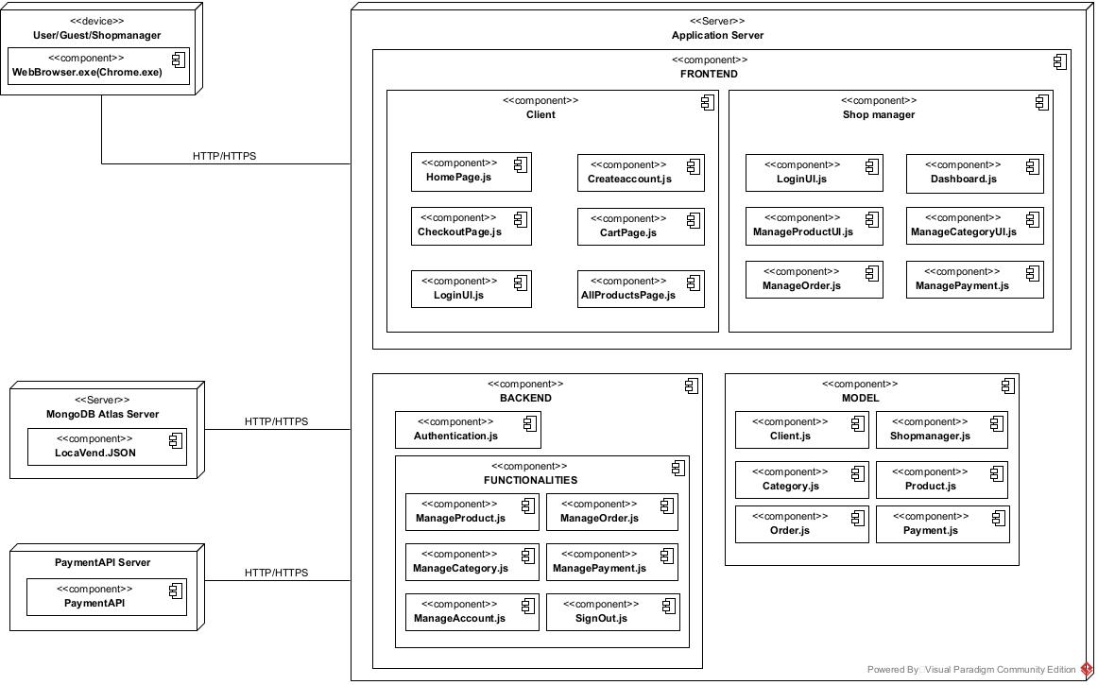System Deployment Diagram

Figure 31: System's Deployment diagram

1. **COMPONENT DIAGRAM**
2. Definition

A Component diagram describes the dependencies between various software component such as the dependency between executable file and source files. They represent the internal structure of our software (Software component).

1. Formalism

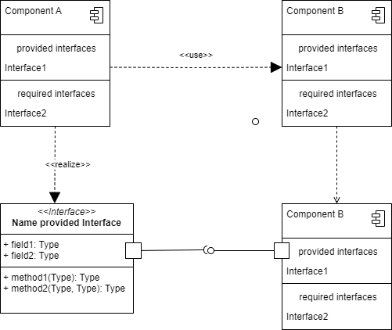

Figure 32: Formalism for Component Diagram

1. Components of a Component Diagram

Table 22: Components of a Component Diagram

|  |  |  |
| --- | --- | --- |
| Elements | Description | Notation |
| Component | A rectangle with the component's name inside, often with two smaller rectangles on the left. It represents a modular part of a system, encapsulating specific functionality or a group of functions. |  |
| Interface | Depicted as a circle or semi-circle attached to a component, it defines a set of operations specifying the component's responsibility. |  |
| Dependency | Illustrated as a dashed arrow, it indicates that one component relies on other components to function correctly. |  |
| Port | Represented as a small square on a component's edge, it defines an entry or exit point for data or control flow. |  |
| Connector | Shown as a solid line between two components or ports, it signifies the communication path between them. |  |

1. System Component Diagram

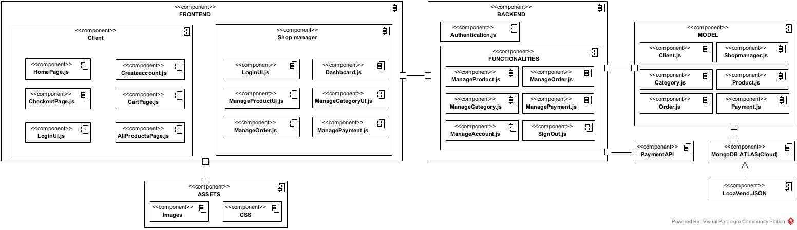

Figure 33: System's Component diagram

**CONCLUSION**

In this phase, we focused on both the logical and physical architecture of the application. We began with an overview of the physical architecture, which allowed us to present the system's deployment. Finally, we discussed the logical architecture, describing the various components that make up our system.



**CHAPTER 6: FUNCTIONALITY TESTING**

Preamble**CHAPTER 6: FUNCTIONALITY TESTING**

Preamble

Preamble**CHAPTER 6: FUNCTIONALITY TESTING**

Preamble**CHAPTER 6: FUNCTIONALITY TESTING**

Preamble

Preamble

Preamble

Preamble**CHAPTER 6: FUNCTIONALITY TESTING**

Preamble**CHAPTER 6: FUNCTIONALITY TESTING**

Preamble

Preamble**CHAPTER 6: FUNCTIONALITY TESTING**

Preamble**CHAPTER 6: FUNCTIONALITY TESTING**

Preamble

Preamble

Preamble

Preamble

Preamble

Preamble

Preamble

Preamble

In this section, we focus on testing our application to ensure the highest possible quality for users and to prevent potential issues from becoming bottlenecks. The goal is to verify that the software meets specified requirements and performs its expected functions.

II.

II.

II.

II.

II.

II.

II.

II.

TESTS SHOWCASES

TESTS SHOWCASES

TESTS SHOWCASES

TESTS SHOWCASES

TESTS SHOWCASES

TESTS SHOWCASES

TESTS SHOWCASES

TESTS SHOWCASES



Content:

INTRODUCTIONContent:

INTRODUCTION

INTRODUCTIONContent:

INTRODUCTIONContent:

INTRODUCTION

INTRODUCTION

INTRODUCTION

INTRODUCTIONContent:

INTRODUCTIONContent:

INTRODUCTION

INTRODUCTIONContent:

INTRODUCTIONContent:

INTRODUCTION

INTRODUCTION

INTRODUCTION

INTRODUCTION

INTRODUCTION

INTRODUCTION

INTRODUCTION

INTRODUCTION

I.

I.

I.

I.

I.

I.

I.

I.

APPLICATION FUNCTIONALITIES

CONCLUSION APPLICATION FUNCTIONALITIES

CONCLUSION

**CHAPTER 7: USER GUIDE**CONCLUSION APPLICATION FUNCTIONALITIES

CONCLUSION APPLICATION FUNCTIONALITIES

CONCLUSION

**CHAPTER 7: USER GUIDE**CONCLUSION

**CHAPTER 7: USER GUIDE**

Preamble**CHAPTER 7: USER GUIDE**CONCLUSION

**CHAPTER 7: USER GUIDE**CONCLUSION APPLICATION FUNCTIONALITIES

CONCLUSION APPLICATION FUNCTIONALITIES

CONCLUSION

**CHAPTER 7: USER GUIDE**CONCLUSION APPLICATION FUNCTIONALITIES

CONCLUSION APPLICATION FUNCTIONALITIES

CONCLUSION

**CHAPTER 7: USER GUIDE**CONCLUSION

**CHAPTER 7: USER GUIDE**

Preamble**CHAPTER 7: USER GUIDE**CONCLUSION

**CHAPTER 7: USER GUIDE**CONCLUSION

**CHAPTER 7: USER GUIDE**

Preamble**CHAPTER 7: USER GUIDE**

Preamble

Preamble**CHAPTER 7: USER GUIDE**

Preamble**CHAPTER 7: USER GUIDE**CONCLUSION

**CHAPTER 7: USER GUIDE**CONCLUSION

**CHAPTER 7: USER GUIDE**

Preamble**CHAPTER 7: USER GUIDE**CONCLUSION

**CHAPTER 7: USER GUIDE**CONCLUSION

**INTRODUCTION**

Software testing is a comprehensive process that ensures that software applications are reliable, secure, and user-friendly. It encompasses a range of techniques and methodologies, each targeting different aspects of software to provide a quality product.

1. **APPLICATION FUNCTIONALITIES**

* **Order and Payment**

Clients can browse available products from the shop, place orders, and make payments using Mobile Money (MoMo).

* **Manage Orders**

The shop manager can view, accept, or cancel client orders, depending on product availability.

* **Manage Products**

The shop owner can add, update, or remove products such as phones, laptops, and accessories from the online catalog.

* **Account Management (Admin)**

The admin oversees all system users (clients and delivery staff), ensuring smooth operation and accurate records.

These modules collectively form a comprehensive platform for gas distribution, ensuring that clients can efficiently place orders and suppliers and admins can manage the system smoothly.

1. **TESTS SHOWCASES**

**Software testing** can be performed at various stages of development, such as **Unit Testing**, **Integration Testing**, **System Testing**, and **Acceptance Testing**, using different methods like **Black Box** or **White Box** testing.

In this section, we will focus on **Integration Testing** to ensure different components (APIs, databases) communicate and work together, and **System Testing** to verify the entire system, from frontend to backend, functions as a whole.

This approach ensures that both the connections between components and the overall system function as intended.

1. Integration testing

API ↔ Database Interaction

These tests ensure that the API correctly interacts with the database by performing CRUD operations. We use Postman to tests the different API end points. Below are the tests carried out on our API’s end points:

* + **Order Management tests**
* Create Order **(POST /api/order):**
  + - 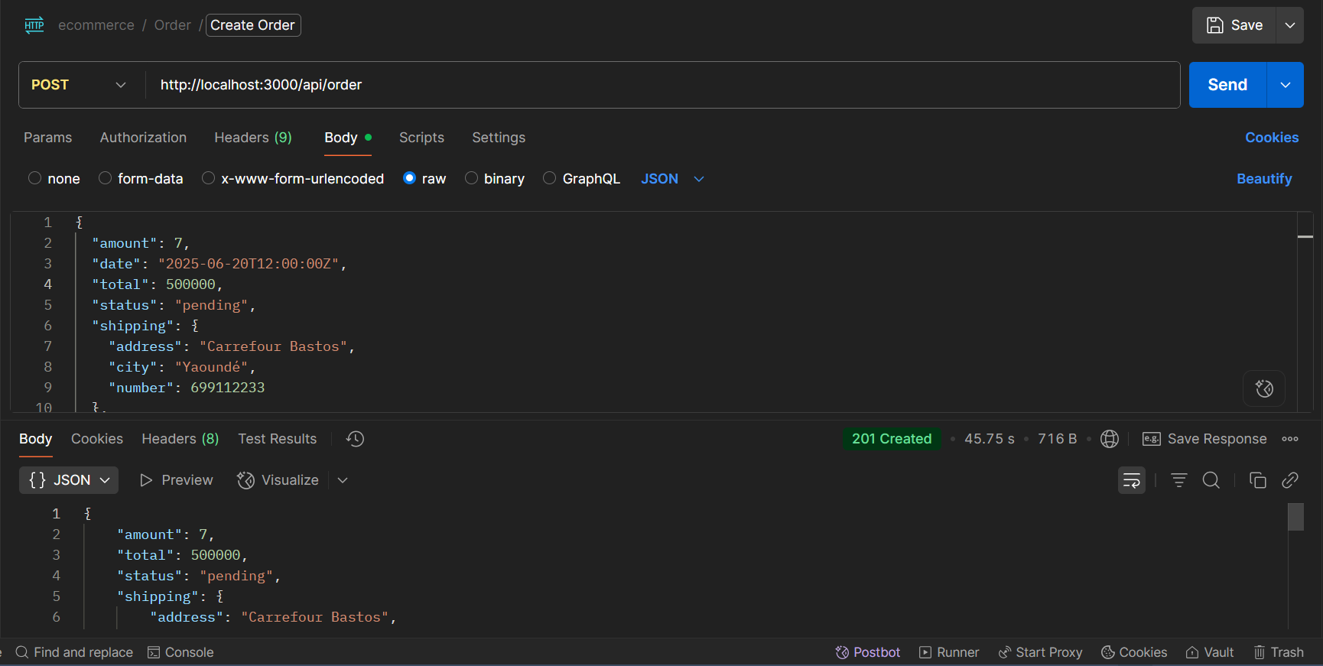This endpoint allows the client to place an order. We tested the creation of an order with valid data (Shipping address, products, payment info) and verified that it was correctly saved in the database

Figure 34:POST Request to /api/order/ to create an order

* + - 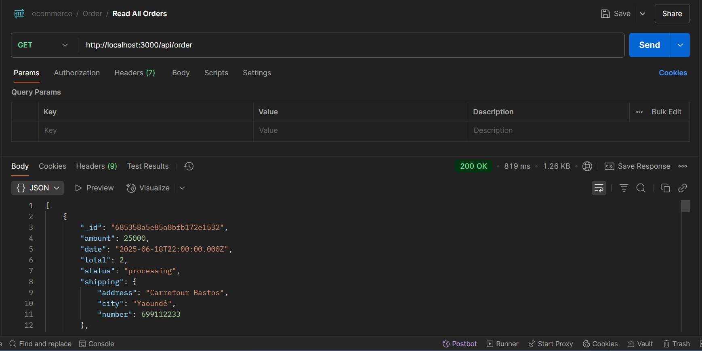Get All Orders **(GET /api/order):** This endpoint enables the shop manager to retrieve all existing orders. We verified that all order records were fetched correctly from the database

Figure 35: GET Request to /api/order to retrieve a list of all orders

* + - 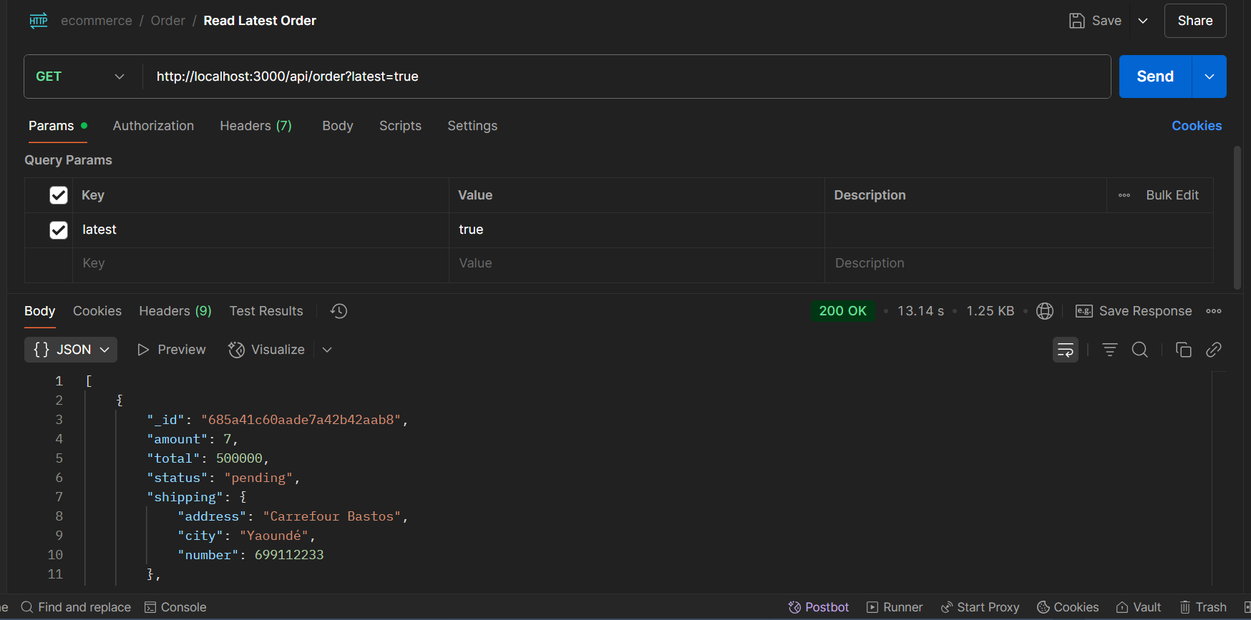Get Latest Orders **(GET /api/order?latest=true)**: This test checks that the API returns the most recent orders made by clients. We ensured the orders were sorted by creation date in descending order.

Figure 36: Get Request to s/api/order?latest=true with parameter (latest = true) to get the most recent orders

* + Product Retrieval by ID – API Test
* **Get Products by IDs (POST /api/cart)**  
  This endpoint allows the frontend to retrieve full product details based on a list of product IDs in the client’s cart.  
  We tested this by sending an array of product IDs to the API and verified that:
* Only products matching the given IDs were returned.
* Each returned product included correct attributes (e.g., title, price, image, stock).
* The response was accurate even when duplicate IDs were included.

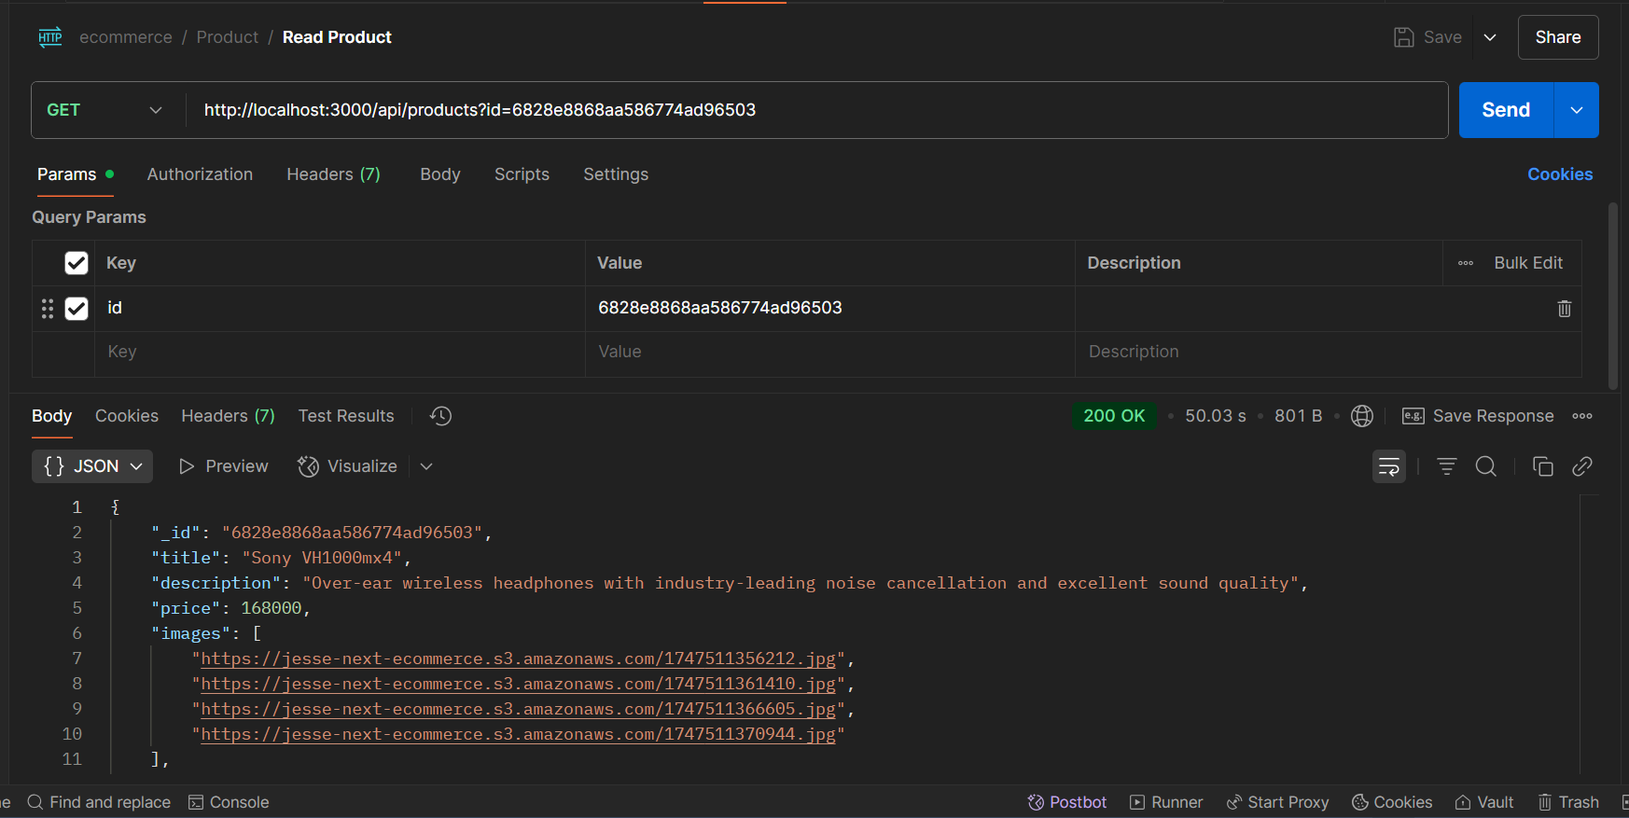This ensures the client’s cart displays real-time product information fetched directly from the database.

Figure 37: API response displaying product details for particular product Id

We tested <https://sandbox.momodeveloper.mtn.com/collection/v1_0/requesttopay>

API endpoint, which request a payment from a client(payer) on behalf of a supplier.

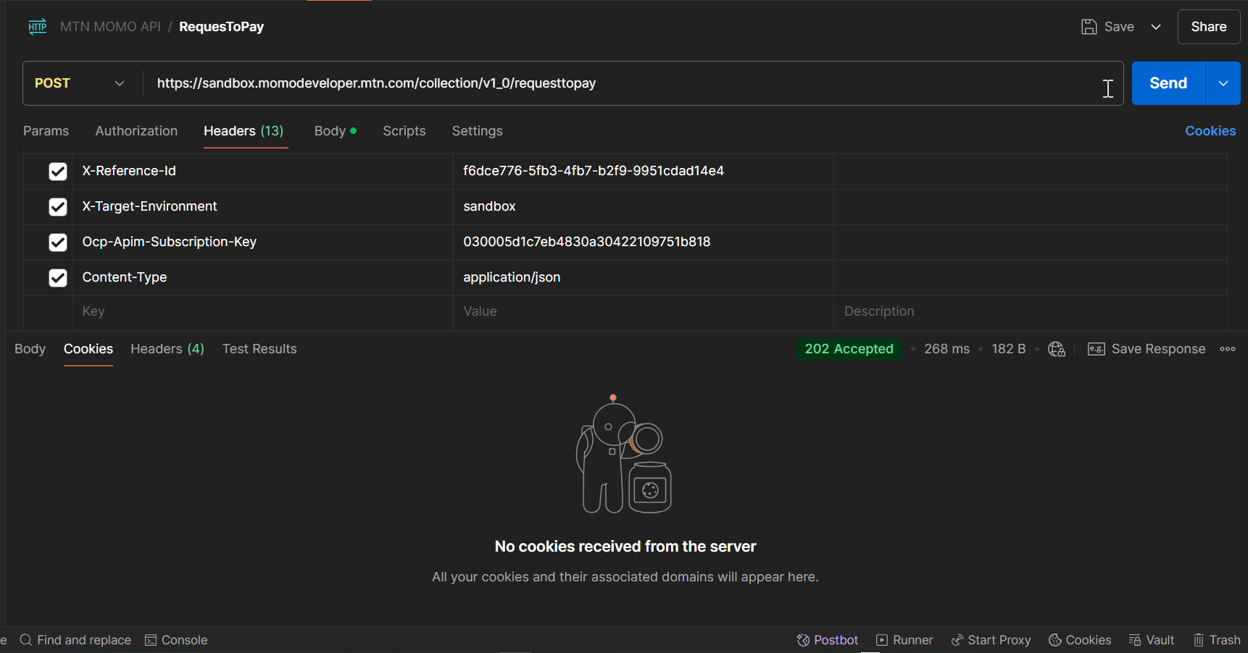

Figure 38:Test to request payment from a client on behalf of a supplier

**CONCLUSION**

Testing is an integral part of the software development life cycle, performed to verify the correctness, reliability, and robustness of the implemented functionality. This phase is critical in software development, as it validates the implemented features and identifies any issues for resolution.



**CHAPTER 7: USER GUIDE**

Preamble**CHAPTER 7: USER GUIDE**

Preamble

Preamble**CHAPTER 7: USER GUIDE**

Preamble**CHAPTER 7: USER GUIDE**

Preamble

Preamble

Preamble

Preamble**CHAPTER 7: USER GUIDE**

Preamble**CHAPTER 7: USER GUIDE**

Preamble

Preamble**CHAPTER 7: USER GUIDE**

Preamble**CHAPTER 7: USER GUIDE**

Preamble

Preamble

Preamble

Preamble

Preamble

Preamble

Preamble

Preamble

A user guide explains how to use a software application in a language that a nontechnical person can understand. Thus, it enables the user to easily use the application to familiarize with the software and discover its functionalities.

III.

III.

III.

III.

III.

III.

III.

III.

USER MANUAL

USER MANUAL

USER MANUAL

USER MANUAL

USER MANUAL

USER MANUAL

USER MANUAL

USER MANUAL

II.

II.

II.

II.

II.

II.

II.

II.

INSTALLATION GUIDE

INSTALLATION GUIDE

INSTALLATION GUIDE

INSTALLATION GUIDE

INSTALLATION GUIDE

INSTALLATION GUIDE

INSTALLATION GUIDE

INSTALLATION GUIDE



Content:

INTRODUCTIONContent:

INTRODUCTION

INTRODUCTIONContent:

INTRODUCTIONContent:

INTRODUCTION

INTRODUCTION

INTRODUCTION

INTRODUCTIONContent:

INTRODUCTIONContent:

INTRODUCTION

INTRODUCTIONContent:

INTRODUCTIONContent:

INTRODUCTION

INTRODUCTION

INTRODUCTION

INTRODUCTION

INTRODUCTION

INTRODUCTION

INTRODUCTION

INTRODUCTION

I.

I.

I.

I.

I.

I.

I.

I.

DESCRIPTION OF APPLICATION

CONCLUSION DESCRIPTION OF APPLICATION

CONCLUSION

**GENERAL CONCLUSION**CONCLUSION DESCRIPTION OF APPLICATION

CONCLUSION DESCRIPTION OF APPLICATION

CONCLUSION

**GENERAL CONCLUSION**CONCLUSION

**GENERAL CONCLUSION**

**GENERAL CONCLUSION**CONCLUSION

**GENERAL CONCLUSION**CONCLUSION DESCRIPTION OF APPLICATION

CONCLUSION DESCRIPTION OF APPLICATION

CONCLUSION

**GENERAL CONCLUSION**CONCLUSION DESCRIPTION OF APPLICATION

CONCLUSION DESCRIPTION OF APPLICATION

CONCLUSION

**GENERAL CONCLUSION**CONCLUSION

**GENERAL CONCLUSION**

**GENERAL CONCLUSION**CONCLUSION

**GENERAL CONCLUSION**CONCLUSION

**GENERAL CONCLUSION**

**GENERAL CONCLUSION**

**GENERAL CONCLUSION**

**GENERAL CONCLUSION**CONCLUSION

**GENERAL CONCLUSION**CONCLUSION

**GENERAL CONCLUSION**

**GENERAL CONCLUSION**CONCLUSION

**GENERAL CONCLUSION**CONCLUSION

**INTRODUCTION**

A user guide is a detailed document that offers step-by-step instructions for effectively using a product or service. It provides a wide range of information to help users understand and utilize the product efficiently. This section will provide a brief overview of our web application, followed by step-by-step instructions on how to set it up, and conclude with detailed explanations of its main features and how to use them.

1. **DESCRIPTION OF APPLICATION**
2. Purpose

**Locavend** is a web-based application designed to support the digital management of a local vendor’s shop, focusing on the sale and supply of electronic products such as mobile phones, laptops, and accessories. The platform allows clients to place orders online and enables the shop manager to handle product inventory, view client orders, and update order statuses. The goal is to modernize the operations of a traditional shop, reduce manual workload, and provide a more convenient shopping experience for clients.

1. Target Audience

**LocalVend** is designed for the following key actors:

* **Clients**  
  Individuals looking to purchase electronic products from the shop.  
  Benefit: They can easily browse items, place orders, and pay using mobile payment options without visiting the physical store.
* **Shop manager**

The local vendor responsible for managing the shop’s inventory and processing orders.

Benefit: Simplifies daily operations through digital inventory tracking, real-time order management, and improved customer service

By addressing the operational needs of the shop manager and the purchasing convenience of clients, **Locavend** offers a practical solution for modernizing local retail in Cameroon.

1. **INSTALLATION GUIDE**

After developing the **Locavend** application, some setup steps are required to deploy and run it. Since Locavend is a web-based application using **MongoDB Atlas** (cloud database) and **Next.js**, we do **not** need to install a local database server like MySQL or use XAMPP. Instead, we only need to set up and run the application server (Next.js) and connect it to MongoDB Atlas through environment variables.

**Required Environment**

* A MongoDB Atlas account (cloud database)
* Node.js and npm installed
* A modern browser (e.g., Chrome, Firefox)

1. Database Setup with MongoDB Atlas
2. Create a MongoDB Atlas Account.

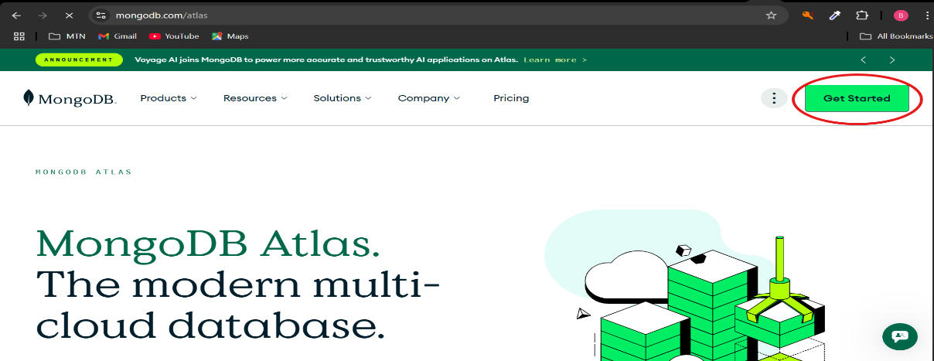Go to <https://www.mongodb.com/cloud/atlas> and create a free account.

Figure 39: Creating MongoDB Atlas Account

1. Create a New Cluster
2. Click “Build a Database”
3. Choose **Shared** cluster (free tier)
4. 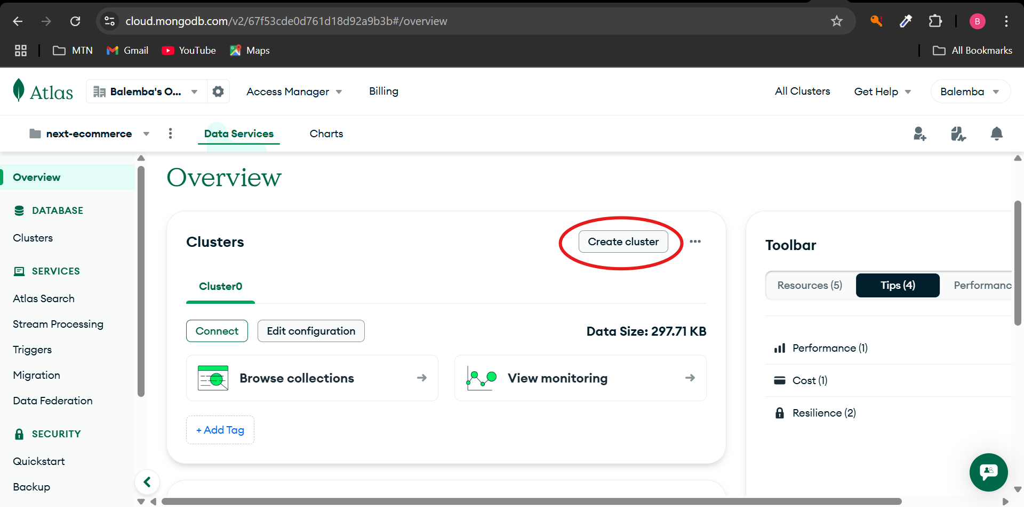Select a region close to you and create the cluster.

Figure 40: Creating cluster

1. Create a Database and Collection
2. Go to **Database** > **Browse Collections**
3. Click **Create Database**
4. 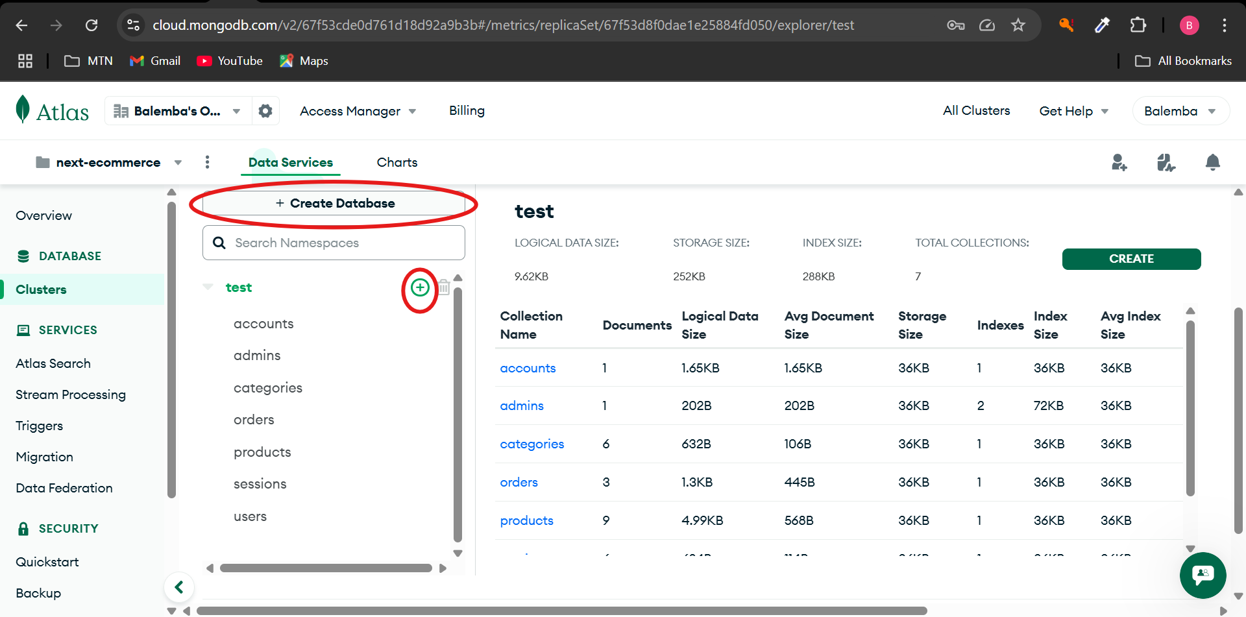Give it a name like **locavendDB** and a collection name like orders.

Figure 41: Creating Database (Bigger red circle) and collection (smaller red circle)

1. Allow Access from Anywhere
2. Go to **Network Access**
3. Click “Add IP Address”
4. 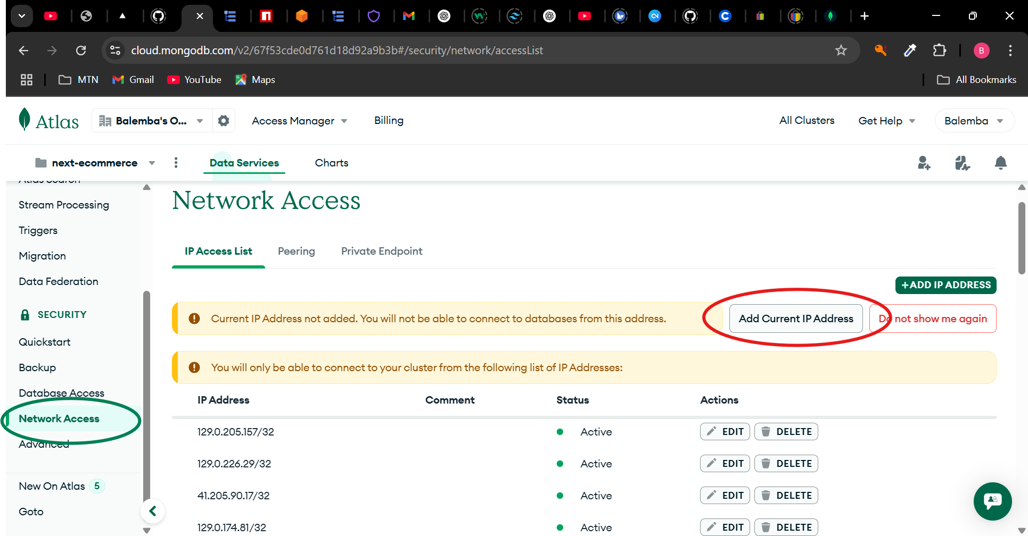Choose “Allow access from anywhere” (0.0.0.0/0).

Figure 42: Allow access(IP Adress) from anywhere (Application Server)

1. Get Your Connection String
2. Go to **Database** > Click **Connect**
3. Choose “Connect your application”
4. 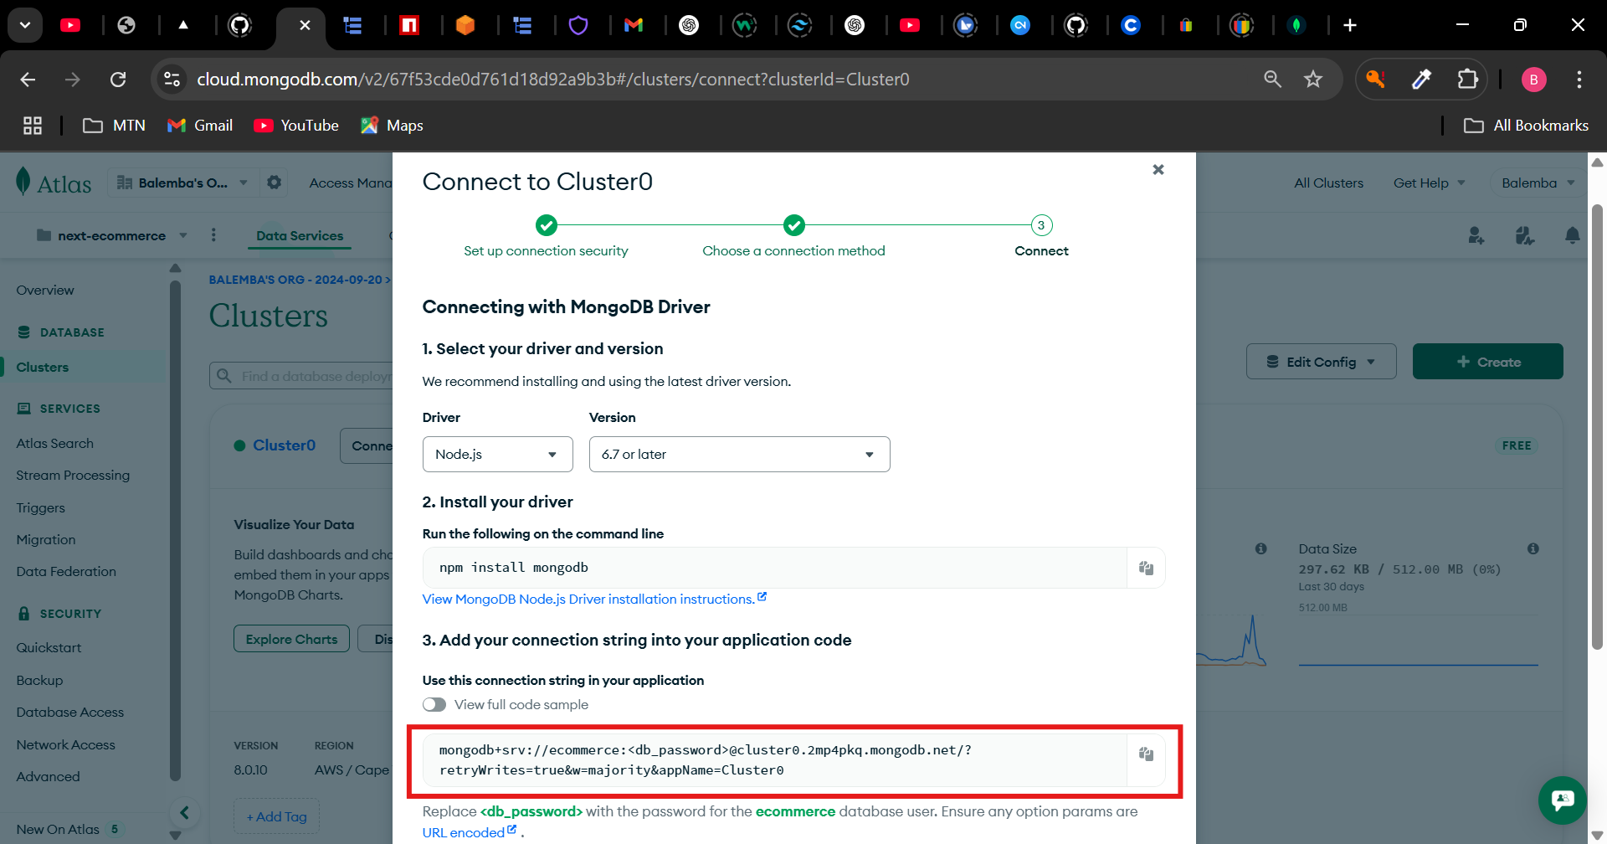Copy the connection URI like this:

Figure 43: Getting connection string to connect backend to cluster in Mongodb Atlas

1. **Paste this URI into your** .env.local **file** in your Next.js project as:



Figure 44: Inserting Connection URI to env.local file into Next js project

1. Application Server (Next.js)
2. 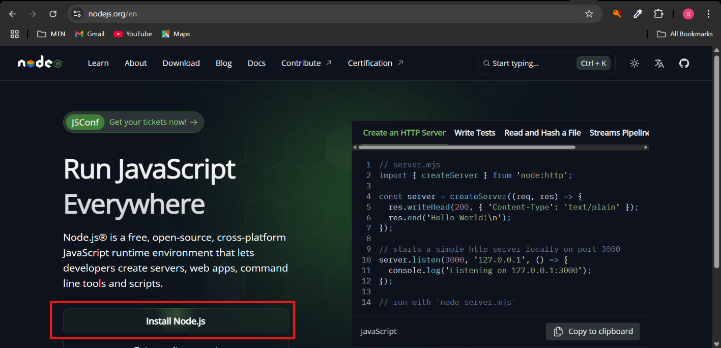Install Node.js and npm (Recent compatible versions)

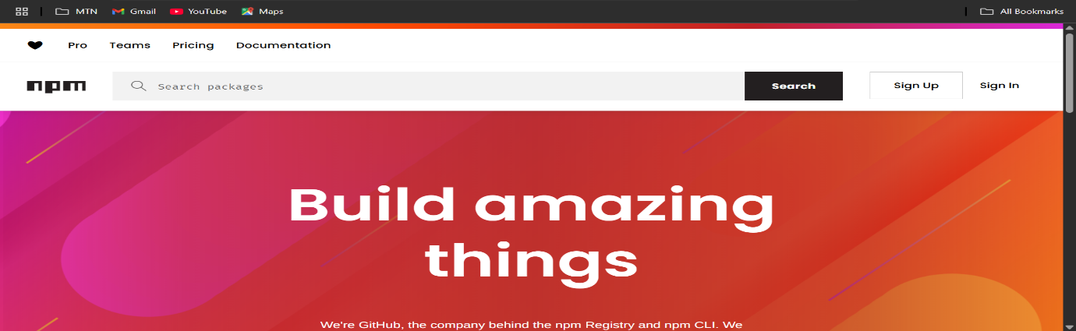Figure 45: Nodejs website for download and installation

Figure 46: Install npm

1. Clone or Download the Project to Target machine

Open your terminal or command prompt and run:



Figure 47: Downloading project to target machine

1. Install Project Dependencies

Navigate into the project folder and run:



Figure 48:Installing Project or Application Dependences

1. Start the Development Server

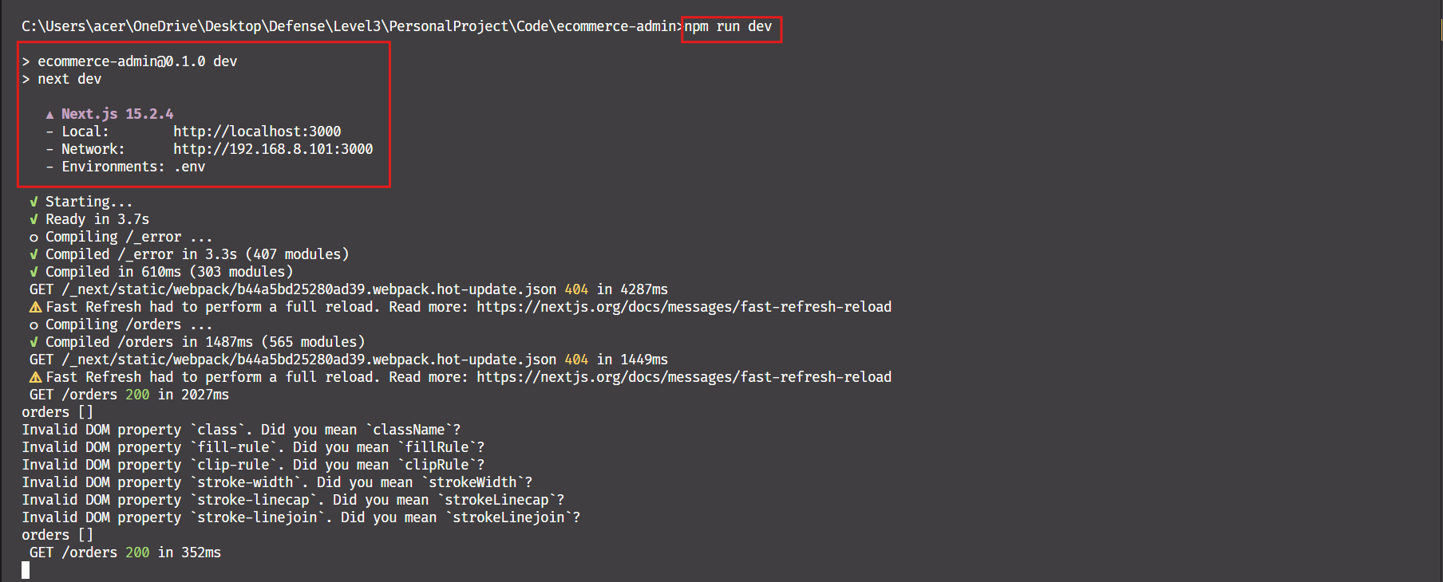

Figure 49: Starting the development server

1. **USER MANUAL**

In this part, the steps of carrying out the operations will be explained in detail. All this will be done through tests and explanations with screenshots in support to allow users not only to know how to actually do manipulations, but also to allow them to have an overview of the results they should expect.

1. **Connecting to the platform**

Connecting to the platform is not complicated at all. However, it is essential to meet a number of prerequisites, namely:

* Have a terminal (computer, tablet or smartphone);
* 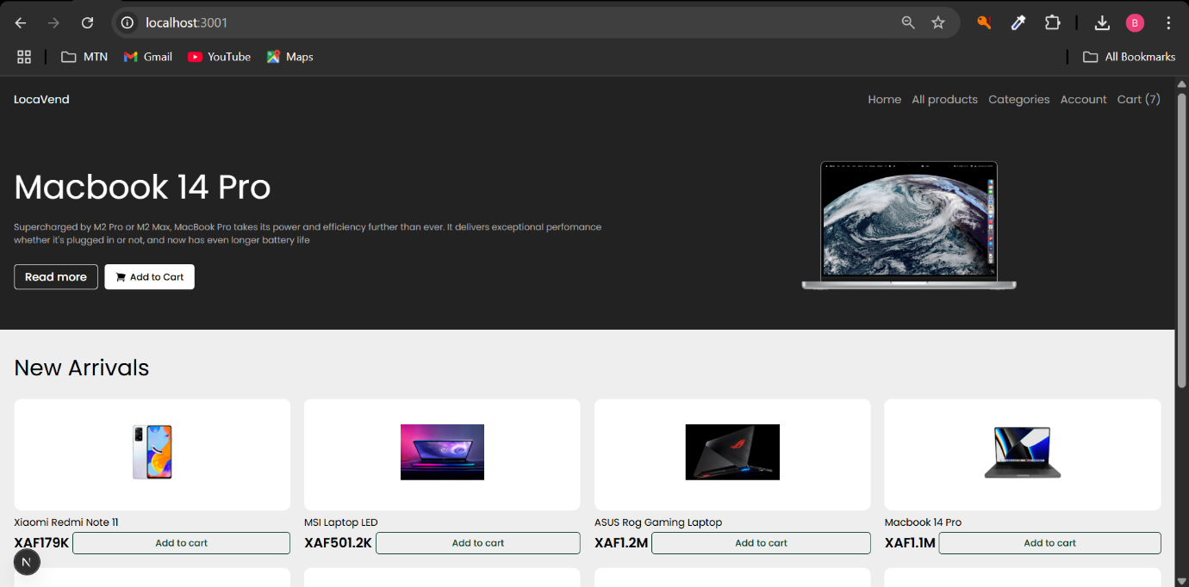Have installed a web browser (preferably the most recent version) in your terminal; Enter the URL: <http://localhost:3001/>. You will the obtain this page

Figure 50: Home page with featured and New arrival products

1. Here we have All products page from which the client or guest can add a product to cart or click on product to view product details.

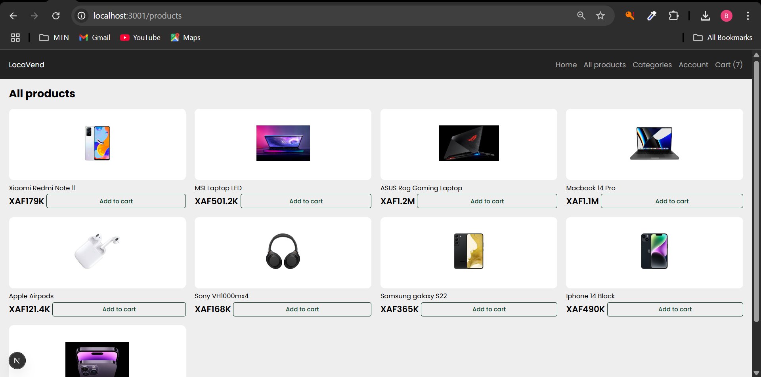

Figure 51: All product listing page

1. Cart Page

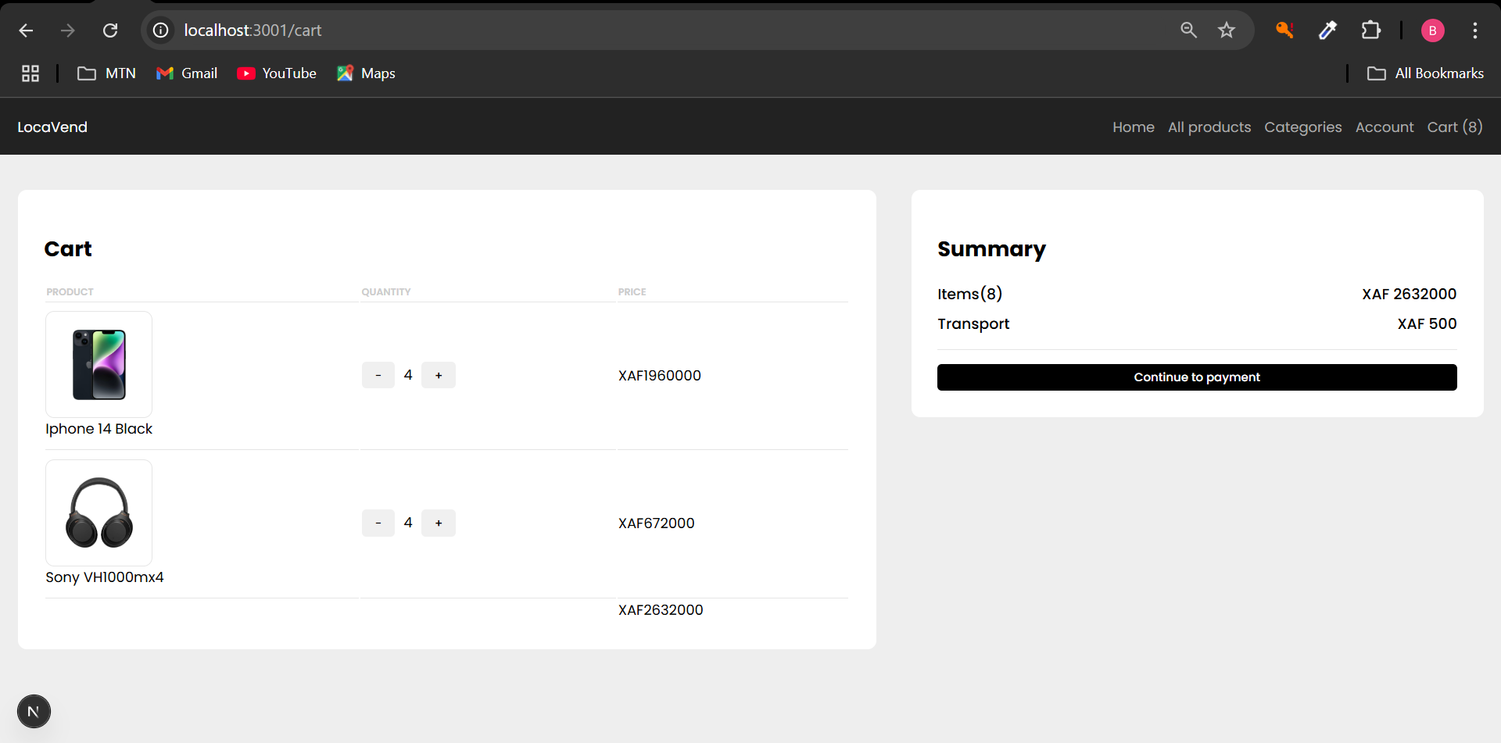

Figure 52: Cart page

1. 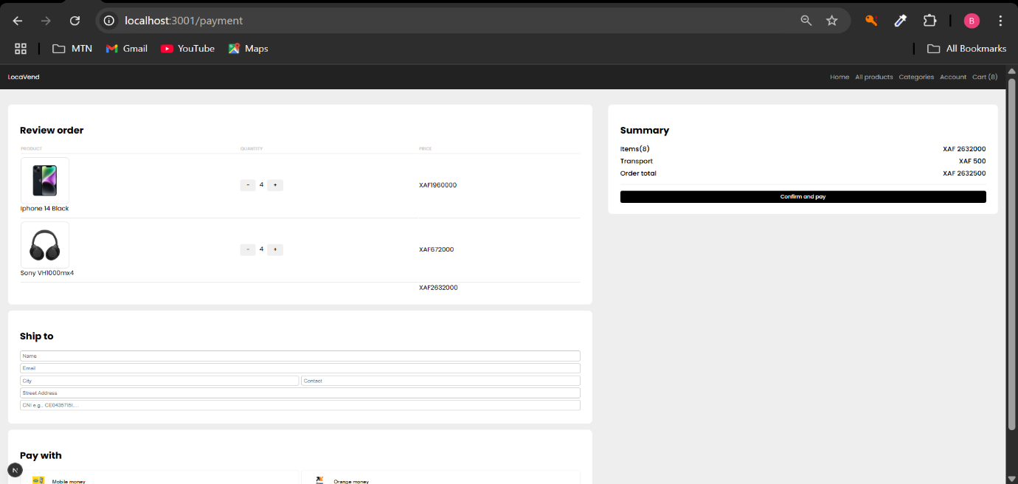Payment/Checkout page

Figure 53: Payment/Checkout page

1. Shop manager Dashboard

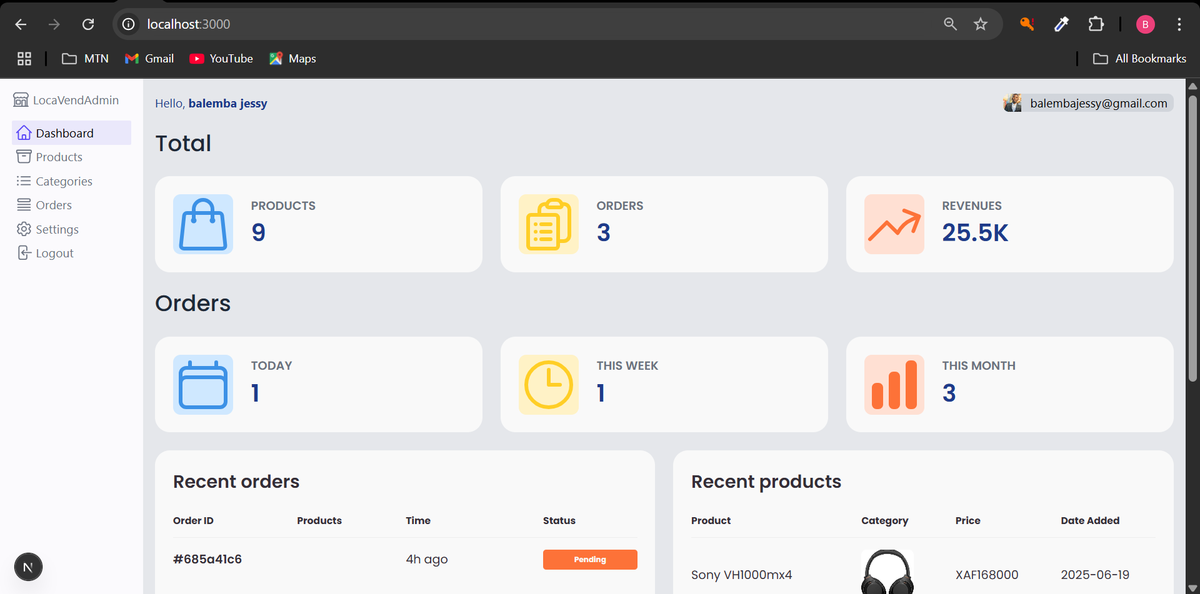

Figure 54: Shop manager Dashboard

1. 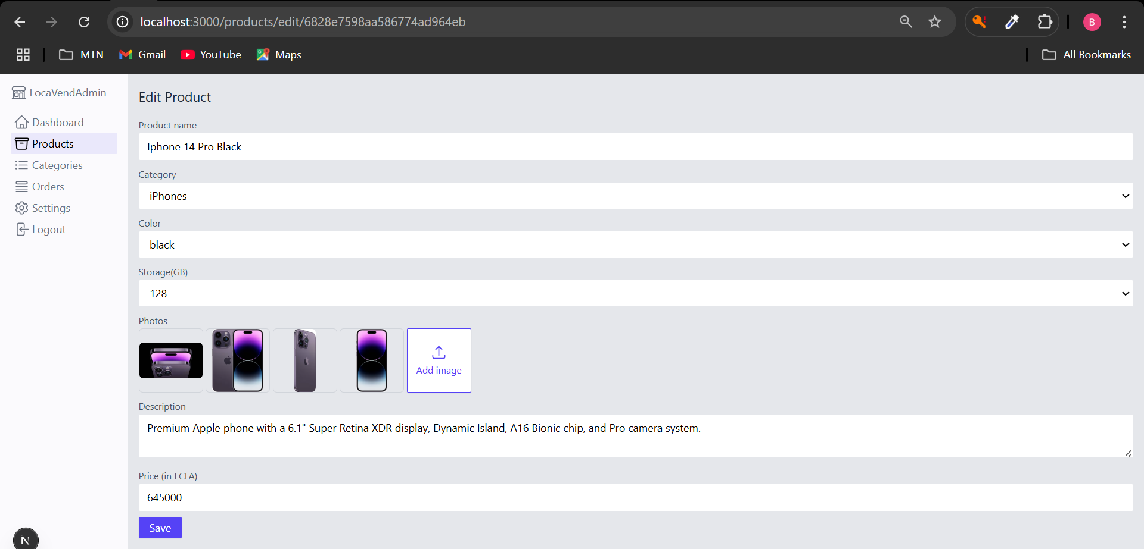Edit Product page

Figure 55: Delivery Person Dashboard

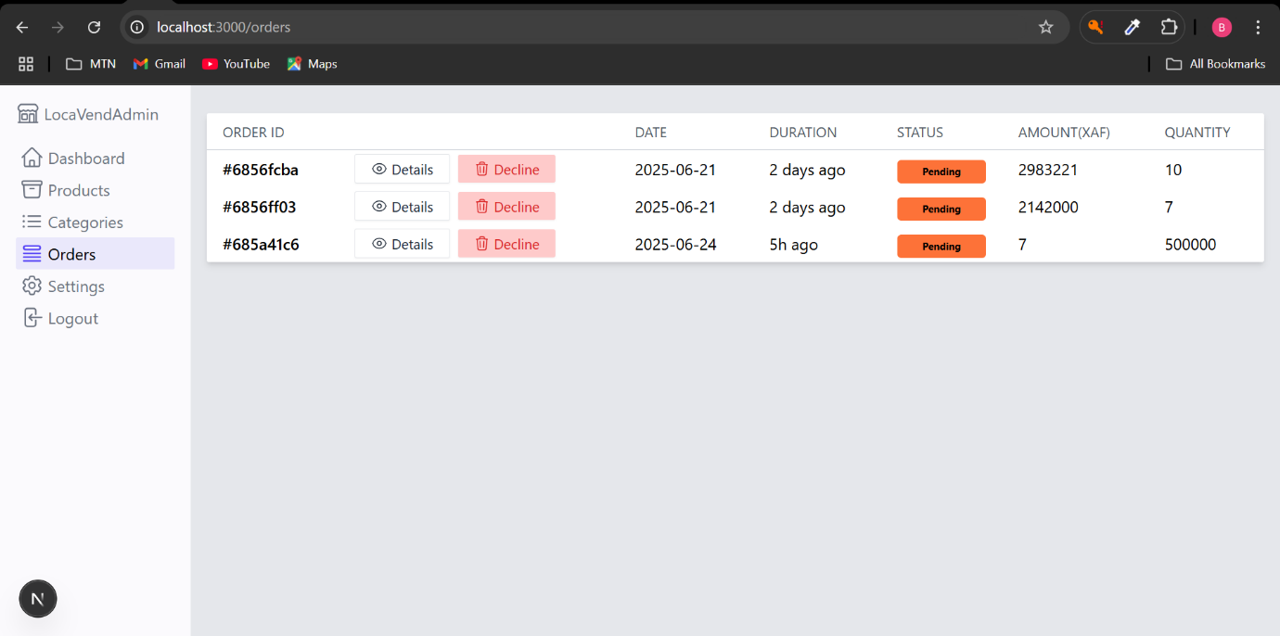7. Order page listing all recent orders.

Figure 56: Order page

**CONCLUSION**

As we conclude this final phase of the report, we have outlined the procedure for deploying the application. The main interfaces have also been presented to help users become familiar with the platform's functionalities and appearance, ensuring a smooth onboarding experience.

**GENERAL CONCLUSION**

**GENERAL CONCLUSION**

**GENERAL CONCLUSION**

**GENERAL CONCLUSION**

**GENERAL CONCLUSION**

**GENERAL CONCLUSION**

**GENERAL CONCLUSION**

**GENERAL CONCLUSION**

In conclusion, this project focused on the development of **Locavend**, a web-based application designed to support the purchase and supply management activities of a local vendor in Cameroon. The system was built to address common challenges such as manual tracking of product orders, lack of transparency in sales processes, and poor coordination between clients and shop managers. By streamlining operations such as order creation, product management, and order status tracking, **Locavend** enhances both efficiency and user experience. The application provides a centralized and digital platform for managing customer orders and inventory, contributing to the modernization of local shop management and improving the overall reliability and convenience for both the vendor and clients.

**ANNEX**

**BIBLIOGRAPHY ANNEX**

**BIBLIOGRAPHY**

**WEBOGRAPHYBIBLIOGRAPHY ANNEX**

**BIBLIOGRAPHY ANNEX**

**BIBLIOGRAPHY**

**WEBOGRAPHYBIBLIOGRAPHY**

**WEBOGRAPHY**

**TABLE OF CONTENTSWEBOGRAPHYBIBLIOGRAPHY**

**WEBOGRAPHYBIBLIOGRAPHY ANNEX**

**BIBLIOGRAPHY ANNEX**

**BIBLIOGRAPHY**

**WEBOGRAPHYBIBLIOGRAPHY ANNEX**

**BIBLIOGRAPHY ANNEX**

**BIBLIOGRAPHY**

**WEBOGRAPHYBIBLIOGRAPHY**

**WEBOGRAPHY**

**TABLE OF CONTENTSWEBOGRAPHYBIBLIOGRAPHY**

**WEBOGRAPHYBIBLIOGRAPHY**

**WEBOGRAPHY**

**TABLE OF CONTENTSWEBOGRAPHY**

**TABLE OF CONTENTSWEBOGRAPHY**

**TABLE OF CONTENTSWEBOGRAPHYBIBLIOGRAPHY**

**WEBOGRAPHYBIBLIOGRAPHY**

**WEBOGRAPHY**

**TABLE OF CONTENTSWEBOGRAPHYBIBLIOGRAPHY**

**WEBOGRAPHYBIBLIOGRAPHY**

* UML 2 For Dummies 1st Edition 2003 by James A. Schardt and Michael Jesse Chonoles.
* GanntProject Introduction for Beginners. 65 pages;
* Javascript_tutorial by tutorialspoint. 50 pages.

**WEBOGRAPHY**

**TABLE OF CONTENTSWEBOGRAPHY**

**TABLE OF CONTENTSWEBOGRAPHY**

**TABLE OF CONTENTSWEBOGRAPHY**

**TABLE OF CONTENTSWEBOGRAPHY**

**TABLE OF CONTENTSWEBOGRAPHY**

**TABLE OF CONTENTSWEBOGRAPHY**

**TABLE OF CONTENTSWEBOGRAPHY**

* <https://www.worldtravelguide.net/guides/africa/cameroon/shopping-nightlife/> | Local shops in Cameroon.
* <https://www.w3schools.com/js/default.asp> | JavaScript Tutorial
* <https://nextjs.org/docs> | Next js basics
* <https://developer.mozilla.org/en-US/docs/Web/JavaScript/Reference/Global_Objects> Standard built-in objects.
* <https://tailwindcss.com/> | Tailwind CSS basics.

**TABLE OF CONTENTS**

**DEDICATION** ........................................................................................................................ i

**ACKNOWLEDGEMENTS** .................................................................................................. ii

**SUMMARY** ........................................................................................................................... iii

**LIST OF FIGURES** .............................................................................................................. iv

**LIST OF TABLES** ...............................................................................................................vii

**GLOSSARY** .........................................................................................................................vii

**ABSTRACT** ......................................................................................................................... ix

**RÉSUMÉ** .............................................................................................................................. x

**GENERAL INTRODUCTION** .......................................................................................... 1

**TECHNICAL PHASE……………………………………………………….2**

* **Introduction** ............................................................................................................. 2
* **Conclusion** ...............................................................................................................15

**CHAPTER 1: EXISTING SYSTEM………………………………………………………..3**

* **Preamble** .................................................................................................................. 4
* **Introduction** .............................................................................................................5
* **Conclusion** ..............................................................................................................29

**I. PRESENTATION OF THEME**

* **Theme** ..................................................................................................................... 6
* **Definition of Terms** ................................................................................................6

**II. STUDY OF THE EXISTING SYSTEM……………………………………………….7**

* i. **Delimitation of the Field of Study** .................................................................... 7
* ii. **Description of the Existing System** ..................................................................8

#### **III. CRITICISMS OF THE EXISTING SYSTEM** ............................................................ 9

#### **IV. PROBLEMATIC** ....................................................................................................... 10

#### **V. LIMITATIONS AND PROPOSED SOLUTIONS** .....................................................10

* **Conclusion** ....................................................................................................…...11

**CHAPTER 2: SPECIFICATION BOOK………………………………………………..12**

* **Preamble** ..............................................................................................................13
* **Introduction** ........................................................................................................ 14
* **Conclusion** ........................................................................................................... 28
* **Introduction** ........................................................................................................ 29

#### **I. CONTEXT AND JUSTIFICATION…………………………………………………..15**

* i. **Context** ..............................................................................................................15
* ii. **Justifications** ....................................................................................................16

#### **II. PROJECT OBJECTIVES…………………………………………………………….17**

* i. **General Objective** ........................................................................................... 17
* ii. **Specific Objectives** ......................................................................................... 17

#### **III. EXPRESSION OF NEEDS………………………………………………………….19**

* i. **Functional Needs** .............................................................................................19
* ii. **Non-Functional Needs** ................................................................................... 20

#### **IV. PROJECT PLANNING……………………………………………………………..21**

* i. **Project Plan** .................................................................................................... 21
* ii. **Gantt Diagram** .............................................................................................. 22

#### **V. ESTIMATED COST OF PROJECT……………………………………………… 23**

* i. **Software Resources** ..................................................................................... 23
* ii. **Hardware Resources** .................................................................................. 25
* iii. **Human Resources** ...................................................................................... 25
* **Total Estimated Cost** ...................................................................................... 26
* iv. **Participants** ................................................................................................ 27

**VI. PROJECT CONSTRAINTS** .................................................................................. 28

**VII. DELIVERABLES** ................................................................................................ 28

* **Conclusion** ...................................................................................................... 29

### CHAPTER 3: ANALYSIS ........................................................................................... 30

* **Preamble** .......................................................................................................... 31
* **Introduction** .................................................................................................... 32

**I. METHODOLOGY** ................................................................................................... 51

* a. **Comparative Study between MERISE and UML** ................................... 33
* b. **Comparative Study of Unified Processes** ................................................. 36
  + i. **Presentation of UP Method** ............................................................ 36
  + ii. **Presentation of the 2-TUP Method** .............................................. 39
  + iii. **Comparative Study between 2TUP and UP** ............................... 41
  + iv. **Justification on the Choice of Analysis Method** ........................ 41

**II. MODELLING** ........................................................................................................ 42

* a. **Use Case Diagram** ...................................................................................... 42
  + i. **Definition** ......................................................................................... 42
  + ii. **Formalism** ...................................................................................... 42
  + iii. **Components of a Use Case Diagram** .......................................... 43
  + iv. **General Use Case Diagram** ......................................................... 45
  + v. **Client Manage Cart Specific Use Case Diagram** ....................... 46
  + vi. **Shop manager Manage Order Specific Use Case Diagram** .... 47
* b. **Communication Diagram** ........................................................................ 53
  + i. **Definition** ....................................................................................... 53
  + ii. **Formalism** .................................................................................... 53
  + iii. **Components of a Communication Diagram** ........................... .56
* c. **Sequence Diagram** ................................................................................... 58
  + i. **Definition** ...................................................................................... 58
  + ii. **Formalism** ................................................................................... 58
  + iii. **Components of a Sequence Diagram** ...................................... 59
* d. **Activity Diagram** .................................................................................... 63
  + i. **Definition** ..................................................................................... 63
  + ii. **Formalism** .................................................................................. 63
  + iii. **Components of an Activity Diagram** ...................................... 64

**CHAPTER 4: CONCEPTION PHASE** ................................................................... 71

* **Preamble** ..................................................................................................... 72
* **Introduction** ............................................................................................... 73

#### A. **Capture of Technical Needs** ............................................................................... 74

* **I. Class Diagram** ....................................................................................... 77
  + i. Definition .....................................................................................77
  + ii. Formalism .................................................................................. 77
  + iii. Components of a Class Diagram .............................................. 78
* **II. State Machine Diagram** ...................................................................... 81
  + i. Definition .................................................................................... 81
  + ii. Formalism .................................................................................. 81
  + iii. Components of a State Machine Diagram ........................... 82
* **III. Package Diagram** .......................................................................... 84
  + i. Definition ............................................................................... 84
  + iii. Components of a Package Diagram ..................................... 85
  + iv. System Package Diagram ..................................................... 86
* **Conclusion** ............................................................................................ 87

**CHAPTER 5: REALIZATION PHASE** ........................................................... 88

* **Preamble** .............................................................................................. 89
* **Introduction** ........................................................................................ 90
* **I. Deployment Diagram** ..................................................................... 91
  + i. Definition .............................................................................. 91
  + ii. Formalism ............................................................................ 91
  + iii. Components of a Deployment Diagram ............................. 92
* **II. Component Diagram** .................................................................... 94
  + i. Definition .............................................................................. 94
  + ii. Formalism ............................................................................ 94
  + iii. Components of a Component Diagram .............................. 95
  + iv. System Component Diagram .............................................. 96
* **Conclusion** .......................................................................................... 97

**CHAPTER 6: FUNCTIONALITY TESTING** ............................................... 98

* **Preamble** ............................................................................................ 99
* **Introduction** .................................................................................... 100
* **I. Application Functionalities** ........................................................ 101
* **II. Tests Showcases** ......................................................................... 102
  + i. Integration Testing ............................................................. 103
    - API ↔ Database Interaction ..................................103
* **Conclusion** .............................................................................................. 107

**CHAPTER 7: USER GUIDE** .............................................................................. 108

* **Preamble** ................................................................................................ 109
* **Introduction** .......................................................................................... 110
* **I. Description of Application** ............................................................... 111
  + i. Purpose ................................................................................... 111
  + ii. Target Audience .................................................................... 111
* **II. Installation Guide** ........................................................................... 112
  + a. Database Setup with MongoDB Atlas ................................... 142
* **III. User Manual** .................................................................................. 119
* **Conclusion** ............................................................................................ 123

**GENERAL CONCLUSION** ............................................................................ 124

**ANNEX** ........................................................................................................... XIV

**BIBLIOGRAPHY** ............................................................................................ XV

**WEBOGRAPHY** ............................................................................................ XVI

**TABLE OF CONTENTS** .............................................................................. XVII